Use the forward and back arrows to move between the following four slides, which introduce Accomack County and set the stage for your case study challenge.Accomack County was established in the Virginia colony in 1634. It was one of the eight original counties of Virginia. The county’s name comes from a Native American word meaning “the other shore.”
Today, Accomack County is home to the Wallops Flight Facility, operated by the National Aeronautics and Space Administration (NASA). The Geographical Setting
Slide 3 of 4
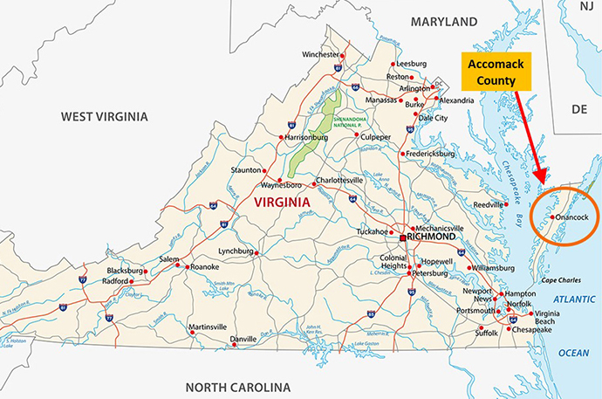
The Chesapeake Bay and Atlantic Ocean surroundings contribute to a unique and pleasurable lifestyle in Accomack CountyVirginia has set new priorities in the area of health and wellness and has challenged each county to develop a plan to ensure that residents live healthy and prosperous lives. Your new role is to improve the health of the residents living in Accomack County.
Through the framework of a clinical reasoning model, you will explore health promotion and health education across the lifespan of a particular population.
- What is one health problem that is of concern to the residents of Accomack County that you would like to address in your new role as the county’s leader of health and wellness?
  - Hint: Look at the measures in Virginia’s Plan for Well-Being Links to an external site.. This will help you identify a problem that can be addressed.
- Narrowing your focus, what specific segment of the population of Accomack County will be the target of your health promotion initiative?
  - What do you want to happen with this target population?
- What health outcome, or goal, do you and your team expect to achieve for the target population in the next year?
  - Be sure to write your goal (objective) in a measurable format. If it is not measurable, you will not know if your initiative made a difference.
- What theory will guide your health promotion initiative? Briefly explain.
- What three actions are necessary to implement your initiative and reach the outcome/goal you’ve set?

