

Statistical Process Control Methods

Process Evaluation
Evaluate your process using 1 of the following:
- Use the lean concept to find ways to eliminate waste and improve the process
- SPC or Six Sigma to reduce defects or variances in the process

While evaluating the process, it is ideal for carrying out SPC to lessen the difference simultaneously. SPC consolidates people, materials, procedures, machines, and gauges to plan changes in input resources as required advantages (items or regulatory administration). In this occurrence regarding handling a seller request, it assists with making things a smidgen smoother while getting and finishing a request (Serhat et al., 2020). While carrying out the SPC for merchant registration physically, it saves time, and the clients don't need to stand by longer for the DSD association to come through or screw up, bringing about clients having the option to get administration sooner rather than later.
Six Sigma is a philosophy centered on making advancement enhancements by overseeing variety and lessening surrenders in processes across the venture. Six Sigma is a business procedure that utilizes well‐structured consistent improvement philosophy and measurable instruments to lessen deformities and cycle fluctuation (Jin et al., 2018). It is a quality discipline that spotlights item and administration greatness. Six Sigma has been utilized in various organizations to decrease working expense, increment deals and income, increment dependability, consolidate advancement in items and administrations, increment efficiency and productivity where the goal of a Six Sigma program is to decrease the variety in the process to the degree that the probability of creating a deformity is non‐existent.

Evaluation of Control Chart and Process Metrics
Complete the following in Excel:
- Calculate the defined process metrics including variation and process capability.
- Develop and display a control chart for the process.

Evaluate the control chart and process metrics using Statistical Process Control (SPC) methods. Determine whether the process could benefit from the use of Six Sigma, Lean, or other tools. (Include all calculation and charts.)

Quality Characteristics | Average Thickness (mm), X-bar
Sample Size, n | 8
Sample Size, k | 3

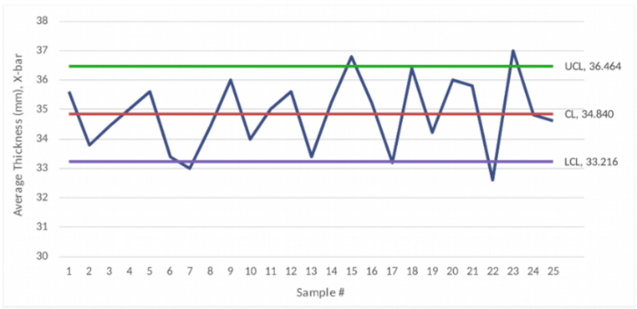
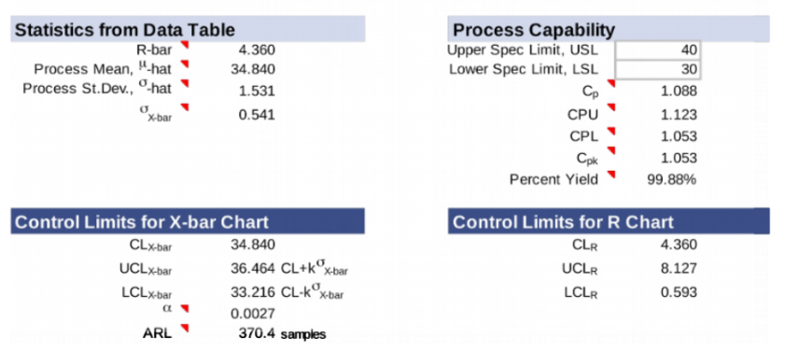

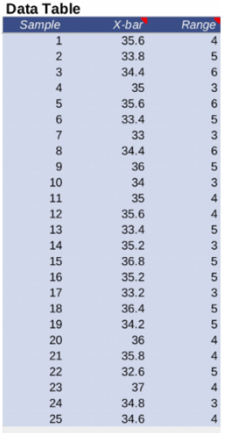
Utilizing SPC to assess a control graph can assist with giving a wide philosophical clarification while observing the interaction's execution and making changes on a case-by-case basis to keep up with control. This graph can help with figuring out which technique is best for checking in merchant’s dependent on the time and cycle included.

Executive Summary
Write a 700-word executive summary that includes the following:
- A summary of the Process Evaluation (using either Lean or SPC or Six Sigma)
- A summary of the Evaluation of Control Chart and Process metrics based on SPC methods
- A summary of your evaluation of whether the process would benefit from the use of Six Sigma, Lean, or other tools
- A description of the SPC project and recommendations for improvements

While assessing the most common way of checking in a seller in a store, there can be a variety of difficulties that might emerge yet carrying out the SPC to lessen abandons in the process assists with making things somewhat better. The SPC helps organizations to advance toward anticipation-based quality control rather than area-based quality controls. By noticing the SPC diagram, the association can adequately foresee the conduct of the strategy (Peres and Fogliatto, 2018). The principal benefits from SPC that helps while checking in a seller depend on the critical variables of utilizing SPC, which incorporate, yet are not restricted to reducing beginning an interaction once more, increase efficiencies, and progress quality in general by lessening the time it takes when beginning checking in a merchant more than once because of DSD issues, it assists with saving a great deal of time when different things should be finished in the day.
Productivity will be at a record-breaking high because less time will be utilized on reiteration. Likewise, the advancement quality will be high since there will be to a lesser extent a possibility that issues might emerge while checking in a merchant physically as opposed to utilizing the DSD innovation gadget.
SPC Charts break down process execution by plotting data focuses, control limits, and a centerline. At last, an interaction ought to be controlled to assess the strategy's capacities. To cause changes, the change should show the normal reason for the change before assessing process capacity. It is imperative to have a significant arrangement ability that won't be exposed to special cases and assortment from an insecure handle (Chakraborti & Graham, 2019). When assembling and framing significant data about the outline and how it can help check in merchants, there are seven principal steps that we want to execute. The seven stages incorporate distinctive cycles, choosing quantifiable characteristics of the strategy, the estimation strategy, conjointly playing out the gage R&R, making a subgroup procedure, and looking at plans, gathering the data, and plotting the SPC outline, depicting the regular variety of properties, and by actually looking at the technique variety (Chakraborti and Graham, 2019).
After additional thought, it is as I would like to think of the assessment of this cycle that handling a seller request can profit from utilizing either the SPC or Lean. Other than profiting from SPC, it has every one of the vital fixings expected to assist with performing better hands-on while checking in orders. Quality data is gathered in item or interaction assessments or readings from various machines or instruments (Clark et al., 2018). Then, at that point, gather the data and assess, screen, and control the interaction. SPC is a methodology to drive persistent improvement. We can ensure that it works at its fullest potential (Clark et al., 2018). When finding out with regards to the lean idea, it is best first to get what it implies. Lean spotlights on securing esteem through less work.
The objective is to furnish customers with ideal worth through the most elevated worth creation process with zero waste. This is typically accomplished by permitting every worker to amplify their capability to make the main responsibility. By utilizing incline toward the gig, the store can ensure that one individual checks in the merchant. Simultaneously, there is someone else on the register, a worker out on the business floor who is willing and ready to assist clients with their requirements, and someone else who can help different representatives who could possibly need assistance (Peres & Fogliatto, 2018). This thought assists with eliminating time for the individual checking in the merchant. That worker doesn't need to continue to stop to help other people, which will make the seller cycle longer because the store will be covered with assistance when required for specific segments of the store.
As recently referenced, there is a great deal of added advantages of involving SPC for checking in sellers. Clients will be fulfilled that they will have laborers accessible to tune in and help. Usefulness can start to rise. There will be an opportunity to lessen innovation programming support essential and rehashing upkeep costs on the DSD gadget, which will help the organization generally.
References
Chakraborti, S., & Graham, M. (2019). Nonparametric statistical process control. John Wiley & Sons.
Clark, M., Young, T., & Fallon, M. (2018). A systematic review of the use of Statistical Process Control methods to measure the success of pressure ulcer prevention. International wound journal, 15(3), 391-401.
Jin, X., Fan, J., & Chow, T. W. (2018). Fault detection for rolling-element bearings using multivariate statistical process control methods. IEEE Transactions on Instrumentation and Measurement, 68(9), 3128-3136.
Peres, F. A. P., & Fogliatto, F. S. (2018). Variable selection methods in multivariate statistical process control: A systematic literature review. Computers & Industrial Engineering, 115, 603-619.
Serhat, A. T. A., Yildiz, M. S., & Durak, İ. (2020). Statistical Process Control Methods for Determining Defects of Denim Washing Process: A Textile Case From Turkey. Textile and Apparel, 30(3), 208-219.

