Assignment 3
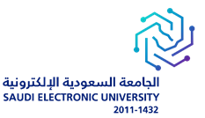

Saudi Electronic University
College of Administrative and Financial Sciences
E-Commerce Department

Student Name:  SolaimanAlabood  Bader Abuhaimed  QusaiAlsaggaf  Fares Aljar  Mohammed Asiri | Student ID:  160032613  140040320  160202678  150136402  160125300
Course Title: E-Business Strategies & Business Models | Course Code: ECOM421
Academic Year/ Semester:  2021-22/First Semester | CRN: 12346
Instructor Name:

Student Grade: | Grade Level:

Saudi Electronic University
College of Administrative and Financial Sciences
ECOM421 – E-Business Strategies & Business Models
Assignment 3 (Group Assignment)

Submission deadline: 13th November, 2021 (End of Week-11)

Assignment Questions
E-Business or Electronic Business is intended at improving organizational competitiveness by implementing innovative ICT tools all over an organization and outside, through links to partners and customers. Managers and decision makers need to know not only how to use the new techniques to systematize prevailing business processes, but also how to redesign and transform business processes taking advantage of E-Business by understanding business environment. Students are expected to understand recent developments in E-Business at the marketplace and be able to employ various concepts of E-Business deliberately to boost business processes. Students will learn how to apply skills and knowledge in planning, managing and nurturing a business by implementing an appropriate strategy. Students have to select any ONE companyfrom the below and do the following as stated:
Q1. Write a brief description about the selected company. (1 Mark)
Q2. List the core competencies of the selected company. (1 Mark)
Q3. Do the SWOT analysis for the selected companies. (2 Marks)
Q4. Design the Business Canvas Model for the selected companies. (2 Marks)
Q5. Analyze Porter’s Five Forces on the selected company. (3 Marks)
Q6. Compare the business strategy of the company with any other company from the same sector and write your observations. (3 Marks)
Q7. As a customer, list changes you have noticed in business practices in the time of COVID-19 of the selected company. (1 Mark)
Q8. As a marketing manager, draft your business strategy/strategies to boost the revenues of the selected companies. (2 Marks)

List of companies as per sectors

Telecom:
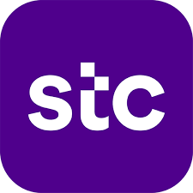

Traditional Retail:

E-Retail:

Online Cab services:


Online Food delivery:
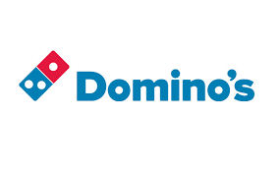
Smartphone:
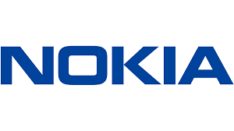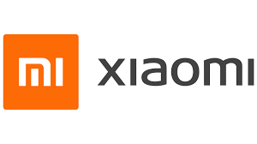
Group Assignment Guidelines (use this as a checklist before your submission)
This is a group assignment in which each group should have members between 3 to 5 students. Any one member from each group will submit assignment over Blackboard within the stated due date. Please make ensure that you have enrolled yourself in a single group only. Kindly read the below instructions:
S. No. | General Instructions
1 | Plagiarism is a serious offence. Any kind of plagiarism will result in a mark of 0.  Say No to Plagiarism. There should be no any plagiarism. Do not copy your answers neither from other students’ answer nor from internet. In case of you have visited any website for your understanding, write the sources of website/article under Reference.
2 | Include the cover page with all information required. In case of not using or not filling cover page, 1 mark will be deducted. Put a table of contents before the answer page.
3 | The use of In-text citations in case of using others’ work. Ensure that you follow the APA style in your project and references.
4 | Your assignment length should be between 1500 to 2000 words in total.
5 | Proofread your work for spelling, grammar and punctuation.
6 | Your file should be saved as Word doc (No submission in PDF format)  Example: Your Group Number_ECOM421_Assignment Number .doc
7 | Formatting style elements
 | Use 1.5 line spacing with adjusting to all paragraphs (alignment).
 | Use the footer function to insert the page number.
 | Use black color for your answers.
8 | Gentle reminder: As per the marking policy available on your blackboard, a deduction of 20% will be applied due to the below reasons:  - Late submission  - Poor structure of the assignment/If the word count is not correct, or if the assignment has multiple spelling, grammar, or punctuation issues.  - Plagiarism is strictly prohibited and in case of copying answer either from internet or from any existing or previous students’ submission will attract 00/15i.e. Zero marks.  - Kindly check plagiarism before submitting the assignment.
“Plagiarism is Injurious to Good Grades.”
GoodLuck!
Answers

Samsung Electronics Co Ltd

Company Description and Profile.
Samsung Electronics Co Ltd is one of the giant firms selling and manufacturing computers and electronics companies. Samsung was established on January 13 in 1969, and I's headquarters is located in Suwon, South Korea. Samsung plunged into the electronic business towards the end of the 1960s, shipbuilding and construction in the mid-years of the 1970s. The company gives top-quality DRAM chips, solid-state semiconductor drives, home appliances, automotive chemicals and telecommunication equipment. The company consists of numerous associated businesses, with most of them under the management of Samsung. The company's mission is to give top quality electronic service and devices and creative and innovative technology. The companies mission statement of Samsung relates to the company's vision which is "Inspired the World, Create the future"
The firm has a prosperous organizational structure based onan innovative driver that aid in structuring the productive society inside the firm. The design of the structure is strong to help it become a global leader and innovative company. In 2012, the company launched an extensive process to transform the firm. The reforms included; refining the firm's management structure in every business section to upgrade abilities all over the entire company. The new corporation structure emphasized three business areas: IT and Mobile communication, consumer electronics, and device solution. The company is devoted to creating and developing highly modern products and services to serve individuals' daily lives.
Core Competency and Competitor Analysis of Samsung Electronics Co Ltd.
A firm's core competencies can be described as a set of expertise and skills that offer a unique organizational value to clients. The company's core competencies are 'innovative products', 'advanced technology and 'creative solution'. The firm utilizes advanced technological means to develop innovative services and products and ingenious solutions. The firm has intercultural and diverse workers who aid in a broad range of perspectives to the firm. Globalization has a crucial role, and the company's designers, strategists and researchers have their sight worldwide to comprehend the lifestyle and requirements of customers in the global market. The global strategy of Samsung is at the peak of world trends. To attain this, the firm has changed its activities, making the core to be digital technology. Via reliable and innovative products and services, a skilled group of individuals, and world citizenship; the company directs the world to a new imaginative way of life. Samsung's management philosophy states that the company will allocate human capital and technology to develop super quality standard services and goods; that will promote the betterment of the global community. At any point, Samsung has numerous competitors around the globe. Samsung has survived the competition nonetheless; its core competencies are issuing it a competitive advantage. Samsung's product design is unique, and the models exactly correlate with the demand in the market.
Additionally, all the company's products are of high quality; and the firm consistently brings new and robust products and technologies. The semiconductor area possesses a technical advantage. Therefore, Samsung's competitive advantage can be outlined as cost reduction and advantage cost performance from large scale production of devices. The other core competency is Samsung's ability to make maximum use of the android operating system in incorporating it in the design of the devices.
Competitor Analysis.
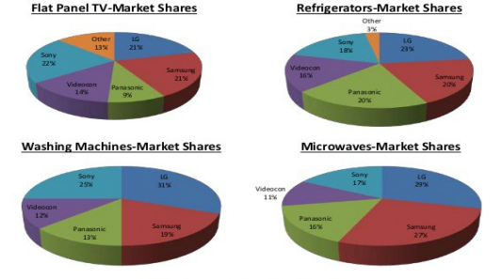
Market share at the national level.

SWOT Analysis.
Samsung's strength.
The following are strengths of Samsung Electronics Co Ltd. They include Research and development, and the company has led the market of smartphones for years. The basis of Samsung has always has been towards innovative development and Research(Madani et al., 2016). Expenses in these areas have made the firm possess a variety of product portfolios than competitors. These include a camcorder, tablet, PC, memory card, camera and other devices. The company has a 34R&D base functioning globally. Secondly, the company has environmentally-friendly innovations. The suitable ecological innovations have enhanced the reputation of Samsung. Competitor companies do not have the same achievement, raising Samsung's appeal through all business lines. Lastly, the company has a fortress in the Asian markets; Samsung still holds markets in Asia, especially China & India. Both China's & India's industry markets are expanding significantly, giving Samsung the advantage of incentives and opportunities these countries come along with.
Samsung's Weaknesses.
The company depends heavily on the American market, and estimations show that both Samsung and Apple sell a minimum of 71% of their mobile devices in the USA. As much as the company has distributed capital and enlarged its activity in Asia, it is still largely dependent on the USA market. The America’s is highly unpredictable, and any economic fall can jeopardize Samsung's revenues and destroy its operational capital. That's the reason Samsung should engage itself in the European and Asian markets to facilitate sustainability and prevent possible failure in caseeconomy of USA goes to recession(Omeike, 2015). Additionally, a reduction in the sale of smartphones is another weakness that Samsung has been going through since 2017. The shift was also realized in China because of sensitivity of pricesin the China market. Therefore, dumping too manygoods inIndia’s, cheaply harming Samsung’s sales/revenue. Lastly, hereditary leadership and management. Since its founding, the company has always been managed by the family for generations. As much as maintaining leadership by family has members given the company intense stability, the firm may fail to grow because of the unavailability of new concepts.
Samsung's Opportunities.
Acquisition and Diversification, it is crucial that the company avoids the problem of being restricted to only a single marketplace. The scenario attracts risks from an economic view and lures unnecessary negative media publicity and political polarization. That is the reason for existence of a business gap inEuropean and Asian marketsthatorganization can conquer. The second is the introduction of innovative goods and services. The mobile productarea is verytransitional, with currentshiftrunning out of relevance instantly. The company can achieve significant developmentviaraising the barthrough quality and innovative goods such as folded phones. And lastly, the company has a chance due to 5G technology. Because the world is moving to 5G, the firm can exploit the knowledgeand this chance. The firm is already in an active business discussion with EU operators to supply 6G and 5G devices.
Samsung's Threat.
The threats that Samsung faces include: Increased competition, there is a rise in a competition specifically from client electronics, computing firms and smartphone goods. Companies are trying to outsmart and outmanoeuvrecompetitors to become the best among technological firms. Secondly, the company faces regulatory and legal threats. Due to globalization and digital orientation, national authorities have started giving their guidelines, increasing regulatory and legal threats to firms worldwide. Samsung is not an exception to these guidelines. Failing to adhere to these guidelines can result in a total shutdown in the prospective markets, catastrophic to Samsung. Lastly, the company is threatened by the rise in counterfeit products. Samsung products are the most counterfeited product. Due to this, the company is likely to face low sales.
Samsung'sCanvas Model

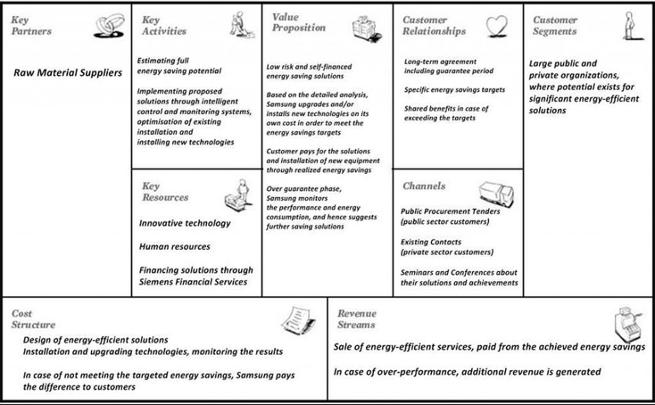
Five Forces Analysis of Samsung Ltd.
Obstacle to entry and exit.
The multinational business is featured by many barriers to entry and minute barriers to exit, specifically where international companies such as Samsung are involved. Entering emerging markets is normally difficult due to various factors that must be considered, such as putting up the supply chain and dissemination network. But global firms can easily leave emerging markets as it just involves selling and handing over the business to a foreign or domestic player if the sales decline.Samsung's entry into emerging markets has been by a step-by-step approach and exits the unprofitable market.Because of this,Samsung usually does their examination prior to entering the upcoming market.
Power of Buyers.
The buyer's power for white products makers such as Samsung is a mixed carrier. The clients have numerous alternatives to select from and have to remain with the goods because they cannot just leave the product since it is a high worth product. Additionally, the client would have to go to the firms for spare parts and after-sales services; this doesn't insinuate that they are at the firms' mercy(Madani et al., 2016).But they have the power over the organizations since most clients from emerging markets demand when selecting which product to purchase and dig all the alternatives before deciding. This shows that clients and businesses need one another.
Power of Suppliers.
In numerous markets that Samsung is in, numerous suppliers are willing to discount their services because the ancillary area is very big. Butthis doesn't allow firms to apply excessive force to the supplier because once the chain of supply is made,it takes a large effort to destroy and create a new supply chain.Companies investigate the markets prior to putting up shops and the aid of consultancies to help them decide.
The Threat of Substitutes.
The component is very high because markets are crowded with numerous alternatives. From the point that durables of the clientareusually long-period purchases, firms such as Samsung Tech Co Ltdshould care when selecting a suitable marketing strategy. Because of this, Samsung and other multinational companies implement differential pricing to lure clients throughout the income pyramid; and turn them away from substitutes.

Stakeholders.
Rising concern about environmentally and social conscious firm activities dictates that firms such as Samsung should take care of their business activities and project themselves to the clients.
Comparison of Strategy between Samsung and Apple company.
In pricing strategies, Samsung lowered the price of smartphoneproductsto improve sales, while Apple had very high prices. Apple used price decoys to make the iPhone deal look good.The business design of Samsung is concentrated on vertical integration of supply chains boosting up the volume of production(Omeike, 2015). While Apple's business strategy concentrates on user experience and model as the company outsources components like manufacturing.Samsung is active and present in numerous social media platforms such as Twitter, Facebook, YouTube, and Samsung TV in brand promotion. While Apple's presence on social media is minimal, it does product promotion via TVCs.

Business Practice Changes during Covid-19.
The Tech heavyweights gave consumers an extension of the standard warranty on its mobiles and consumer electronics for those individuals who had expired warranty from March 20 and May 31. The company also ensured that all their exclusive shops were certified to keep clients safe from the pandemic. The firm did a sanitation exercise in all their Exclusive shops and has ensured the availability of handwashing areas and sanitizers to enhance hygiene.
Strategyfor Increasing Revenue.
Strategic Alliance between Samsung and Microsoft.
The video game market is rapidly growing. Forming a partnership with Microsoft to create a virtual gaming device. The company can combine 3D TV technology with a popular video gaming console such as XBOX

References.
Madani, F., Abdulai, M., Ha, J., &Koosawangsri, R. (2016). Samsung's Innovation Strategy in Smart Phones Market. SSRN Electronic Journal. https://doi.org/10.2139/ssrn.3023595
Omeike, S. (2015). Strategy as Interaction: The Dynamics between Strategy Execution Effectiveness and Organizational Interactions During Strategy Implementation. SSRN Electronic Journal. https://doi.org/10.2139/ssrn.2676390

