INSTRUMENT: ASSIGNMENT ON "ECONOMIC GLOBALIZATION"

VENUE: ECON 2010 PRINCIPLES OF MACROECONOMICS

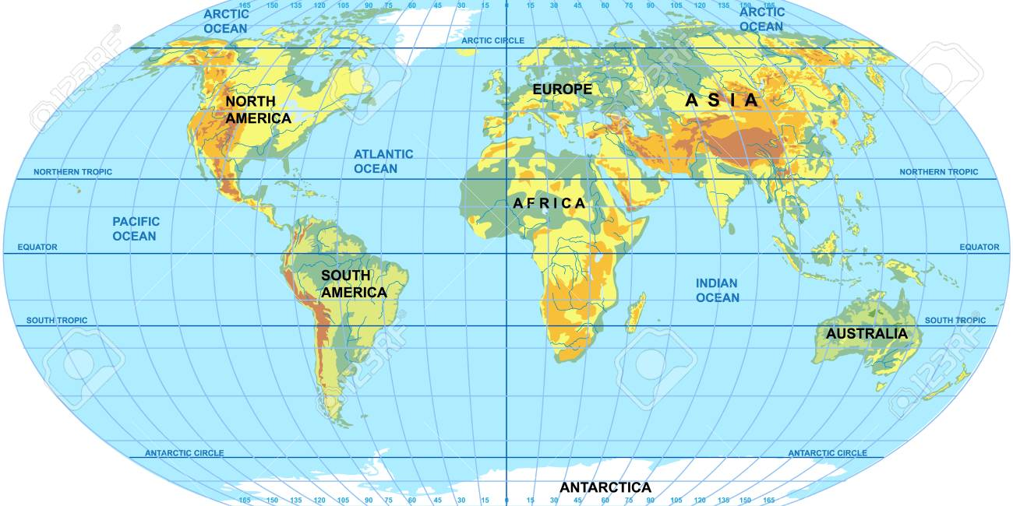

Factors Affecting Globalization:

a. Capital Flows
b. Labor Flows
c. Technology
d. Transportation
e. Communication
f. Specialization
g. Economic Growth
h. Income Inequality
i. Trade Agreement

Introduction: Of late, there has been a growing debate on globalization. Those advocating in favor, argue that globalization reduces cost of production that helps both developed and developing countries to be more competitive, and in turn, achieve higher economic growth and prosperity. This is done by minimizing inefficiencies in the production systems, liberalizing international trade, free flow of capital and labor as well as transfer of technology. On the other hand, those who stand against, argue that globalization has brought more destruction than construction. As for example, it has led to job losses particularly to national countries as more multinational companies relocate to regions and/or countries where they can benefit from lower labor-wages. They go on to say that globalization has also paralyzed small local businesses as they cannot not stand competition from large multinational companies. For developing countries, globalization has also posed a threat to the agriculture sector as their markets often get flooded with produce items from developed countries. The above figure is accompanied by a number of factors affecting globalization.

Purpose: This assignment is designed to test the students' understanding of the definition of globalization, fundamental attributes of globalization and factors driving the process of globalization and its current trends and possible responses to these trends. In addition, the assignment is aimed at assessing the degree to which ECON 2010 students can effectively formulate and communicate their arguments and influence decision-making.

Approach: Using the following questions below, write a 3-page essay in 12-point single space.

1. What does the term 'globalization' mean to you?
2. Select any two factors affecting globalization and explain how they contribute to the process of globalization.
3. Describe some features of current trends of globalization and possible responses to these trends.

Submission of the Assignment: Your essay must be well thought out using complete and clearly meaningful sentences. Use MLA Formatting Style Guide. The essay must have citations. Also include references at the end. On completion, please upload the document in a single MSWord File into the ECON 2010 Assignment Dropbox on eLEARN.

