
College of Administrative and Financial Sciences
Assignment 2
Deadline: 20/11/2021 @ 23:59

Course Name: Communications Management | Student’s Name:
Course Code: MGT-421 | Student’s ID Number:
Semester: 1st Semester | CRN:
Academic Year: 2021-2022

For Instructor’s Use only
Instructor’s Name:
Students’ Grade: Marks Obtained/Out of | Level of Marks: High/Middle/Low

Instructions – PLEASE READ THEM CAREFULLY
- The Assignment must be submitted on Blackboard (WORD format only) via allocated folder.
- Assignments submitted through email will not be accepted.
- Students are advised to make their work clear and well presented, marks may be reduced for poor presentation. This includes filling your information on the cover page.
- Students must mention question number clearly in their answer.
- Late submission will NOT be accepted.
- Avoid plagiarism, the work should be in your own words, copying from students or other resources without proper referencing will result in ZERO marks. No exceptions.
- All answered must be typed using Times New Roman (size 12, double-spaced) font. No pictures containing text will be accepted and will be considered plagiarism).
- Submissions without this cover page will NOT be accepted.
Assignment Regulation:
- All students must use their own words.
- Assignment -2 should be submitted on Saturday 20/11/2021 (by the end of week 11) using the Black Board only.
- This assignment is an individual assignment.
- Citing of references is also necessary in APA style.
  - Your answers MUST include at least 1 outside references (other than the slides and textbook)
  - Using references from SDL will be highly valued.

Assignment Structure:
 | Type | Marks
Assignment-2 | Critical Thinking | 2
 | Writing Exercise | 3
Total |  | 5

Learning Outcomes:
- Ability to illustrate techniques and assess skills of correct business research report writing; learn report writing style using an approved style and apply the basics of oral communication in a presentation of a project, including proper speech, organization, use of graphical aids, and effective non-verbal communications.
- Ability to write effective business letters, memorandums, and case studies.

Critical Thinking
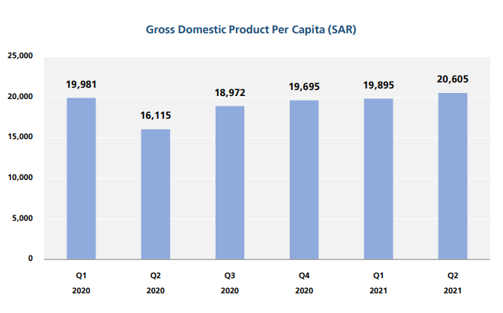
- Visual aids are used by business writers for many purposes. Here we have a graph used to represent the Gross Domestic Product (GDP) Per Capita for Saudi Arabia. Why do you think the author decided to use the bar graph among the other visual aids? Briefly analyze the bar graph below? (2 Marks)

Source: GASTAT

Writing Exercise
- In the role of a senior decision-maker in business, write a (policy/ notice of change) memo for your employees on one of the following subjects: (3 Marks)
- On-site smoking
- Changes in working hours
- Overtime
- Or early retirement.

Answer:

&&&&

Reference

Gross Domestic Product Second Quarter 2021. (2021). General Authority for Statistics. https://www.stats.gov.sa/

