
College of Administrative and Financial Sciences

Assignment 2
Deadline: 20/11/2021 @ 23:59

Course Name: Introduction to International Business | Student’s Name:
Course Code: MGT-321 | Student’s ID Number:
Semester: I | CRN:13196
Academic Year: 1442/1443 H

For Instructor’s Use only
Instructor’s Name: Dr. Ghazala Aziz
Students’ Grade: Marks /5 | Level of Marks:

Instructions – PLEASE READ THEM CAREFULLY
- The Assignment must be submitted on Blackboard (WORD format only) via allocated folder.
- Assignments submitted through email will not be accepted.
- Students are advised to make their work clear and well presented, marks may be reduced for poor presentation. This includes filling your information on the cover page.
- Students must mention question number clearly in their answer.
- Late submission will NOT be accepted.
- Avoid plagiarism, the work should be in your own words, copying from students or other resources without proper referencing will result in ZERO marks. No exceptions.
- All answered must be typed using Times New Roman (size 12, double-spaced) font. No pictures containing text will be accepted and will be considered plagiarism).
- Submissions without this cover page will NOT be accepted.

Assignment Regulation:
- All students are encouraged to use their own word.
- Assignment -2 should be submitted on or before the end of Week-11 in Black Board only.
- This assignment is an individual assignment.
- Citing of references is also necessary.

Assignment Structure:
A.No | Type | Marks
Assignment-2 | Critical Thinking | 5
Total |  | 5

Learning Outcomes:
- Discuss the reasons for and methods of governments’ intervention in trade (Lo 1.2)
- Identify and evaluate the significant trade agreements affecting global commerce (Lo 1.1)
- Carry out effective self-evaluation through discussing economic systems in the international business context (Lo. 3.1)

Critical Thinking
Read the Management Focus on, “NAFTA’s Tomato Wars,” available in your e-book (page no. 620), and answer the following questions:
The NAFTA Tomato Wars
When the North America Free Trade Agreement (NAFTA) went into effect in December 1992 and tariffs on imported tomatoes were dropped, U.S. tomato producers in Florida feared that they would lose business to lower-cost producers in Mexico. So they lobbied the government to set a minimum floor price for tomatoes imported from Mexico. The idea was to stop Mexican producers from cutting prices below the floor to gain share in the U.S. market. In 1996, the United States and Mexico agreed on a basic floor price of 21.69 cents a pound.
At the time, both sides declared themselves to be happy with the deal. As it turns out, the deal didn’t offer much protection for U.S. tomato growers. In 1992, the year before NAFTA was passed, Mexican producers ex- ported 800 million pounds of tomatoes to the United States. By 2011, they were exporting 2.8 billion pounds of tomatoes, an increase of 3.5-fold. The value of Mexican tomato exports almost tripled over the same period, to $2 billion. In contrast, tomato production in Florida has fallen by 41 percent since NAFTA went into effect. Florida growers complained that they could not compete against low wages and lax environmental oversight in Mexico. They also alleged that Mexican growers were dumping tomatoes in the U.S. market at below the cost of production, with the goal of driving U.S. producers out of business.
In 2012, Florida growers petitioned the U.S. Department of Commerce to scrap the 1996 minimum price agreement, which would then free them up to file an anti- dumping case against Mexican producers. In September 2012, the Commerce Department announced a preliminary decision to scrap the agreement. At first glance, it looked as if the Florida growers were going to get their way. It soon became apparent, however, that the situation was more complex than appeared at first glance. More than 370 business and trade groups in the United States— from small family-run importers to meat and vegetable producers and Wal-Mart Stores—wrote or signed letters to the Commerce Department in favor of continuing the 1996 agreement.
Among the letter writers was Kevin Ahern, the CEO of Ahern Agribusiness in San Diego. His company sells about $20 million a year in tomato seeds and trans- plants to Mexican farmers. In a letter sent to The New York Times, Ahern noted that “yes, Mexico produces their tomatoes on average at a lower cost than Florida; that’s what we call competitive advantage.” Without the agreement Ahern claimed that his business would suffer. Another U.S. company, NatureSweet Ltd., grows cherry and grape tomatoes under 1,200 acres of green- houses in Mexico for the American market. It employs 5,000 people, although all but 100 work in Mexico. The CEO, Bryant Ambelang, said that his company couldn’t survive without NAFTA. In his view, Mexican-grown tomatoes were more competitive because of lower labor costs, good weather, and more than a decade of investment in greenhouse technology. In a similar vein, Scott DeFife, a representative of the U.S. National Restaurant Association, stated, “people want tomato-based dishes all the time. . . . You plan over the course of the year where you are going to get your supply in the winter, spring, fall.” Without tomatoes from Mexico, a winter freeze in Florida, for example, would send prices shooting up, he said.
Faced with a potential backlash from U.S. importers, and from U.S. producers with interests in Mexico, the Commerce Department pulled back from its initial conclusion that the agreement should be scrapped. Instead, in early 2013, it reached an agreement with Mexican growers to raise the minimum floor price from 21.69 cents a pound to 31 cents a pound. The new agreement also established even higher prices for specialty tomatoes and tomatoes grown in controlled environments. This was clearly aimed at Mexican growers, who have invested billions to grow tomatoes in greenhouses. Florida tomatoes are largely picked green and treated with gas to change their color.
Sources E. Malkin, “Mexico Finds Unlikely Allies in Trade Fight,” The New York Times, December 25, 2012, p. B1; S. Strom, “United States and Mexico Reach Tomato Deal, Averting a Trade War,” The New York Times, February 3, 2013; J. Margolis, “NAFTA 20 Years After: Florida’s Tomato Growers Struggling,” The World, December 1, 2012
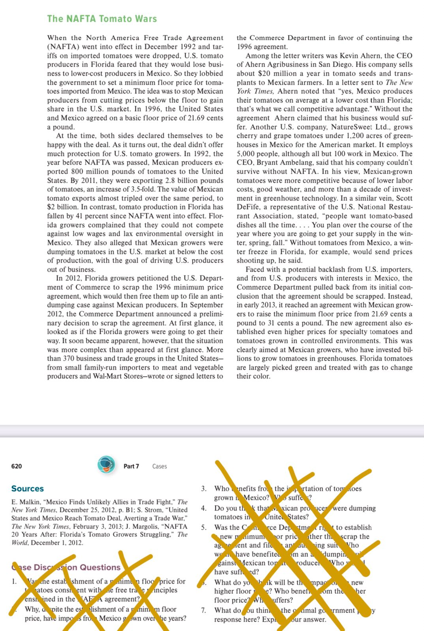

Assignment Question(s): (Marks: 5)
- Do you think that Mexican producers were dumping tomatoes in the United States? Discuss.
(mark:1)
- Was the Commerce Department right to establish a new minimum floor price rather than scrap the agreement and file an antidumping suit? Who would have benefited from an antidumping suit against Mexican tomato producers? Who would have suffered? (marks:3)
- What do you think is the optimal government policy response here? Explain your answer. (mark:1)

Answer:
1.

2.

3.

&&&&

