Task Organization of Unit to Conduct Operation

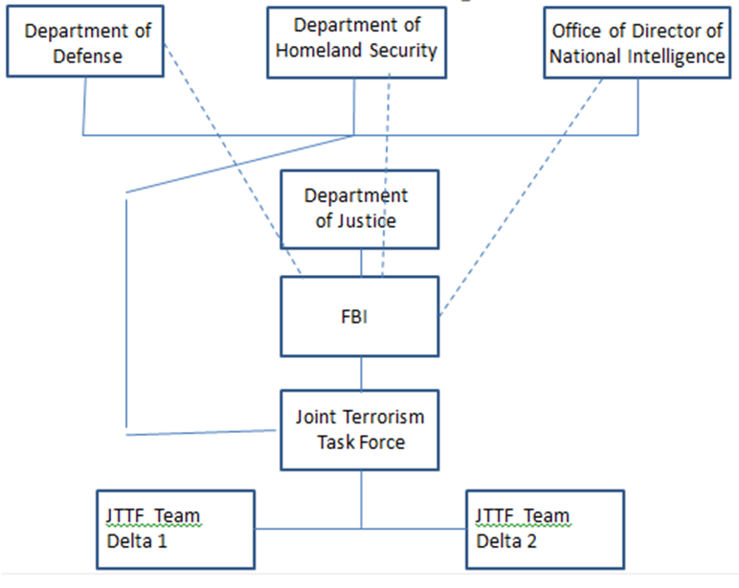

- Analysis of the current situation:
  - Define terrorism and organized crime. How are they alike and different?.
  - Discussion of possible or actual terrorist threats to an area of the U.S. or U.S. interest.
      - Identified terrorist organization name/symbol(s).
      - Terrorist organization’s identified or implied mission and objective(s) against the U.S.
      - Cell structure composition (types of specialists involved) and disposition (geographical or specific locations).
      - Reporting structure (names of leaders and team/cell members).
      - Communications strategy and methodology.
      - Types of threat capabilities available to the organization.
      - Terrorist organization’s center of gravity (critical vulnerability that when destroyed or disabled make the organization ineffective).
  - Discussion of Nexus between terrorist organization(s) identified as a threat and organized crime (OC)/transnational organized crime (TOC) organization(s).
      - Identified organized crime/transnational OC organization name/symbol(s).
      - OC/TOC organization’s vision and mission for its illegal business enterprise.
      - Organization’s composition (structure) and disposition (geographical locations).
      - Reporting structure (Leaders and organization members).
      - Communications strategy and methodology.
      - Identified nexus between the OC/TOC organization and the terrorist organization (Explain the symbiotic nature of the two organizations and how this relationship is in effect.).
      - Impact of risk related to the nexus.
      - What is the illegal activity (…ies) of the OC/TOC and level of participation?
      - OC/TOC organization’s center of gravity (critical vulnerability that when destroyed or disabled make the organization ineffective).

  - Threat assessment and identification of potential targets to include type(s) of threat medium and corresponding deliverable(s).
      - Type of threat(s).
      - Delivery means.
      - Date, time group (DTG) of potential terrorist attack.
      - Location(s) of possible attack(s).
      - Potential after effects of attack(s).
- MISSION of the Operation (Who, what, when, where, and purpose/end state).
- Strategies for countering the identified organizations.
Strategic Operational Plan Proposal Reviewed by:________________________________
(Instructor’s Name)
APPROVED/DISSAPROVED
Date/Time:____________________/___________hours.

