Megan Rall
QSO 635 Final Project
Wal-Mart South Korea
April 15, 2018

Organization Analysis:
Wal-Mart is arguably the most effective retailor maintaining dominance as a discount retailer, they preserve the best sales per square foot, along with exceptional inventory turns and operating profit side by side to others in their same business class. The reason for this? Supply chain optimization, with the goal of providing customers with what they wanted, when they wanted, with everyday low prices. This goal in mind, Wal-Mart focused on evolving an innovative supply chain strategy to maintain a competitive edge and lead in the market leadership spot. Wal-Mart stocks merchandise manufactured in seventy plus countries, manages more than eleven thousand stores in twenty-seven countries, while handling an estimated inventory amount of thirty-two billion (Lu, 2014). Wal-Mart utilizes crucial data, through Vendor Managed Inventory (VMI), where manufactures are accountable for managing their merchandise in the retail stores. This technology is called “Retail Link” distributing the vendors real-time data permitting inventory to be gauged by universal product code (UPC) on hand values, gross margin, turns and in-stock percentages (Petersen, 2013).
Materials Requirement Planning
Material requirement planning (MRP) is a computer based system, it exploits unique data to track inventory, granting vendors/manufacturers the ability to project and slate requirement demands, for the consumer (Gallego, n.d.). Wal-Mart uses the system, Collaborative Planning, Forecasting and Replenishment (CPFR), starting with tests in 1996, on Listerine mouthwash. While this configuration was far from flawless early on, it was chosen by numerous organizations internationally because the model has buyers and sellers work together at all phases of the fulfillment process (Solutions, 2017). “It has been long recognized that one of the most efficient methods for improving forecast accuracy and increasing service, while reducing costs, is better collaboration between trading partners” (Sheffi, 2002). Figure 1 (Solutions, 2017).
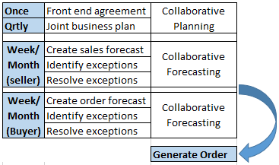
Figure 1: In 1996, Listerine mouthwash was tested for using Collaborative Planning, Forecasting and Replenishment (CPFR) System, in-stock percentage increased by 10% and total lead time drop by 10 days. This increased sales, over test period, by over eight million dollars (Solutions, 2017).

Forecasting, Capacity Planning and Scheduling
Though usage of UPC data, Wal-Mart can cultivate their gross margin dollars. Wal-Mart manages UPC data by studying category management, procuring the right merchandise mix, and margin to comprehensively contribute to average market basket (Gordon, 2008). Handling inventory principally through this strategy aids to lessen total operating cost by distributing the stock position obligation on the vendors/manufactures. Likewise, market research and consumer demand also become the vendors obligation for their merchandise. “Retail Link” supplies the vendor all the knowledge they require to satisfy consumer demand. They are then held liable if inventory is over invested or under invested, in 2010 a three percent penalty was incurred for early or late deliveries (“Walmart Tightens Slack on Supply Chain”, 2017). Real-Time data provides hourly updates UPCs as a whole, and then by location. In recent developments, a smartphone app called “Supplier Portal Allowing Retail Coverage”, SPARC, was designed to boost vendor knowledge to satisfy Wal-Mart’s four-day delivery window (Petersen, 2013). Wal-Mart has enabled their vendors to handle their particular inventory, driving to a strong supply chain model.
Wal-Mart utilizes cross-docking for finished inventory, moving inventory directly from inbound (distribution center) to outbound (retail store), without the merchandise every sitting stationary. This technique insures inventory levels remain low, and merchandise is in stores, to sell, in the shortest interval possible (Lu, 2017). There are three forms of inventory categories Wal-Mart recognizes (Greenspan, 2017):
- Transit Inventory: held in transit for number of days, dependent on transport times (domestic: days, international: months)
- Buffer Inventory: minimal excess of merchandise stored at retail stores, in order to maintain consumer demands if influx occurs
- Anticipation Inventory: like buffer inventory but only seasonal, such as Black Friday inventory
A vital part of Wal-Mart’s victory is being able to categorize their inventory in these three classifications, leading to crucial management of merchandise and sustaining low costs (Greenspan, 2017).
Facility Location
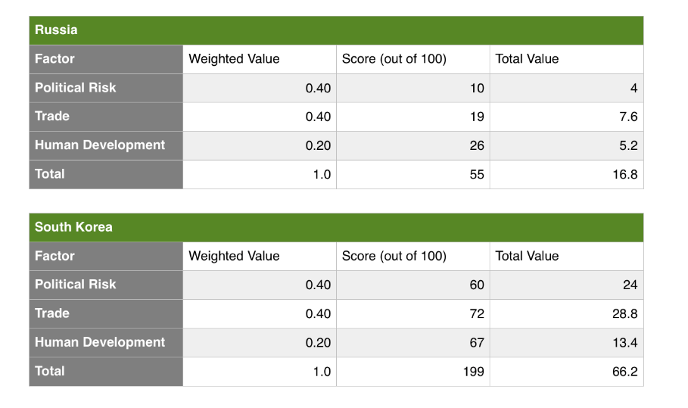
Table 1: FRM Russia vs. South Korea: Wal-Mart expansion
Factor Rating Method
Developing the Factor Rating Method (FRM) for Wal-Mart to enter either Russia or South Korea I used weighted factors political risk, trade environment and human development factor. After the scores were totaled I concluded South Korea would be the correct market to pursue, over Russia. Revisiting previous history with Wal-Mart’s failed attempt to enter these international markets is how I chose these factors to weight potential reentrance. Merchandise arriving from point A to point B is the basis of the supply chain, but utilization of these factors has a direct effect on the supply chain process.
- Political risk: (.4 out of 1) A business and economy of a nation are impacted by the political atmosphere. Managing an international business would pose difficulties if the country or nation operating under has any type of turmoil politically related in the home country.
- Trade: (.4 out of 1) The United States trade record with South Korea has a better trade record with South Korea over Russia (Representative, South Korea, 2017).
- Human development: (.2 out of 1) Using Human Development Index (HDI) to assess this factor. HDI relates statistics of life expectancy, education, and per capita income.
Preferred Location:

Considering the above FRM analysis and weighting out the core areas, I would give endorsement to expanding Wal-Mart into South Korea over Russia. Wal-Mart must avoid any pitfalls they encountered on their first try in the South Korea market and look at benchmarking their competition in South Korea, including E-Mart and Lotte. Emart (competitor) and Wal-Mart are on the opposite ends of the spectrum when it comes to in store experience (as seen in figure 2). Emart is more comparable to a spa experience, with numerous samples, and friendly service giving a different overall experience than a Wal-Mart store which is more comparable to a warehouse of goods (Marshall, 2010). As figure 2 shows the inside of an Emart location “The new studio space hosts pre-natal classes, product demos and wellbeing activities such as yoga, transforming into a children’s play area on the weekends when more families visit the store. Another addition is the dedicated pop-up space, taken over once a month by a Korean specific brand” (Featured store: E-mart’s Marie’s Baby Circle evolution in Seoul, 2017).

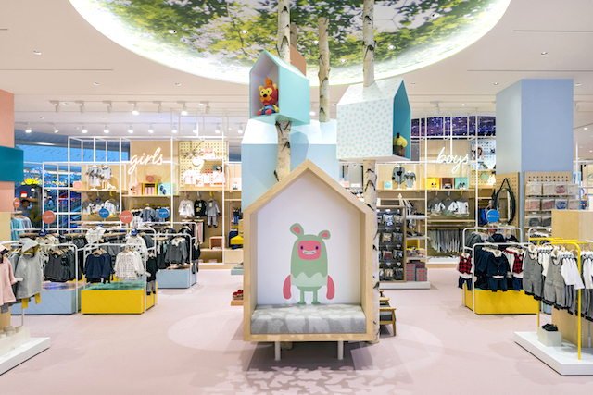
Figure 2: Inside Emart
Wal-Mart currently has a superior supply management process/strategy which gives them the upper hand, for any country they are to expand into. They will have to focus on the cultural difference of South Korea and build new relationships with local vendors, to receive the right product at an attractive price for the market. Product benchmarking is important, customers in South Korea want quality over price. The original entrance to the market, product design was a factor. Wal-Mart should focus on top selling items, focusing on quality and brand names to make a positive name for themselves. Wal-Mart will have to deviate from their low-cost products (such as Great Value Brand) and focus on brand names, with this comes volume of merchandise sold. Logistically operations will have to fluctuate because unlike the US, South Korea will not be purchasing high quantities of low priced goods. Wal-Mart could also depend on major companies in South Korea to help gain the upper hand such as Samsung, and LG. With this international endeavor, proper and timely response plans will be critical to Wal-Mart’s survival and achievement in South Korea.
Constraints
Bottlenecking Issues
A limited number of countries have grown more than South Korea throughout the last twenty-five years. South Korea’s economy has matured in a brief time to include ‘single working life’ evolving from a dictatorship to boisterous democracy. South Korean society was before impressed by bowdlerization today graces the globe with their cinema, music, and innovation. The victories South Korea has seized have also developed a series of conflicts, battling being extremely educated, and the youth being overly ambitious (The Economist, 2013).
The countries evolution is very dense and narrow to limited occupations and businesses. Manufacturers are more distinguished than service organizations, though service organizations have only started to provoke jobs. Top employers like Samsung and Hyundai employ graduates right from the top universities, because of this habit, the chance of accessing later in life is near impossible, formulating an industry market double bottleneck problem.
Wal-Mart should use these circumstances to secure high quality, high performance personnel. Pinpointing key strategies, they can acknowledge and regulate bottlenecking instantaneously to commit to the success of Wal-Mart in South Korea. Bottlenecks will arise when personnel have trouble finishing their duties in a prompt fashion, by concentrating on cultivating efficiency (one of Wal-Marts corporate goals) these tactics will be parallel with their mission statement.
Wal-Mart’s should follow a list of priorities to avoid bottlenecking(Miksen, 2017):
- Hire and retain a high-preforming team
  - South Korea has one of the utmost labor forces on the globe, their concentration will be attracting the new employees. Focusing on high-performing employees will mitigate bottlenecking problems from underperformance.
- Clear and concise summary of daily job responsibilities, along with goals for individuals that align with corporate objectives.
- Provide management staff overall guidance to encourage productivity and ward off an un-motivated, inspired, interested body of personnel, with clear cut goals and accomplishments.
Transportation Issues
One of South Korea’s major transportation constraints is the geographical area, because they are essentially disjoined from the mainstream of Asia as a result of political pressure with North Korea. Because of this constraint, South Korea puts full weight on merchant ships to haul merchandises and trade across the globe. South Korea relies on this as a heavy transportation mode with presently, there are 1,907 merchant ships, 100 bulk carries, 394 general cargo and 89 container ships, of these there are approximately twenty-two refrigerated cargo ships. These ships operate out of eight major ports, with only three being container ports (CIA World Factbook, 2017).
The South Korea’s government has proposed to devote 92 trillion (US:$82.8 billion) of government spending in social overhead capital until the year 2020.
The total investment, plus government expenditures (Suk-yee, 2016):
- $58.2 trillion- Road Infrastructure
- $48.1 trillion- Railway
- $13.3 trillion- Ports
- $5.1 trillion- Airport
- $7 trillion- Logistics and R&D
These enhancements will permit longer and more efficient roads (+6.6%) and railways, new flights through new airports (growing 2,000 flights per year), and progress of over one-hundred fifty percent in annual container handling efficiency. As for logistics and R&D developments, these will include new road architecture around Port of Busan and a supplementary innovative public transits structure. Currently, South Korea is aware of their constraints of infrastructure but are taking all necessary steps to improve by 2020 (Suk-yee, 2016). Taking into consideration one piece of the pie, port development, will permit Wal-Mart to function more efficiently and effectively in South Korea.

Push or Pull System
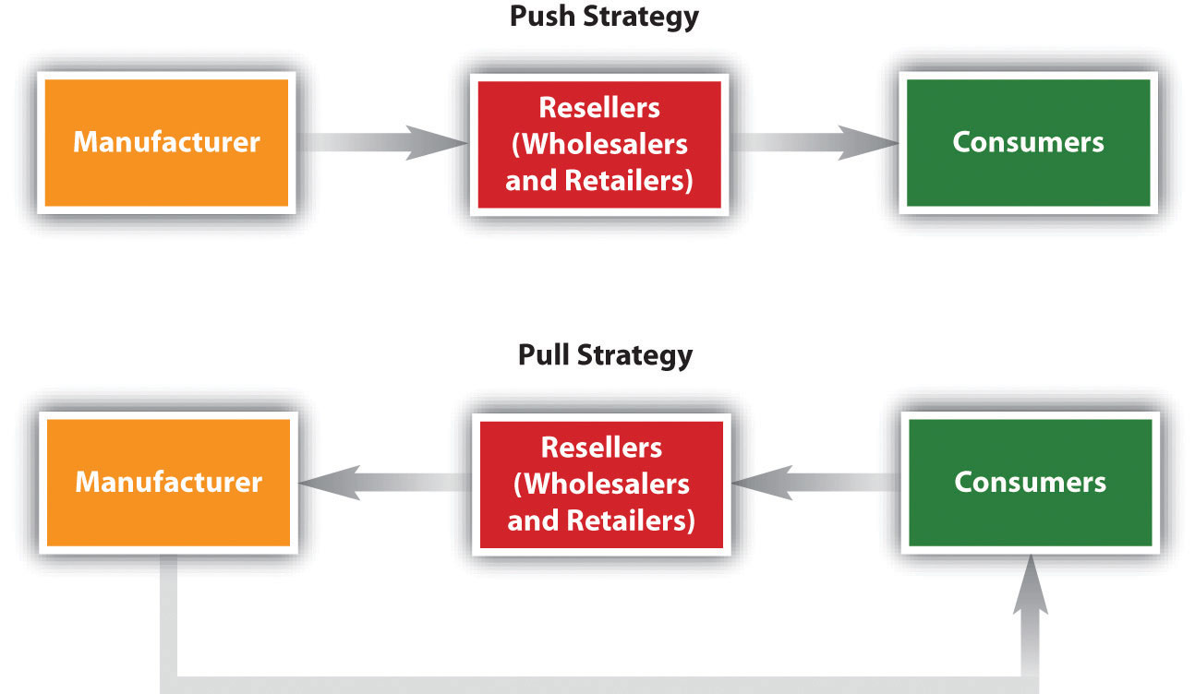
Figure 3: A Push versus Pull Strategy (University of Minnesota, 2015).
For the South Korean market, I would encourage Wal-Mart to sustain practice of the pull. The pull system empowers employees performing the duties to pull in various responsibilities, whereas a push system will generate a list. Taking advantage of the pull system in a new market recognizes the customers, granting the customers a voice to ask for what they desire, through purchasing power. Doing this will aid the organization to assess their merchandise mix to prosper in the market they once failed in.
Using a pull system permits Wal-Mart to use Just-In-Time (JIT) inventory, through forecasting and applying complex data, as well as, cope with any fluctuations in purchasing behaviors in a new market. A separate influence and advantage of the pull strategy is the strength to save money, by not warehousing or holding merchandise stock with a low demand, leading to benefits in transportation to the individual store fronts. Planning will be essential in procurement and movement of merchandise as ports are congested, meaning in stock of high demand product is essential to their success rather than staying in stock of low demand items. In order for a successful pull system the planning, allocation and replenishment teams will have to adjust and modify to different transportation and cultural conditions in South Korea, unlike the U.S.
Warehousing
Strategies
A resourceful warehouse approach is individually one of the utmost crucial features for Wal-Mart to deliberate in the development into the South Korean market. Warehouses have a weighty function in supply chain management for any organization, from corresponding supply and demand, decreasing inventories, and reduction in time necessary to order, fill, and transport merchandise to lessening expenditures, as well as, a positive impact on customer experience ("Warehousing: Charting the Way to a Winning Strategy - Operations Featured Article - A.T. Kearney - A.T. Kearney", 2017). Wal-Mart is current described as a frontrunner in proficient warehouse solutions, which should be transmitted over into South Korea. Although Wal-Mart is a leader in the supply chain world there are nevertheless considerations that should be made upon development: cost saving opportunities; warehousing strategy assistance to fulfill customer need; benefits of same space warehouse and retail. Replies to these demands will assist Wal-Mart in guaranteeing they can be successful upon expansion.

Cost Savings
In order to provide the best price and margin cost savings is key in warehouse strategy, a key part of end-to-end fulfillment. Focusing on cost savings in warehousing will certify inventory quantities are never too high or low, which would have a negative impact on warehouse profits. In 2016, seventy-five percent of logistics authorities testified their stock surpassed capacity, on the other hand, seventy percent of warehouse authorities could not give resolution for more area than merchandise ("Warehousing: Charting the Way to a Winning Strategy - Operations Featured Article - A.T. Kearney - A.T. Kearney", 2017). Wal-Mart is extremely prosperous using their Vendor Managed Inventory (VMI) model, this method assists the warehouse in ensuring inventory of goods is at the correct level. In this method, vendors are accountable to oversee their own inventory levels and then to restock, as needed. With VMI, suppliers became accountable for maintaining their goods in Wal-Mart’s warehouses, this resulted in the organization being able to forecast an almost perfect fulfilment of products (Lu, 2017). In South Korea’s extension, Wal-Mart must focus on making and maintaining relations with South Korea’s local suppliers to keep the VMI model functioning, as they have done in other countries. Wal-Mart’s successful warehousing model is not dependent solely on VMI, they have also executed cross-docking which conserves inventory and keeps expenditures low. Wal-Mart utilizing cross-docking by having suppliers deliver merchandise to its distribution center where then the merchandise is “cross-docked” or moved directly onto a Wal-Mart truck and transported to Wal-Mart store fronts, never sitting in the warehouse. Cross docking assists in maintaining low inventory and transportation costs while also decreasing tie in transits, the entire method removes inefficiencies (Lu, 2017).
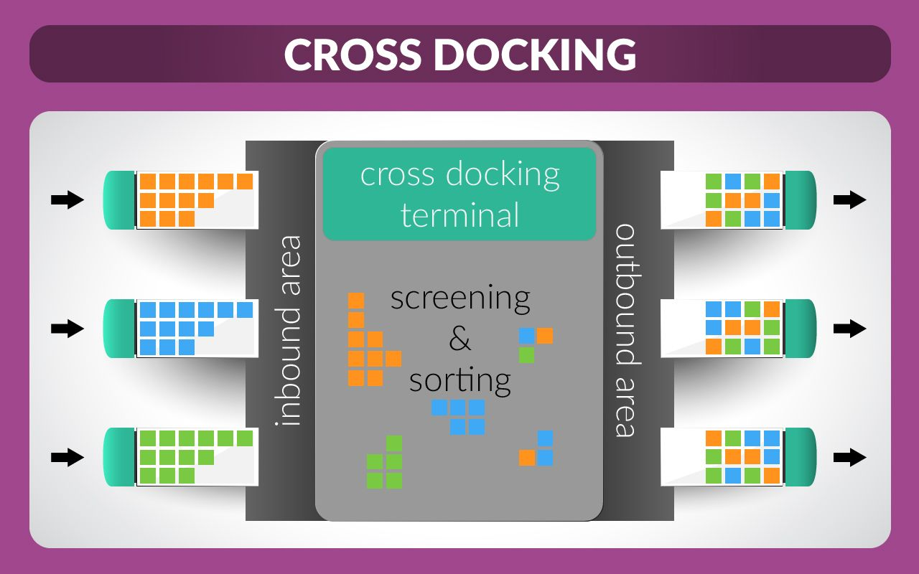
Figure 4: Cross-Docking in Warehouse (Guy, n.d.).
Another key metric of cost savings is communication and standardization in processes. The five-step approach: define, measure, analyze, improve and control, overall reducing variations in processes which are costly ("Warehouse Cost Savings: 18 Considerations to Reduce Costs", 2017). Focusing on communication between vendors, warehouses and the supply management division will be key guaranteeing there are no breaks in the method. If communication is broken Wal-Mart must be quick to recognize and react in order to continue driving low costs. As a company, Walmart has already had demonstrated success in guaranteeing open communication between all key stakeholders. In order to ensure maximum efficiency, the complete network of vendors, warehouses and store fronts have repeatedly been labeled as acting as though they are a single organization, this method now just needs to be converted to the South Korean market (Lu, 2017).
To continue with cost savings beyond merchandise and transportation Wal-Mart must focus on labor hours, this part is crucial because it is mainstream for labor costs to account for fifty percent of overall costs in a warehouse. With the education level of South Korea, and a look at the HDI being one of the highest on the globe Walmart needs to ensure they are remaining competitive with wages and benefits to associates, managers and administrative positions, to attract a much-needed employee base. Recommendations for hiring and retaining quality and skilled workers: training, flextime, reward program, safety training, cross-training ("Warehouse Cost Savings: 18 Considerations to Reduce Costs", 2017). While offering these type of added benefits and wage associate performance needs to be gauged continuously, with effective labor management in the warehouse system incidentals can be decreased by up to thirty percent, concentrating on high performance and low performance areas ("Warehouse Cost Savings: 18 Considerations to Reduce Costs", 2017).
With all the areas previously identified as cost saving for a warehouse system the layout is another crucial design element that will assist in a fruitful and effective warehouse allowing for more cost savings. Some key elements are having merchandise location, utilizing UPC technology and overall square footage of a warehouse are all crucial factors. Wal-Mart should utilize these three elements to reduce time between picking localities to overall increase output. The technology behind the design to reach this level of efficiency Wal-Mart must cultivate methods to continually oversea locations and time to pick for all orders and items ("Warehouse Best Practices", 2017). With the design of a warehouse for Walmart several key areas should be remembered and take priority such as returns, cross-docking and e-commerce shipments. With all these factors being part of the design process a product will not be touched more times than needed, overall improving productivity.
Walmart should focus on their e-commerce business in South Korea realizing the importance of a warehouse not only fulfilling brick and mortar generated orders but also online customer orders. The process is vastly different for e-commerce than brick and mortar orders, with items being picked by individual, rather than LDU, and then packed and shipped to each unique shopper (Nash, 2017). With the recent closure of many brick and mortar business there has never been a higher demand of online order, Wal-Mart currently maintains different methods of e-commerce delivery (Ship to consumer, pick up at store, etc.) and will have to continue this model to meet the demand for their new market. With e-commerce playing a crucial role in the retail word, Wal-Mart could potentially save costs by developing a strategy for both store and online fulfillment in one location.

Customer Needs
Businesses today must be quick to realize changes in the market, whether in the US or South Korea, based on consumer trends. Not only does Wal-Mart need to be reactive but also proactive planning ahead for decades in the future to be able to supply consumers with what they need, maintaining loyalty for years to come. A crucial metric in meeting consumers’ needs is assuring merchandise is in stock, when consumers want it (supply and demand). Walmart currently holds the biggest information technology structure of any private organization on the globe. Wal-Mart is able to precisely predict its consumer demand, forecast and track merchandise inventory levels, produce extremely effective transportation itineraries, and administer consumer relations, as well as, service response logistics (Lu, 2017).
Additional merchandise on hand should be maintained in the warehouse for high velocity items, giving the consumer the option to pick up in store or buy online. Managing merchandise inventory though UPC management will continue to be crucial for Wal-Mart, using UPCs allows for use of real-time data to be managed through Wal-Marts’ present system, Retail Link. Retail Link utilizes a worldwide satellite system that is linked to analysts who can project supplier requests to the supplier system, viewing transactions in real-time from all capacities whether point of sale systems in store or the warehouse systems though e-commerce (Lu, 2017).

Same Location
Taking into account Wal-Mart is in the retail business and not a manufacturing, there would be no requirement to partake in a factory/warehouse one-location model. However, taking it one step further Wal-Mart could find a competitive advantage by maintaining a warehouse/retail site, using on on-location standard in South Korea. Reentering the South Korean market with an on-location model has the possibility to lessen any transportation worries with the new market. Commissioning the same inventory for in-store and online sales, using the same inventory pools takes the business further than the warehouse partitions, allowing all merchandise to be obtainable from any retail channel ("New Retail Strategies: It’s a Store! It’s a Site! It’s a Warehouse! - Inbound Logistics", 2017). Wal-Mart is focusing on the e-commerce market in the US and how to handle all types of inventory replenishment, utilizing the warehouse/retail store same location could have a huge potential for success in the new market, where phone app ordering has increased tremendously.
Wal-Mart currently utilizes the VMI model which will be their competitive advantage once they are able to implement to its full capacity in the South Korean market, again proving why the push-pull method would be the best. Not only does Wal-Mart benefit from VMI but so do the vendors, vendors have access to be able to fulfill orders at all times and know what products the consumer demands based on velocity (Solutions, 2017).

Quality Best Practices
Logistics Management
As stated previously, there are numerous ‘best-practices’ in logistics Wal-Mart can continue to capitalize on, as well as, use in the future that would attest to be valuable in South Korea. Because Wal-Mart is a retailer, not a manufacture, vendors are trusted for their fund of merchandise, leading to an extensive supplier submission, as well as, a certification practice. To meet Wal-Mart’s vendor minimums, they must offer details on the organization and products, as well as, guarantee they will meet the quality and volume of each individual piece of merchandise. By managing their inventory through their vendor agreement, it enables vendor supplies to decrease any errors, man hours, and the time investment while also offering improved accuracy and service to the consumers (Best Practices in Today's Distribution Center - Inbound Logistics", 2017). Vendor Managed Inventory (VMI) is a technology infrastructure they require their supplier to utilize, this system works to ensure accountability to the vendor ensuring inventory is in stock, as well as, managing delivery lead times.
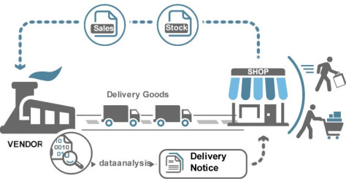
Figure 5: VMI Cycle (Luu, 2017).
Again, Wal-Mart puts accountability and obligation to the supplier to fulfillment of shipments at the necessary destination on time. With South Korea being a market Wal-Mart once failed they will have to develop relationships with local suppliers to have merchandise consumers want, as well as, keeping up with demand.
Just-In-Time (JIT) and Cross-Docking are logistic best practices that Wal-Mart currently has mastered, as mentioned earlier, making sure merchandise is not stagnant in a warehouse (where it is not available to the consumer) for a prolonged timeframe, making sure as merchandise comes into Wal-Mart’s possession it goes out to the brick-and-mortar facilities.
To control unnecessary cost the focus on effective logistics is crucial for revenue making managing from the start (source) to the end (consumer) a focus that is high on any retailors list. Before entering the new market of South Korea, a plan for logistics should be a top priority for Wal-Mart. Organizations use logistic plans as a ‘best-practice’, especially for organization that have developed globally. Development of logistical plans ensure the organization is able to effectively manage their merchandise if any obstacles with the logistics flow occur. Presently in the United States Wal-Mart controls their personal logistics through an owned taskforce of carriers (trucks), whereas in South Korea they will have to trust relationships with outside organizations. By developing dealings with native merchants, and even government executives like custom representatives they could rely on the usage of third party logistics, or 3PL. With global expansion into a foreign country there will be numerous ‘handoffs’ of each piece of merchandise, including numerous carriers, moving through customs and even ports, as well as, consolidators, when noting the change of hands for merchandise to this increase the possibility of unanticipated dealings rises substantially (JDA Software, 2017). When looking at the unanticipated dealings that could arise I believe this method of management and oversite would be the most efficient and effective for the expansion.
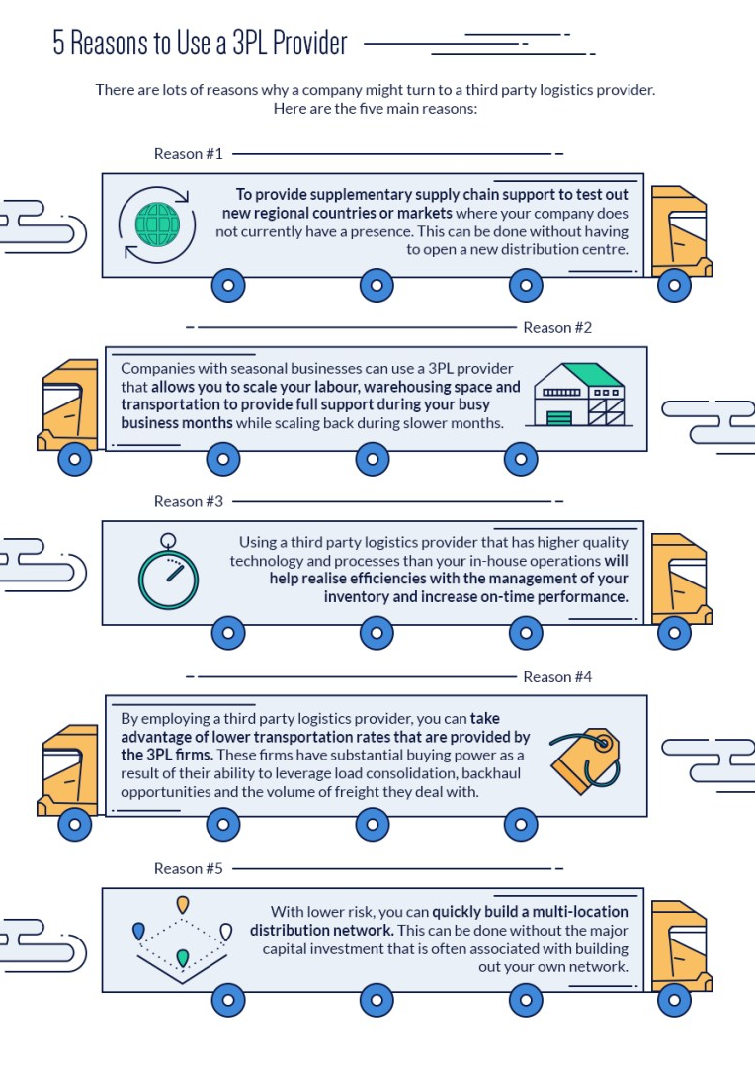
Figure 6: 3PL (Memery, 2016).
Another aspect that should not be overlooked is how essential it will be to have a compliance manager(s) on staff for their South Korea location(s). The employed manager(s) will be fundamental in gauging compliance of suppliers, as well as, making sure customer and company expectations are met. In this crucial position, the employee persons will focus on 3PL gauging their ability to meet expectations. By maintaining a compliance position Wal-Mart will guarantee they are providing quality merchandise that is availability to meet the expectancies of their new market in South Korea.

Figure 7: Compliance Management
Conclusion
After complete review of the initial steps to entering this market for a second time it is easy to see that entering either market, Russia or South Korea, is not a simple choice. There are advantages and disadvantages to both locations but with the infrastructure limits in Russia, I believe South Korea should be Wal-Marts choice, as well as, they have already failed in the market using the ability to revisit the weaknesses and improve their overall model.

Reference:
Best Practices in Today's Distribution Center - Inbound Logistics. (2017). Inboundlogistics.com.
Retrieved 9 April 2018, from http://www.inboundlogistics.com/cms/article/best-practices-in-todays-distribution-center/
CIA World Factbook . (2017, July 9). South Korea Merchant marine. Retrieved from Index Mundi: http://www.indexmundi.com/south_korea/merchant_marine.html
Featured store: E-mart’s Marie’s Baby Circle evolution in Seoul. (2017). Inside Retail Asia. Retrieved 15 April 2018, from https://insideretail.asia/2017/11/06/featured-store-e-marts-maries-baby-circle-evolution-in-seoul/
Gallego, G. IEOR 4000: Production Management. Columbia.edu. Retrieved 4 March 2018, from http://www.columbia.edu/~gmg2/4000/pdf/lect_06.pdf
Greenspan, R. (2017). Walmart: Inventory Management - Panmore Institute. Panmore Institute. Retrieved 3 March 2018, from http://panmore.com/walmart-inventory-management
Gordon, L. (2008). Leading Practices in Market Basket Analysis. Irgintl.com. Retrieved 4 March 2018, from http://www.irgintl.com/pdf2/1.pdf
Guy, W. Cross-docking vs Warehousing Differences. Nebraska Warehouse. Retrieved 1 April 2018, from http://nebraskawarehouse.com/cross-docking-vs-warehousing-differences/
JDA Software, S. (2017). Best Practices in Global Logistics - Supply Chain 24/7.
Supplychain247.com. Retrieved 9 April 2018, from http://www.supplychain247.com/article/best_practices_in_global_logistics/Global_Logistics
Kearney - A.T. Kearney. (2017). Atkearney.com. Retrieved 1 April 2018, from https://www.atkearney.com/operations/ideas-insights/featured-article/- /asset_publisher/4rTTGHNzeaaK/content/warehousing-charting-the-way-to-a-winning- strategy/10192?inheritRedirect=false&redirect=https%3A%2F%2Fwww.atkearney.com %2Foperations%2Fideas-insights%2Ffeatured- article%3Fp_p_id%3D101_INSTANCE_4rTTGHNzeaaK%26p_p_lifecycle%3D0%26p _p_state%3Dnormal%26p_p_mode%3Dview%26p_p_col_id%3Dcolumn- 2%26p_p_col_count%3D
Lu, C. (2017). Walmart's successful supply chain management. Tradegecko.com. Retrieved 29
March 2018, from https://www.tradegecko.com/blog/incredibly-successful-supply-chain-
Luu, M. (2017). Walmart’s Vendor-Managed Inventory Model. The blog of Logistics at MGEPS at UPV. Retrieved 15 April 2018, from https://logisticsmgepsupv.wordpress.com/2017/03/13/walmarts-vendor-managed-inventory-model/
Marshall, S. (2010). WalMart Failed in Korea Because of a Lack of Walkin Around. Sebastian Marshall. Retrieved from http://sebastianmarshall.com/why-walmart-failed-in-korea
Memery, R. (2016). Everything You Need To Know About 3PL. Global Trade Magazine. Retrieved 15 April 2018, from http://www.globaltrademag.com/global-logistics/everything-need-know-3pl
Miksen, C. (2017). How to Avoid Bottlenecks in the Workplace. Retrieved from Chron : http://smallbusiness.chron.com/avoid-bottlenecks-workplace-25556.html
Nash, K. (2017). Walmart Builds Supply Chain to Meet E-Commerce Demands. WSJ.
Retrieved 29 March 2018, from https://www.wsj.com/articles/Walmart-builds-supply-chain-to-meet-e-commerce-demands-1431016708
New Retail Strategies: It’s a Store! It’s a Site! It’s a Warehouse! - Inbound Logistics. (2017).
Inboundlogistics.com. Retrieved 31 March 2018, from http://www.inboundlogistics.com/cms/article/new-retail-strategies-its-a-store-its-a-site-its-a-warehouse/
Petersen. C. (2013, March 27). Walmart’s secret sauce. How the largest survives and thrives. Retrieved from Retail Customer Experience: http://www.retailcustomerexperience.com/blogs/walmart-secret-sauce-how-the-largest-survives-and-thrives/
Representative, O. o. (2017). South Korea. Retrieved from the Office of the US Trade Representative: http://ustr.gove/map/countiresaz/
Solutions, S. (2017). Balancing Push and Pull Strategies. Scdigest.com. Retrieved 31 March
2018, from http://www.scdigest.com/assets/Experts/Guest_11-03-31-1.php Suk-yee, J. (2016, 10 21). South Korean Government to Spend 92 Trillion Won on Transportation Infrastructure. Retrieved from Buesiness Korea : http://www.businesskorea.co.kr/english/news/politics/16256-investment-soc-south-korean-government-spend-92-trillion-won-transportation
The Economist. (2013, 10 26). South Korea’s education system, The great decompression. Retrieved from The Economist : https://www.economist.com/news/leaders/21588373-there-are-perils-country-having-all-your-children-working-too-hard-one-big-exam
University of Minnesota. (2015). A Push versus a Pull Strategy. Retrieved from https://open.lib.umn.edu/principlesmarketing/chapter/11-7-sales-promotions/
Walmart Tightens Slack on Supply Chain. (2017). Asq.org. Retrieved 8 March 2018, from http://asq.org/qualitynews/qnt/execute/displaySetup?newsID=8082
Warehouse Best Practices. (2017). The Balance. Retrieved 1 April 2018, from Warehouse Cost Savings: 18 Considerations to Reduce Costs. (2017). Transportation
Management Company | Cerasis. Retrieved 1 April 2018, from http://cerasis.com/2016/07/12/warehouse-cost-savingsWarehousing: Charting the Way to a Winning Strategy - Operations Featured Article - A.T.

