Complete the Assignment Checklist. Check off items that you have in inventory.

- For items that are not applicable to you and your living situation, please write N/A (not applicable) in the space, otherwise it will be counted as incomplete.﻿
- Remember to protect personal information by using pseudonyms, or by providing only partial information
  - ​Ex: Sister: Britley *****, phone: 724-***-****, email: b********@yahoo.com
Review the rubric for more information on how the assignment will be graded.
Please note: You are not required to purchase any items on this list, however, take note of the items you are missing and consider how it could impact your safety and survival in a disaster.

My Family’s Disaster Plan
Learn about the natural disasters that could occur in your community and how you can respond to them. Provide at least two references and sources of information. Use APA Style for your reference.
Possible hazards in my area:
1. Hurricanes: Hurricane season begins on June 1st to November 30th (Miami Dade County, 2020) One should monitor radio or television for weather updates and instructions from public safety officials, stay indoors, preferably in a room without windows. Use flashlights and not candles or kerosene lamps, listen to advisories from local law enforcement agencies regarding roadways and bridges being locked down. (Miami Dade County, 2020) Residents that are impacted by a hurricane may register for FEMA assistance at the DisasterAssistance.gov.
2. Tropical Storms: Stay inside and away from any window, skylight, or any glass floors. Be sure to find safe area in the home. Do not go outside. (Hurricanes: Science and Society, n.d)
3. Flooding: If there is a threat of flooding at home, turn off any electricity at the main breaker. (Hurricanes: Science and Society, n.d) It is important to be careful when driving during a flooding situation, always keep in mind that 6in. of standing water is enough to stall some cars and just one foot of water can float a vehicle and two feet of moving waters is enough to sweep a car away. (Flood preparedness and response, 2019)

Emergency Phone Numbers
(Program these into all phones and post in a common area in the home.)
- Police department: (305) 418 7200, Dade County Police Department 1701 NW 87 Ave. Doral, FL 33172
- Fire department: (786) 331-5000, MDFR Firehouse 47 9361 SW 24th St. Miami, FL 33165
- Local emergency services: (305) 630-7900, Town & Country Emergency Room 11800 Sherry Ln., Miami, FL 33183
- Healthcare provider(s): (305) 669-0690, Miami Medical Consultants 4950 S Le Jeune Rd., Coral Gables, FL 33133
- Local American Red Cross: (305) 644- 1200, American Red Cross Greater Keys 335 SW 27th Ave. Miami, FL 33145
- Poison Help: 1-800-222-1212
- Other local emergency personnel numbers: 1800-621-FEMA (3362)

Employers and School Officials Contacts
I know the emergency response plans for employers and schools. __X___
School:
Address: West Coast University. 9250 NW 36TH St. Doral, FL
Phone: (786) 501- 7070
Contact name: Adiela Naranjo
Child | Day Care/School | Phone #
N/A | N/A | N/A
N/A | N/A | N/A
N/A | N/A | N/A

Employer:
Address: 9250 NW 36 St. Doral, FL
Phone: (786) 501- 7051 Ext. 48***
Contact name: Adiela Naranjo
Family Communication Plan
Prepare a family communication plan so that each member of the family can contact one another quickly.
- Everyone has a cell phone or calling card __YES___
- Young children know how to call (numbers are saved) __N/A____
Name | Contact Name | Phone | Email
Iv** Os**** | Ivan | (305) 346- **** | Iva*****@hotmail.com
Dey*** Re**** | Deya | (786) 262- **** | Dey*****@gmail.com
Car*** Rod**** | Carlos | (786) 344- *** | Car******@hotmail.com

Identify two meeting places for your family in the event that you are separated.
Near your home: Baptist Hospital
Location: Miami, FL
Address: 8900 N Kendall Dr.
Phone: (786) 596- 1960

Away from your home (in the event you cannot return home):
Location: South Miami Hospital
Address: 6856 SW 53 Street
Phone: (305) 666- 5871

Draw a floor plan of your home and attach it to your submission; mark two escape routes from each room. ______
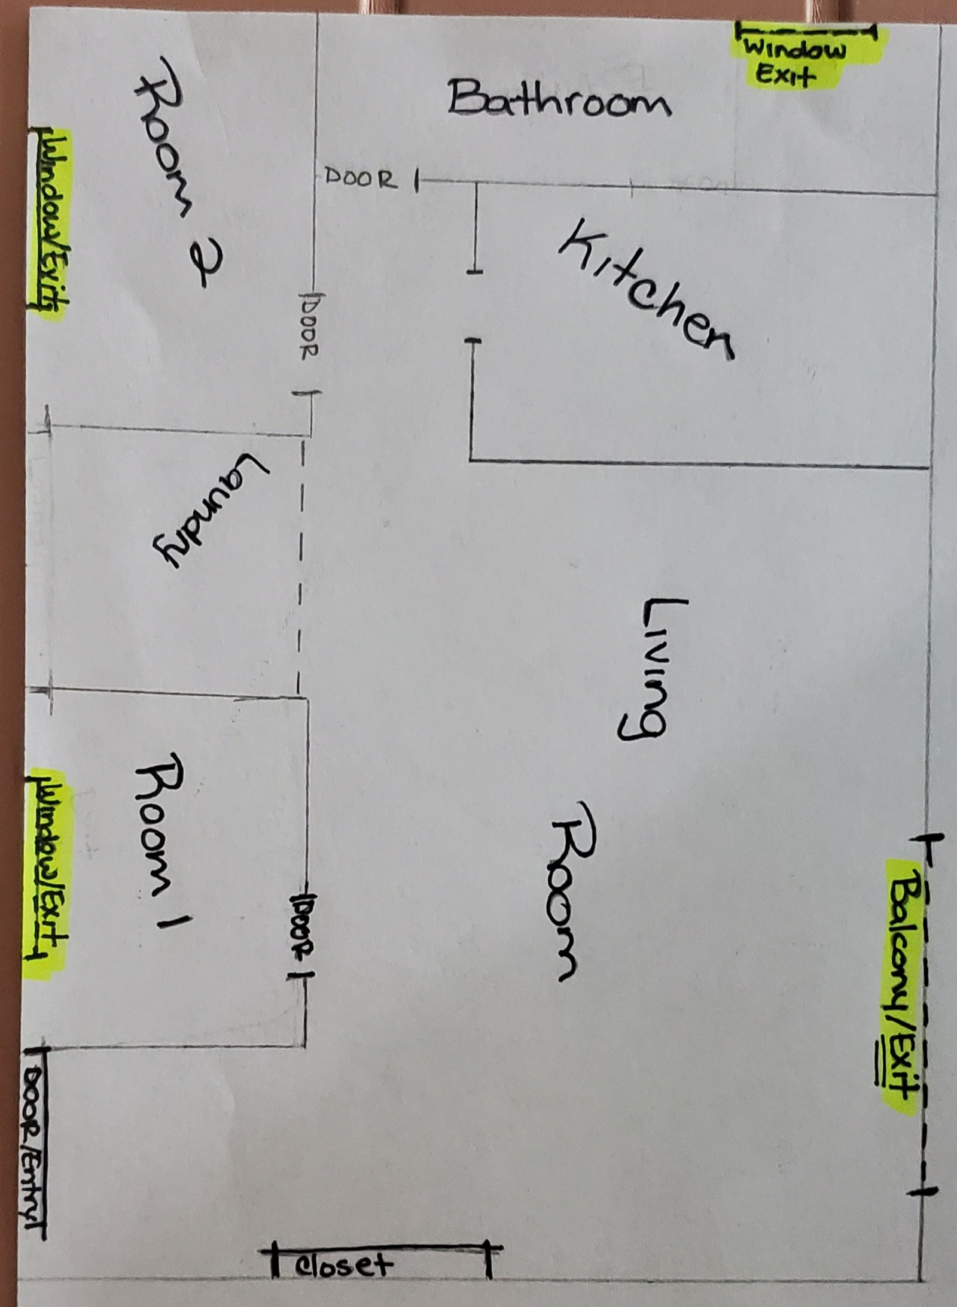

Pick a friend or relative who lives out of the area for household members to call/email to say they are okay.
Name: Nelc** Coi***
Phone: (786) 422-3953
Email: Nelc****@gmail.com

Everyone in the house knows how and when to shut off utilities. ___X___
Utility Name | Number | Shut-Off Location/Main Controls
Electric | 1 | Main Hallway
Water | 3 | Main Hallway
Gas | N/A | N/A

Evacuation Plan and Transportation
Extra gallon of gas __N/A____
Local government resource ___N/A___
Contact person/agency: N/A
Address: N/A
Phone: N/A

Certifications
Stay current and up to date (e.g., CPR, ACLS, PALS, TNCC).
- Certification #1: CPR
- Date of Completion/renewal: 06/2020
- Certification #2: BLS
- Date of Completion/renewal: 06/2020

Property, Health, and Financial Well-being
Review property insurance policies for disaster policies. __N/A____
Current __N/A____
Appropriate to needs __N/A____
Review life-insurance policies. __N/A____
Current _N/A_____
Appropriate to needs _N/A_____
Review health insurance policies. _N/A_____
Current _N/A_____
Appropriate to needs _N/A_____
Review financial documents. __YES____
Emergency savings $_4000_____
Easily accessible, small cash savings $ _700__
Important Documents and Items Secured
Make sure you have copies of important documents and items that can be stored in a fireproof watertight container.
Important Items | Check off Photocopied Items That are Safely Stored
Personal identification | X
Cash and coins | X
Credit card(s) | X
Extra set of house keys and car keys | X
Birth certificate | X
Marriage certificate | X
Driver’s license | X
Social Security card | X
Passport/visa | X
Wills | N/A
Deeds | N/A
Inventory of household goods (with photos & serial numbers) | X
Insurance papers | X
Immunization records  - Allergies  - Medications | X
Bank and credit card numbers | X
Stock/bonds | N/A
Emergency contact list (phone/address/email) | X
Local map and emergency shelter locations | X
Pet information | N/A

Consider ways to help neighbors who may need special assistance (ESL/medical/living alone).
Name | Special Help Needed | Address | Phone
Fran***** | Hearing Aid | 10315 SW 24 ST. Miami, FL 33165 | (305) 599-****
Salo***** | N/A | 15878 SW 69 Ln. Miami, FL 33193 | (305) 654- ****

Pet Arrangements: N/A
As per local and state health and safety regulations, pets are not permitted in some shelters such as American Red Cross shelters. Service animals are permitted.

Name of shelter vet:
Address: N/A
Phone: N/A

Names of pet friendly hotels/motels or friends/family out of the area:
Name: Iler*** Osp***
Address: 401* SW 25 ** Miami, FL 33165
Phone: (305) 785-****

Name: Hilton Garden Inn Miami Dolphin Mall
Address: 1695 NW 111 Ave. Ste# A. Doral, FL 33172
Phone: (305) 500- 9077

Name: NUVO Suites Hotel
Address: 1750 NW 107 Ave. Doral, FL 33172
Phone: (786) 472- 9095

Special Needs Assistance
Special needs assistance organization in community.
Name: Be Unique Academy
Address: 11025 SW 84 St. Cottage#16.
Phone: (786) 856- 6217

Register with local office of emergency services or fire department.
Name: MDFR Firehouse 47
Address: 9361 SW 24 St. Miami, FL 33165
Phone: (786) 331- 5000

Create a network of neighbors, friends, relatives, coworkers to aid you in an emergency _____
- Mobility escape chair in place _N/A____
- High-rise/apartment arrangements for emergency evacuation _N/A__
- Extra wheelchair batteries, oxygen, catheters, medications, food for service animals _N/A___
- Caregiver identification information __X___
- Medical bracelet, etc. _N/A____

Disaster Supply Kit “Go Bag”
You and your family may need to survive on your own for 3 days or more. Consider having additional supplies for up to two weeks confinement or shelter. You should prepare emergency supplies for the following situations:

Go Bags
Home: Make sure all family members know where the go bags are and have access them. _YES____

Specific go bags:
Pet go bag _N/A____
Child go bag with special items for feeling safe and staying occupied _YES_
Car: 3-day supplies included with emergency roadside equipment _YES____
Work go bag _YES_

Water Supplies
Stocking water supplies should be a top priority. Drinking water in emergency situations should not be rationed. It is critical to store adequate amounts of water for your household. Check off the supplies you have on hand and indicate the date the supply needs to be refreshed.
- Two quarts of water daily for drinking for each person in household. _YES_
- Extra two quarts of water daily for children, nursing mothers, and those who are ill and need more. _YES_
- One gallon/week supply of water stored for sanitary and cooking needs for household. _YES_
Change water every 6 months.
- Update water supplies _11/24/2020___ (date)

Safety Tip: Water Storage and Collection in an Emergency
- Do not store in glass containers or other containers that can break.
- Do not rely on untested devices for decontaminating water.
- If you have a well or public water, follow treatment methods provided by your public health service or water provider.
- Store water in a cool, dark place.

Food: Preparing and Emergency Supply
Food, unlike water may be rationed except for children and pregnant women. No special food needed. Keep canned foods and dry mixes stocked. Replenish food supplies every 6 months. Use and replace. Store newer items in the back, older items in front.
Stock high energy protein foods in go bags:
Peanut butter _YES___
Trail mix _YES__
Granola bars _N/A__
Peanuts _N/A__
Hard candy _N/A__
Boxed juices _YES__
Powdered milk _N/A__
Dry fruits_YES__
Keep infant foods and special diet foods in supply. _N/A_

First Aid Supplies
Assemble a first aid kit for your home and each vehicle. __YES__
Check off all of the basic items you have and list additional specialty items you have on hand:
First aid manual _N/A__
Sterile adhesive bandages, assorted sizes _YES_
Safety pins assorted sizes _YES_
Cleansing agents _YES__
Antibiotic ointment _YES__
Latex gloves (2 pair) _YES__
Petroleum jelly or other lubricant _YES_
2-inch and 4-inch sterile gauze pads (4 to 6 of each) _YES__
Triangular bandages (3) _N/A___
Sunscreen_YES_
Scissors_YES__
2-inch and 3-inch sterile roller bandages (3 rolls each) _N/A__
Tweezers _YES_
Needle_N/A__
Moistened towelettes _N/A__
Antiseptic _N/A__
Thermometer _YES__
Tongue depressor blades (2) _N/A__
Prescription medication list (ask your pharmacist about storing prescription medications) _N/A___
Extra pair or prescription eye glasses or contacts_N/A___
Nonprescription drugs:
Aspirin and non—aspirin pain relievers _N/A__
Antidiarrheal medication _YES___
Antacid_YES__
Laxative_N/A__
Vitamins_YES__
Syrup of ipecac _N/A___

Tools and Emergency Supplies
Assemble these items in a disaster supply kit in case you need to leave quickly.
Check off all of the basic items you have and list additional specialty items you have on hand.
Tools
Portable, battery-powered radio, TV, alarm clock _N/A_____
Flashlight and extra batteries _YES___
Signal flare _N/A___
Matches in a waterproof container _N/A___
Shut-off wrench, pliers, shovel, hammer, screwdriver, and other tools _YES__
Duct tape and scissors _YES__
Plastic sheeting _N/A___
Whistle _N/A___
A-B-C fire extinguisher _N/A___
Tube tent _N/A___
Compass _N/A___
Work gloves _N/A___
Paper, pen, pencils _YES___
Needles and thread _N/A___

Sanitation and Hygiene
Washcloth and towel _YES__
Towelletes, soap, hand sanitizer, liquid detergent __YES__
Toiletries _YES___
Heavy-duty plastic garbage bags _YES__
Medium--sized plastic bucket with tight lid and small shovel for digging a latrine _N/A__
Disinfectant and household chlorine bleach _YES___

Kitchen Items
Manual can opener _YES___
Mess kits or paper cups, plates, plastic utensils _YES__
All-purpose knife _YES__
A dropper (eye dropper) with measurements _N/A___
Liquid bleach to treat water _YES___
- Only use regular, unscented chlorine bleach products that are suitable for disinfection and sanitization as indicated on the label. The label may say that the active ingredient contains 6 or 8.25% of sodium hypochlorite. Do not use scented, color safe, or bleaches with added cleaners. If water is cloudy, let it settle and filter it through a clean cloth, paper towel, or coffee filter.
Sugar, salt, pepper _YES___
Aluminum foil, plastic wrap _YES__
Resealing plastic bags _YES__
If food must be cooked, a small camping stove and can of cooking fuel _N/A__
Clothes and Bedding
One complete change of clothes and footwear for each member of household. Shoes should be sturdy work shoes or boots. __YES__
Rain gear, hats and gloves, extra socks and underwear, thermal underwear, sunglasses. _YES__
Blankets or sleeping bag and pillows for each member. _N/A___

Specialty Items as Needed For:
The baby _N/A___
The elderly _N/A___
Pets _N/A__

Other Items
Add a list of additional items to include here. Review other disaster preparedness websites for items not included here. Check off items that you have and list items you need to acquire.

Item | Included
Entertainment activities items like cards, volleyball, books | Need to buy
Phone chargers’ plug-ins and portables | Yes
Chap Stick | Yes

References
Flood preparedness and response | Response/Recovery | Occupational safety and health administration. (2019, September 19). Occupational Safety and Health Administration. https://www.osha.gov/dts/weather/flood/response.html
Hurricanes: Science & Society. (n.d.). Hurricanes: Science and society: During a hurricane: How to be safe. Hurricanes: Science and Society: Home. https://www.hurricanescience.org/society/risk/huricanesafety/
Miami Dade County. (2020). Hurricane readiness guide. Untitled Document. https://www.miamidade.gov/global/emergency/hurricane/home.page

