Fresh Brewed! Coffee Shop

Project Management Plan
Submitted to DeVry University
Undergraduate Faculty of the School of Business
In Partial Fulfillment of the
Requirements for the Degree of

Business Administration – Kelvin Luquias
Technical Management – Marissa De La Garza
Technical Management – Kya
Technical Management –
Business Admin - Herrisha

by
Kelvin Luquias, Marissa De La Garza, Kya McKinney, Matey Akwetey-Aboagye & Herrisha Morris
March 2020

Project Overview
Fresh Brewed is a coffee shop that will draw customers who want to experience a high quality blended of coffee from all over the world and confectionery made by local artists. Our target audiences will be coffee and art lovers of all ages. The shop will also provide customers with free Wi-Fi, books and occasionally live entertainment. Fresh Brewed will built in a rental space of approximately 1000sqft, big enough to host coffee equipment and customers. The whole project will be supervised by the Project Manager and team. We hope the complete the project in 208 days from start to finish with an opening date of January 15,2021. For more details on the specifics of the project refer to Appendix A and B.

Project Scheduling

The Product Backlog
The table below is a “list of the new features, changes to existing features, bug fixes, infrastructure changes or other activities that a team may deliver in order to achieve a specific outcome”.
Story Name | Description | Epic
Pitch the project idea | Describe what, why and whom the project is | Story
Put together a team | We need a supporting to help with the project | Story
Finding the right location | Go to multiple location to see which will fit the project. | Story
Find a design team | Get an architect and engineer to design for the project | Story
Find a General Contractor | Get a contractor to build the project | Story
Find a Marketing team | To make the project successful we need a marketing package. | Story
Plan for construction | Where the project begin | Story

The Sprint Backlog
The log below shows a list of tasks identified by the team that needs to be executed within the first 3 weeks of the project. If these tasks are not complete successful the project will not take off. Figure 2: is the project schedule for the first 3 weeks.
Sprint | Start Date | End Date | Goal
1 | 4/15/20 | 2/28/20 | Pitch project idea to stakeholders for approval in order to get funds need for the project
2 | 4/29/20 | 5/1/20 | Establishing a team to help with the project
3 | 5/4/20 | 5/15/20 | Scout for a location for the project
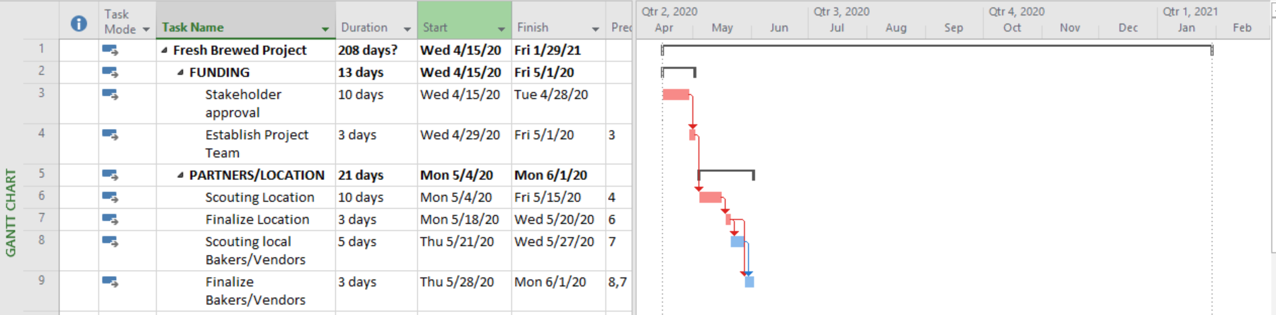

Figure 2. The Project Schedule for the first sprint.

Appendix B: Initial Scope Statement
Fresh Brewed! Coffee Shop Initial Scope Statement
Project Purpose
The purpose of this project is to create a unique experience for the locals to spend time. IT shall provide opportunities for businessmen and women to network by utilizing the space provided, free wifi, and small private spaces. Not only will customers be able to enjoy their time at the coffee shop, this project will include four small conference room areas where guest scan enjoy confectionaries and small breakfast food items over meetings.
Goals & Objectives
The key objectives that the project is aiming to deliver, ideally listed in decreasing priority order.
1. Create a fun but safe environment for businesspeople and families
2. Become number one coffeeshop in area
3. Provide quality products
4. Maintain 70% gross margin
5. Exceed benchmark expectations
Scope Summary/Boundary Conditions
This will be a small coffee shop so we will nee dot obtain a lease on a 1,000sq. ft standalone or strip mall location. This is the first shop of its kind so we are starting off with one location, initially, with more to follow. This project plan shall outline in greater detail our need to select quality contractors to provide the building with no issues upon inspection in cluding but not limited to, plumbing inspections, electrical inspections, city inspections, etc. We are on a limited timeline so these are requirements that must be met the first time. During the project duration, we must focus on properly managing risk, remaining on budget and within timeframe and resources.
Scope Details
In Scope  - Objective  - Construct space into comfortable coffeeshop  - Deliverables  - Fully constructed interior for coffee shop  - Comfortable seating area  - Ambient lighting  - Kitchen appliances  - Coffee & Espresso machines  - Conference tables  - Highly established Mesh wifi network  - Milestones  - Contractors selected – Day 5  - Permits approved – Day 12  - Construction complete – Day 90  - Final inspection of building – Day 100  - Kitchen appliances delivered & installed – day 110  - Seating areas developed – day 123  - Décor – Day 185  - Final Approvals – Day 190  - Opening day - Jan 5, 2021  - Technical Requirements –  - Building must meet code and be safe  - Need Energy Star ratings on all lighting and appliances  - Accommodate 75 patron capacity  - High efficiency storage capability  - State of the art mesh network for internal and guest Wi-Fi  - Best in class coffee and espresso machines | Out of Scope  - Exclusions –  - Parking lot – already developed  - Building – already developed  - Maintenance building – Completed by property owner  - Landscaping – Owner responsibility  - HVAC Renovation – Owner responsibility  - Contractors liable for their work being completed according to code

Appendix D: Product Backlog
(Note: Appendix D should be on its own page.)
Table 1: Project Epics and Stories
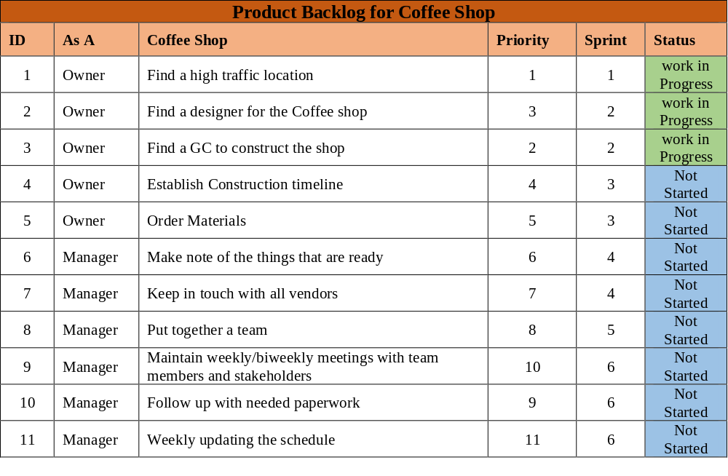
Figure 3: Product Backlog

Appendix E: First Sprint Backlog
A list of task that make up the first three week sprint
- Put together a team
- Find a high traffic location
- Find a designer for the Coffee shop
- Inform team members on what comes next
- Take a look at the overall progress
- Make note of the things that are ready
- Find a GC to construct the shop
- Order Materials
- Keep in touch with all vendors
- Maintain weekly/biweekly meetings with team members and stakeholders
- Follow up with needed paperwork
- Weekly updating the schedule
Items Needed
Automatic Drip Coffee Maker
Espresso Machine
Industrial Coffee Grinder
Water
Refrigeration System
Containers
Security System
Shelves
Freezers
Product Storage
Blenders
Coffee
Sugar
Dairy Products
Almond milk
Chocolate, Carmel, and Flavor

