GMOs and Feeding the World
"The controversy surrounding genetically modified organisms has real importance for society, there are complex scientific and logical issues to sort through, and the topic is rife with misinformation and motivated reasoning……" -Dr. Novella, academic neurologist; Yale University School of Medicine
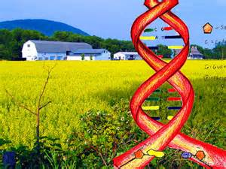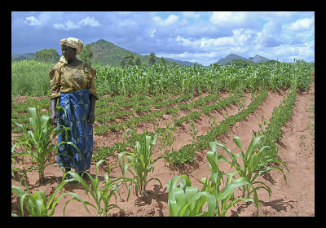
Objectives:
- Journey around the world and explore the use of GMOs and their application for feeding the world.….
- Defend your belief on the following: Are GMOs a good thing for society or are we heading into dangerous territory in their use?
Directions: Please respond with a different color of ink and include your original questions.
- You will be asked to review the background information I have provided and visit the various articles and videos for each question.
- You will then respond to the questions following the attached websites.
- Finally, you will be asked to find alternate evidence and defend YOUR views on the issue.
- Total point value: 70 points
What are the ethical concerns regarding GMOs in the food industry?
Remember, the first step in ethical problem solving and policy decision making involves ascertaining the facts. Facts by themselves, however, only tell us what is; they do not tell us what ought to be. Resolving an ethical issue also requires an appeal to values. Before tackling the GMO debate, let’s review the five different approaches philosophers have developed to deal with moral issues. (use these in defending your views for GMOs on the final question)
- Utilitarian Approach: What benefits and what harms will each course of action produce, and which alternative will lead to the best overall consequences?
- Rights Approach: What moral rights do the affected parties have, and which course of action best respects those rights?
- Fairness or Justice Approach: Which course of action treats everyone the same, except where there is a morally justifiable reason not to, and does not show favoritism or discrimination?
- Common Good Approach: Which course of action advances the common good?
- Virtue Approach: Which course of action develops moral virtues?
(1) The GMO Controversy:
Article #1: http://theness.com/neurologicablog/index.php/the-gmo-controversy/
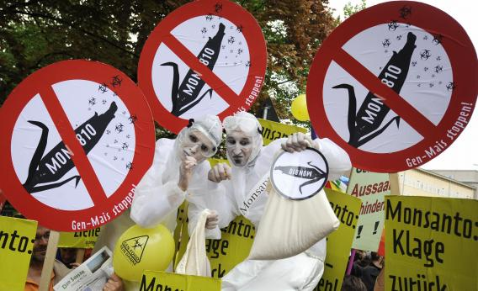
"GMO critics despise corporate control and greed, and fear the unnatural, while GMO advocates see this technology as an example of the triumph of human ingenuity and science"
“God (Nature in my view) makes all things good; man meddles with them and they become evil…" "― Jean-Jacques Rousseau; philosopher, 1770
15 points; each question is worth 1 point, unless otherwise noted – all T/F .5 point-
- Beliefs concerning GMOs tend to be dominated by two opposing narratives: What are they?
- GMO advocates point out that pretty much all food that is consumed by humans has already been extensively modified by human activity. (True or False?)
- What was corn cultivated from? (.5 point)
- Cultivation uses a combination of what two basic processes to create countless varieties of common plants?
- What is artificial selection? (.5 point)
- What is cross pollination? (.5 point)
- Orange carrots are not the result of a mutation (True or False?)
- What is mutation breeding?
- How many mutagenic plant varietals were released between 1930 and 2007? (.5 point)
- What are the two basic types of GMOs? (.5 point)
- What is the difference between the two types of GMOs? (.5 point)
- What are the four types of GM plants currently approved for use?
- Contamination of genes from other kingdoms occurs, even in nature (True or False?)
- According to the American Association for the Advancement of science, GM crops are the most extensively tested crops ever added to our food supply. (True or False?)
- According to the article, studies comparing GM and non-GM potatoes, soy, rice, corn and triticale found that the GM and their non-GM counterparts are NOT nutritionally equivalent.” (True or False?)
- The National Academies of Science states that “To date, no adverse health effects attributed to genetic engineering have been documented in the human population.” (True or False?)
- What does the World Health Organization say about GM foods? (.5 point)
- Plants that are produced through hybridization, which can chaotically mix in hundreds of genes, and plants resulting from mutagenic breeding do not require the same safety testing currently required of GMOs. (True or False?)
- According to the article GM crops with insect and herbicide resistance can be useful and even protect the environment, but they have to be used as part of what type of strategy?
- What are the three major seed companies? (.5 point)
- What are some of the claims made against Monsanto that, according to the article, are not true? (.5 point)
- According to the article, the big seed companies have overhyped their own products and encouraged overreliance on their GMOs as a single solution to farming’s complex issues. True or False?(.5 point)
- Why are Monocultures counterproductive? (.5 point)
- According to the article, Seed companies should be encouraged to not just make one variety with a favorable trait, but do what?
- According to the article, Genetic modification is a powerful technology, and its impact will depend entirely on what?

(2) Attack of the Killer Tomatoes?
Article #2: http://www.scu.edu/ethics/publications/submitted/schulman/tomatoes.html

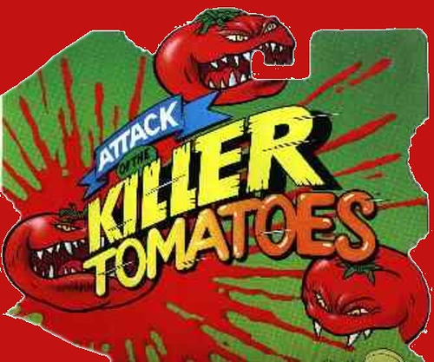

"On one hand, you have the proponents who are talking about the benefits of genetic engineering in terms of science. On the other, you have people in butterfly costumes."
10 points total: each question is worth 1 point unless otherwise noted.
- England's Prince of Whales claims that GMOs do what?
- Where does the Catholic church stand with regard to GMOs?
- Why does the author compare GMOs to microwaves and DDT? (.5 point)
- What type of harm has resulted to humans as a result of ingesting GMOs?
- What is the "Terminator gene" and what is the controversy surrounding it? (.5 point)
- Why are the risks of GMO being defined by those who are frightened?
- How long have GMOs been on the market here in the United States without the consumer knowledge?(.5 point)
- Under what conditions does the Food and Drug Administration require the labeling of Genetically modified foods? (.5 point)
- What might increase the consumer's trust in the use of GMOs?
- The United States has the Food and Drug Administration and Environmental Protection Agency to regulate food safety. Who regulates food safety in Europe?
- What disease occurred in Europe that ultimately put the blame on farmers and, according to the authors, led to a heightened fear of the food industry by Europeans?
- What is the consequentialism theory?

(3) Technologies behind the controversy

Video #1 Genetic Modification (5 min) http://www.youtube.com/watch?v=LSBnoGZoAHs
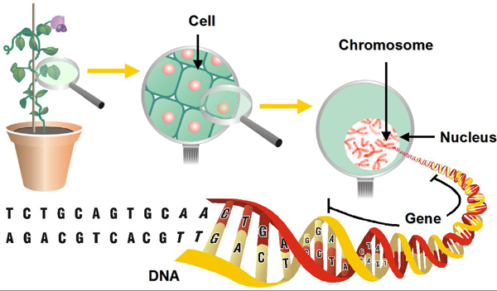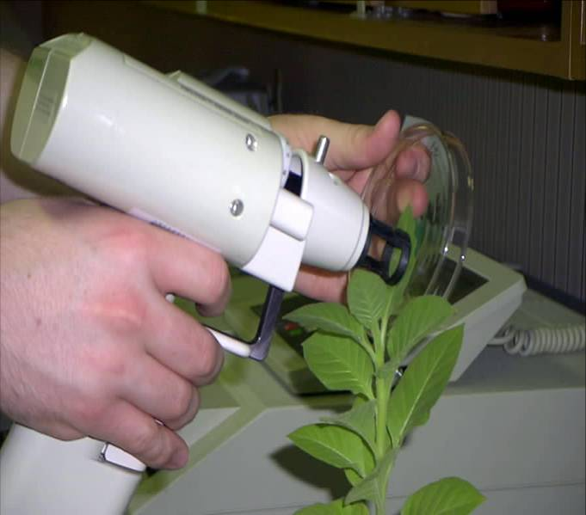
"The crops we see today are vastly different from those plants that existed at the dawn of civilization Since the beginning o agriculture farmers and gardeners have altered the genetic codes of plants and animals even if they were not aware of it at the time. …".
5 points total. Each question is worth 2 points unless otherwise noted

- What is the difference between cross-breeding and transgenic plants?
- Where did the Modified Bacterium approach to gene insertion come from?
- How does a gene gun work? (1 point)

(4) The Farmer's perspective: Evolution, BT Corn Genes and Bug Genes
.Video #2 https://www.youtube.com/watch?v=n9xpKx03g9M

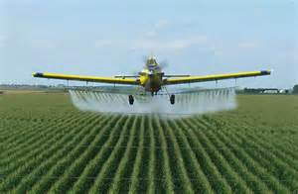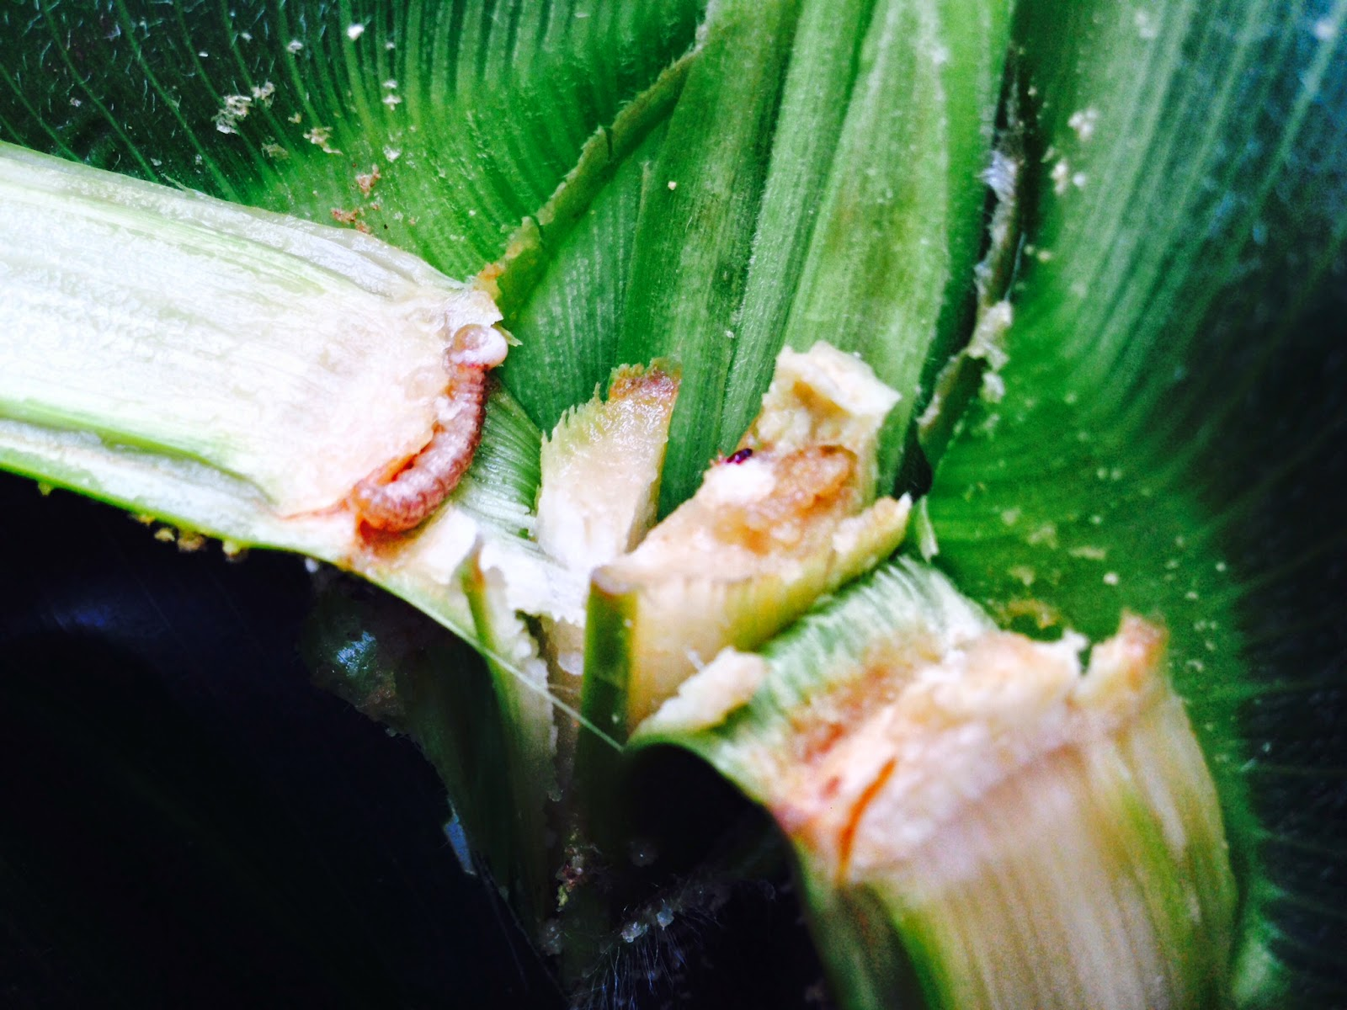
85% of the foods we eat come from large farms….Farmers want to know : " Can Monsanto's genetic technology help get rid of a big pest: the European Corn borer caterpillar?"

5 points total: Each question below is worth 1 point

- How specific can farmers get with conventional pesticide spraying techniques?
- Why would a farmer turn to GE crops for controlling insects?
- Is the BT toxin harmful to humans ? Is it harmful to most other insects?
- What did the Environmental protection agency mandate in order to deal with the issue of resistant pests?
- Who monitors whether or not the farmers are laying aside land for this area of refuge for insects?

(5) Straight Talk on Genetically Modified Organisms

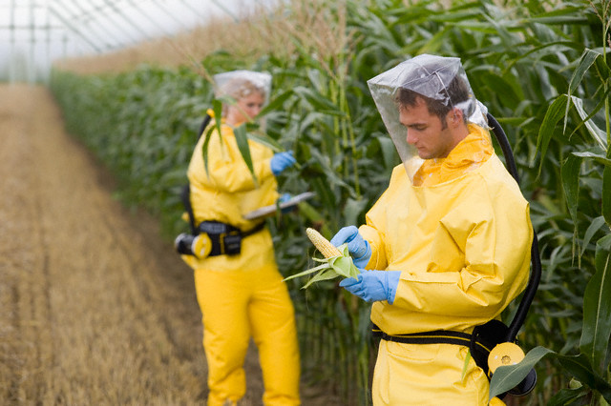
Article #3: http://cspinet.org/new/pdf/biotech-faq.pdf

"label claims are misleading, because they falsely imply that the food made without GE ingredients is somehow safer than or superior to the same product made with GE ingredients. "
5 points total
- What kind of traits have been engineered into agricultural crops? (1 point)
- The U.S. Food and Drug Administration, the National Academy of Sciences and the European Food Safety Agency all agree that GMOs are safe to eat. True or False? (.5 point)
- How can Americans avoid eating GM products? (.5 point)
- Which U.S agencies regulate GE crops? (.5 point)
- Which agencies regulate the environmental safety of GE crops? (.5 point)
- According to the article, the EPA needs to ensure that farmers comply with refuge requirements. What are these?
- What precautions are being taken related to the creation of new allergies through GM products??

(6) Food and Agriculture Organization of the United Nations

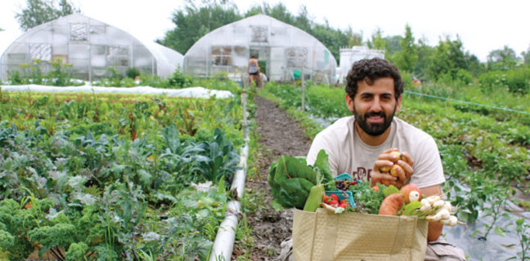
Article #4 http://www.fao.org/english/newsroom/focus/2003/gmo7.htm
"An ecosystem, you can always intervene and change something in it, but there's no way of knowing what all the downstream effects will be …" - Dr. Richard Lewontin, Professor of Genetics, Harvard University
(5 points total)

- Describe five pros of GM technology related to agricultural production, health and the environment.
- Describe five cons of GM technology related to health, the environment and socio-economical factors.

(7) The case for engineering our food
(10 points: all questions are worth 1 point unless otherwise noted, We may be viewing portions of this TEDs talk in class if time permits)

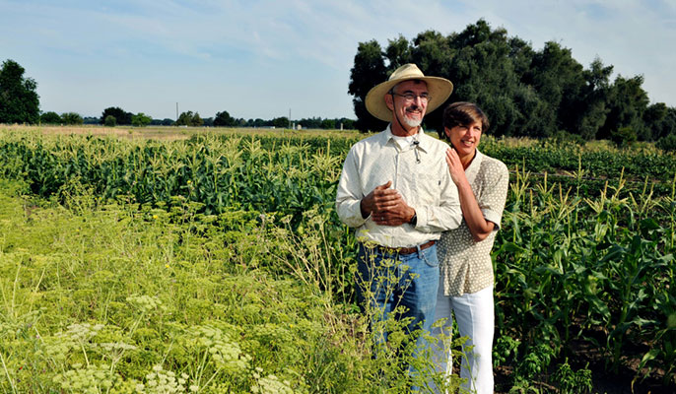
Image:https://www.universityofcalifornia.edu/sites/default/files/Pamela_Ronald_and_Raoul_Adamchak_on_the_UC_Davis_certified_organic_farm_hero.jpg
Video #3 (17 minutes) https://www.ted.com/talks/pamela_ronald_the_case_for_engineering_our_food?language=en
Pamela Ronald studies the genes that make plants more resistant to disease and stress. In an eye-opening talk, she describes her decade-long quest to isolate a gene that allows rice to survive prolonged flooding. She shows how the genetic improvement of seeds saved the Hawaiian papaya crop in the 1990s — and makes the case that modern genetics is sometimes the most effective method to advance sustainable agriculture and enhance food security for our planet’s growing population. In this TEDs talk, Dr. Ronald also shows us why genetic modification isn't necessarily hostile to traditional (even organic) farming.
“ I know so many people who are anti-GMO, but I've always considered that to be a misunderstanding of a technology that's been around since the dawn of agriculture.....”
Directions: view the attached TEDs talk (above) Complete the following questions:
- Genetic modification is not new; virtually everything we eat has been genetically modified in some manner. True or false?
- The rice in the cereal that many of us fed our babies was developed by what process? )2 points)
- Why were over 70 million rice farmers in developing countries having trouble growing rice? (2 points)
- If you bite into an organic conventional papaya that is infected with the ringspot virus you will be chewing on tenfold more viral protein than the “vaccinated” genetically modified papaya. True or false?
- In less developed countries, 500,000 children go blind every year because of a lack of what vitamin?
- After 20 years of careful study and rigorous peer review by thousands of independent scientists, every major scientific organization in the world has concluded that the crops currently on the market are safe to eat and that the process of genetic engineering is no more risky than older methods of genetic modification. True or false?
- According to Pamela Roland in “The Case for Engineering our Food”, instead of worrying about the genes in our food, we must focus on what? (2 points)
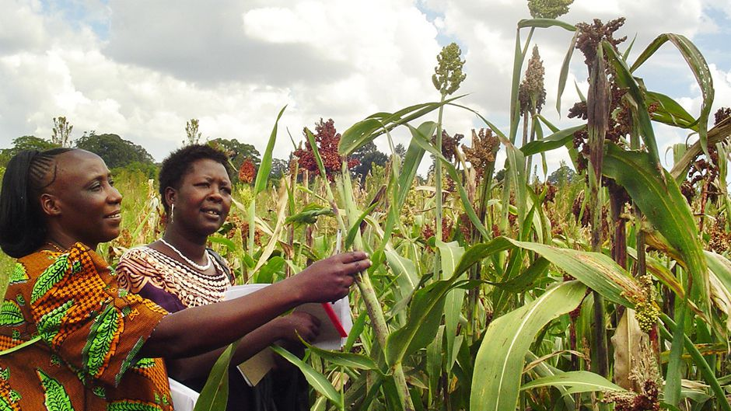
Image: https://i.unu.edu/media/ourworld.unu.edu-en/article/2917/nourish-the-planet.jpg
(8) Viewing the issue from all angles: (15 points)
- Search the internet for another TEDs talk or video that present views opposing those of Dr. Panela Ronald (in “The Case for Engineering Food” above).
Post the link to the video here: ____________________________(3 points)
- Summarize the key points of the video you attached and oppositions to GMOs (5 points)
- Based on the pros and cons, where do YOU stand on the issue of GMOs? (7 points)

