9-200-044
R E V: J A N UAR Y 15, 2002

L I SA ME U L B R OE K

Kmart Inc. and Builders Square

Introduction
In July 1997, Kmart appeared to be nearing a year-long effort to sell its faltering Do-It-Yourself (DIY) home improvement chain, Builders Square. Leonard Green & Partners, a Los Angeles-based retail buyout firm, had proposed to buy Builders Square (BSQ) and merge it with Hechinger’s, a Washington, D.C.-based DIY chain that had been a pioneer in the retail home improvement industry. The newly-formed Builders Square-Hechinger combination would create the nation’s third largest DIY retailer, and seemed to be one of the few options left to Kmart. Kmart’s CEO, Floyd Hall, had a difficult decision to make: should he move forward with Green’s offer of $10 million for Builders Square, or should he continue the search in hopes of receiving a higher offer? Green’s offer seemed surprisingly low, even given Builders Square’s recent sub-par performance, yet bidders for Builders Square had been slow to materialize. Indeed, Kmart’s recent talks concerning a joint venture with Waban Co.’s HomeBase centers ended when Waban’s management withdrew without explanation. As the decision neared, Kmart’s options seemed limited and time was short.

Kmart and its Entry into Specialty Retailing
Kmart Corporation, one of the world’s largest mass merchandise retailers, began as the S.S. Kresge Company in 1912 and by the 1950s it was one of the largest general merchandise retailers in the United States. In 1962, it opened its first Kmart discount store in Detroit. By the late 1970s, Kmart’s success had attracted new competitors to the discount retailing industry. These new competitors, which included Wal-Mart and Dayton-Hudson’s Target stores, entered the market with more inviting stores that made Kmart’s facilities appear shoddy. Responding to this rapidly escalating competitive pressure and in the face of sinking profits in its core discount-retailing operations, Kmart formed a Specialty Retail Group charged with acquiring retail companies with “. . . a proven track record . . . and a sound management team [who] must enthusiastically endorse rapid physical expansion.”1
Kmart’s Specialty Retail Group diversified Kmart’s business substantially, eventually growing to include retail giants Borders Books, OfficeMax, The Sports Authority, Pace and Makro Membership Warehouse Clubs, PayLess Drug Stores, and Home Centers of America (later renamed Builders Square). Kmart also responded to the intensely competitive climate of 1984 by introducing more

1 Kmart Inc., Letter to Shareholders, 1984 Annual Report.
_
Professor Lisa Meulbroek and Research Associate Jonathan Barnett prepared this case. HBS cases are developed solely as the basis for class discussion. Cases are not intended to serve as endorsements, sources of primary data, or illustrations of effective or ineffective management.

Copyright © 2000 President and Fellows of Harvard College. To order copies or request permission to reproduce materials, call 1-800-545-7685, write Harvard Business School Publishing, Boston, MA 02163, or go to http://www.hbsp.harvard.edu. No part of this publication may be reproduced, stored in a retrieval system, used in a spreadsheet, or transmitted in any form or by any means—electronic, mechanical, photocopying, recording, or otherwise—without the permission of Harvard Business School.

200-044 Kmart Inc. and Builders Square

upscale, brand-name merchandise, hoping to boost margins, but neither Kmart’s move into specialty retail operations nor its move into more upscale merchandise were enough to keep competitor Wal- Mart at bay. By 1991, Wal-Mart surpassed both Kmart and industry leader Sears, Roebuck & Co. in sales, to take the top retailing spot. In 1992, with 400 fewer stores, Wal-Mart store sales were 50% higher than Kmart stores’ $26.5 billion. Despite Kmart’s 1993 restructuring (a $1.35 billion effort that involved closing, relocating, and refurbishing stores, and employee layoffs), Wal-Mart’s advances continued.
Sensing that the specialty retail acquisition program had focused too much of management’s attention away from Kmart’s core retail business, and still under intense pressure to improve the company’s core discount stores, in 1994 Kmart’s Chairman Antonini began unraveling his predecessor’s specialty-retailing empire. Over the next two years, Kmart divested all specialty retail operations, with the exception of Builders Square. Kmart’s losses continued, however, resulting in a downgrade of its debt to non-investment grade (BB by Standard & Poor’s Corp. and Ba2 by Moody’s Investors Services, Inc.), a tightening of debt covenants, a prohibition on paying dividends, and higher interest rates on its bank debt.2 In March of 1995, CEO Antonini was asked by the Board to step down. Three months later, Kmart’s Board named Floyd Hall, former CEO of competitor Target stores, The Museum Company, Grand Union, and B. Dalton Booksellers, as president, chairman and CEO.
Under CEO Hall, Kmart made some financial progress, but despite years of effort to both upgrade stores and merchandise, Kmart’s sales per square foot trailed that of leading competitors Wal-Mart and Target significantly, and the need to divest Builders Square intensified.

The Home Improvement Industry
The home improvement industry first emerged in the decade following World War II. The economic expansion of the 1950s and 1960s that swept across the country spurred industrial growth and increased personal income levels, inducing those with sufficient capital to become homeowners rather than home renters. As the inchoate home improvement market evolved, so too did the store formats that catered to the various segments that comprised the building and remodeling market. During the 1950s and 1960s, hardware stores and lumberyards, which catered primarily to building contractors, faced new competitors and a new “home center” format. Home centers were combination hardware stores and lumberyards that catered to both the professional trade and to the rapidly growing do-it-yourself consumer segment. These 30,000 square-foot stores offered cheaper prices and a wider selection of inventory—about 25,000 stock keeping units (SKUs)—than the local hardware store and eliminated the extra trip to the lumberyard. Typically, home center stores sold not only to do-it-yourselfers but to building contractors, industrial, and government customers as well.
Builder Square’s potential partner in Kmart’s proposed sale, Washington D.C.-based Hechinger, had earned a reputation as a pioneer in the do-it-yourself industry. Unlike other home centers, Hechinger focused exclusively on the do-it-yourself segment, reasoning that such a strategy would insulate it from the capriciousness of the construction market, while distinguishing it from competing home center stores. This strategy worked well: each year between 1972 and 1979, Hechinger increased sales and earnings. Against this backdrop of encouraging growth during a period of economic stagnation, Hechinger unveiled larger stores, averaging 60,000 square feet of selling space, that were early versions of the warehouse outlets that would later flourish in the 1980s and 1990s.

2 Kmart’s aggregate 1996 fiscal-year-end debt was $4.7 billion. This amount included approximately $1.5 billion of capital lease obligations, but excluded $4.8 billion in operating lease obligations.

2

Kmart Inc. and Builders Square 200-044

This format was in stark contrast to that of industry leader Lowe’s Companies, which did not have a store larger than 33,000 square feet. Hechinger’s larger stores were impeccably maintained, carried roughly 40,000 SKUs, and offered cordon-bleu service from sales associates who were loaded with product knowledge. Analysts deemed Hechinger “the premier home center in the industry” and the standard by which all other home center chains judged themselves. Hechinger’s vast selection of particular products gave customers little need to shop elsewhere for home improvement and repair items, creating what company officials termed “category dominance.”3 By 1980, Hechinger operated 27 stores selling lumber, paint, tools, garden supplies, and housewares, as well as a limited selection of toys and sporting goods.
As Exhibit 1 shows, growth in the DIY home improvement market continued throughout the 1980s, attracting new competitors. One such newcomer was Home Depot Inc., an Atlanta, Georgia- based retailer, that quickly rose to the top of the industry. Home Depot introduced a new method of hardware merchandising known as “Big-Box” retailing. Home Depot’s strategy was to place the highly personalized service typically found in a neighborhood hardware store in a warehouse the size of two football fields, carrying 45,000 to 50,000-plus SKUs. Home Depot generated sales sufficient to support these large-scale stores by catering to contractors, not just do-it-yourselfers, driving the smaller hardware stores and home centers out of business. Lowe’s also increased the pressure on other home centers by following Home Depot’s lead and introducing similar warehouse- style home improvement centers with knowledgeable sales forces, a wide assortments of products, and low prices.
In response to Home Depot’s success and Lowe’s endorsement of the “Big-Box” format, Hechinger announced they too would build a chain of warehouse-styled stores, expanding beyond its previous Washington, D.C.-based market to include New York, South Carolina, New Jersey, Connecticut and Ohio, and offering to better its competitors’ lowest prices by 5%. The rapid growth in the home improvement industry also attracted Kmart’s attention, and in 1984 Kmart decided to enter the freestanding home improvement business as part of its diversification strategy.

Kmart’s Entry into the Home Improvement Industry
In 1984, Kmart acquired “Home Centers of America,” a San Antonio-based chain of nine do-it- yourself home improvement warehouse stores. By year-end, Kmart opened six additional stores, renaming the chain Builders Square. As it had done with its other specialty retail operations, Kmart guaranteed Builders Square’s store lease payments, thereby reducing the cash expenses associated with establishing a new store (in fact, in some cases these guarantees were inherited obligations resulting from the conversion of some less successful Kmart stores into the new Builders Square format). A typical Builders Square store occupied 80,000 square feet, offered 35,000 SKUs and featured brand-name merchandise at discount prices. Like other home improvement centers, Builders Square offered lumber, building materials, hardware, paint, plumbing and electrical supplies, and other home improvement goods. Analysts described Builders Square as a modest Home Depot substitute that Kmart expanded aggressively in far reaching markets where the company would not have to compete directly with Home Depot or Lowe’s. Like Home Depot, the staff at Builders Square included professional carpenters, roofers, building contractors, painters and other home improvement tradespeople who were available to advise do-it-yourselfers and contractors. By 1989, Builders Square’s 141 stores generated nearly $1.8 billion in sales and $35 million in earnings.

3 Hechinger shoppers looking for a hammer could choose from 62 on display (see the T. Grant (ed.), International Directory of Company Histories, volume 12).

3

200-044 Kmart Inc. and Builders Square

The Home Improvement Industry Shifts Towards the “Big-Box” Format
Through the 1990s, Hechinger, Builders Square, and many other smaller competitors continued to face mounting pressure from the “Big-Box” format of Home Depot and Lowe’s, resulting in industry- wide consolidation described by analysts as “the big getting bigger and the weak getting weaker.”4 Between 1991 and 1996, Home Depot rapidly grew from 174 to 512 stores, and never closed a store. Concurrently, Lowe’s expanded its operating base from 309 stores in 1990 to 402 stores in 1996. Both chains continued their expansion plans unabated. Home Depot’s management planned to open an additional 111 stores in 1997 and to double its store count in the next five years. During this same period, Lowe’s planned to double the number of its stores to 800. Experts thought the U.S. market could successfully support a total of 2,000 big-box stores. If Home Depot and Lowe’s successfully carried out their expansion plans, within five years every market in the United States with at least 50,000 households would have both stores.
While both Home Depot and Lowe’s furthered their lead over other industry participants, Home Depot appeared to be the primary beneficiary of increased consolidation: in 1991, the sales differential between the two companies was $2 billion; by 1996, this sales differential had grown to
$11 billion (see Exhibit 2 for the 1996 rankings of the top ten home improvement retailers, Exhibit 3 for a summary of select income statement and balance sheet data for home improvement retailers, and Exhibit 4 for indexed returns for Builders Square’s competitors).
As Home Depot and Lowe’s grew in size, they built up their buying power with suppliers, gaining concessions in pricing, exclusive merchandise, and other benefits that were not available to smaller chains, further contributing to the retrenchment or dissolution of regional home center chains.5 Home Depot was particularly notorious for squeezing its 20,000-plus North American suppliers. Nowhere else was this strategy (and Home Depot’s control of the buyer-supplier relationship) more evident than at the company’s week-long biannual product-line reviews. These reviews drew thousands of vendors lured by the opportunity to both showcase their wares and to secure a purchase order commitment from the giant retailer. Despite the long distances that many vendors traveled to attend these events, Home Depot did not roll out the red carpet to welcome its would-be suppliers. Indeed, in 1997, CEO Blank hosted the event in a cavernous, unheated metal barn in Forth Worth, Texas, with no indoor bathrooms. 6

The Declining Fortunes of Builders Square and Hechinger
As Home Depot and Lowe’s expanded, Builders Square began to exhibit clear signs of distress. Builders Square had been successful in establishing an immediate presence in key markets, but the lack of a clustering strategy often prevented it from maximizing profits. In 1991, Builders Square closed 10 stores in Georgia, Florida and California, citing increased competition and the decision to curtail lower-volume stores.7 Despite increased sales, Builder Square’s earnings began a downward

- M. Exstein, “Home Depot Company Report,” Credit Suisse First Boston Corporation, October 31, 1997.
- As reported in M. Exstein’s October 31, 1997 Home Depot Company Report (Credit Suisse First Boston Corporation), in 1996 both Handy Andy Home Improvement Centers and Ernst Home & Nursery liquidated, Grossman’s Inc. liquidated all its traditional east coast locations, Rickel Home Centers announced it would close all 49 units by the end of 1997, and PayLess Cashways, the industry’s fourth largest competitor, reported a $38.6 million loss.
- As reported in B. Upbin’s article, “Profit in a Big Orange” (Forbes, January 24, 2000), in another year, CEO Blank scheduled the biannual product-line review at an indoor arena at the Kansas City Stockyards immediately after a rodeo. Buzzing flies and the smell of horse manure suffused the air.
- Three of the ten stores to be closed were located in Atlanta, Georgia, Home Depot’s home market, which had 13 stores in the metropolitan area. Home Depot also had a stronghold in the Florida and California markets.

4

Kmart Inc. and Builders Square 200-044

trend, falling 23.7% in 1993 to $61 million and 54.1% in 1994 to $28 million (see Exhibit 5 for a summary of select income statement and balance sheet data for Builders Square).
Kmart decided to phase out the Builders Square existing self-service warehouse-style home improvement stores and operate large format (100,000 square-foot-plus) superstores (dubbed Builders Square II) that emphasized customer service and provided an extensive selection of quality products and services. By 1995, Kmart had converted 91 Builders Square stores to this new format, but nevertheless, Builders Square sales continued to decline. Kmart management was forced to scale back its plans to convert to the Builders Square II format, and closed 15 of 184 stores in operation. That same year, Kmart recorded a Builders Square-related $370 million pretax write-down, signaling that management was considering divesting the chain.8
Conceding that Builders Square had a number of problems, including the relatively small size of the original format BSQ I stores which failed to meet customers’ demands, poor service, and the absence of a geographic clustering strategy which prevented Builders Square from achieving economies of scale, operating efficiencies and maximization of profits, Kmart reclassified Builders Square as a discontinued operation in 1996, creating a $390 million loss, net of taxes, including $5 million of current year losses.9 That same year, Kmart initiated exploratory talks with potential acquirers of the ailing chain, including Home Depot, Lowe’s and Waban. Kmart received serious offers from competitors to buy specific stores or groups of stores, but Kmart’s managers declined such offers to “cherry-pick” the stores, preferring to sell all stores within a specific geographic region together. At the same time, potential bidders outside the do-it-yourself industry were reluctant to enter an industry already dominated by Home Depot. Despite their efforts to solicit offers, Kmart was unsuccessful in eliciting the type of offer it sought, and the need to divest became paramount as competition increased and Builders Square’s business continued to shrink.
Just as Builders Square attempted to compete with Home Depot by introducing the new Builders Square II format, in 1987 Hechinger acquired two-year old Home Quarters (HQ), an operator of six larger, warehouse-style stores in Virginia and North Carolina, and a smaller unit in Florida. These new stores averaged 101,000 square feet, a 42% increase over existing Hechinger stores. The HQ stores ultimately accounted for 52 of Hechinger’s 117 stores, and generated most of the company’s profits. But Hechinger still had many smaller stores that were ill-prepared to compete with the industry leader Home Depot, which continued its aggressive, almost predatory, expansion (rumor had it that the day Home Depot opened its first store in one of Hechinger’s markets, it marked the occasion by sending the closest Hechinger store a bouquet of black roses).
Responding to the competitive threat, Hechinger lowered retail prices and sought to convert more under-performing Hechinger stores to the HQ format, yet its sales continued to decline, and its losses mounted (see Exhibit 6 for select income statement and balance sheet data for Hechinger). Hechinger was forced to close 22 stores, calling off plans to further develop previously acquired real estate properties, and suspending its dividend. Hechinger management decided that they must sell the firm, and retained investment bank Donaldson, Lufkin & Jenrette Securities Corporation (DLJ).

- Kmart’s $370 million write-down was the result of the company’s decision to adopt Financial Accounting Standards (FAS) No. 121 “Accounting for the Impairment of Long-Lived Assets and for Long-Lived Assets to be Disposed Of.” As described in Kmart’s 1995 Annual Report, FAS No. 121 requires firms to record impairments of long-lived assets when there is evidence that events or changes in circumstance have made recovery of an asset’s carrying value unlikely. In conducting its review, Kmart management considered the expected operating cash flows together with a judgement as to the fair value that the company could receive upon sale of its investments, and recorded a $532 million pre-tax charge relating to Builders Square and certain international operations.
- At the end of 1996, Kmart had a market equity value of $6.6 billion. Its total revenue was $31 billion, on which its net losses were $220 million.

5

200-044 Kmart Inc. and Builders Square

During 1996, DLJ held discussions with a group of potential buyers, including Leonard Green & Partners, L.P.

The Leonard Green & Partners Proposal
Leonard Green & Partners (LGP) proposed to acquire both Builders Square and Hechinger, combining the two ailing chains to create the nation’s third largest DIY home improvement chain, with 279 stores in 29 states and over $4.5 billion in revenue. LGP, a Los Angeles-based buyout group had experience in restructuring troubled firms. Indeed, founding partner Leonard Green was known in the industry as a “rescuer of the dogs of retailing, a finder of value in underachievers or troubled companies.”10 LGP would form a holding company comprised of the two companies, and would invest $25 million in cash for a 100% ownership position in that company. Kmart would receive $10 million in cash and warrants (if exercised, the warrants would give Kmart a 30% ownership interest in the newly-combined firm), and Hechinger would receive $128 million for its outstanding shares. In return, Kmart would contribute 162 Builders Square stores, giving LGP the right to “put back,” or return, 25 leased Builders Square stores of its choice to Kmart, while LGP retained the cash from liquidating the inventory and fixtures in those stores.11 In addition to the aforementioned cash and warrants, the new company would assume responsibility for Hechinger’s outstanding debt and more than $2 billion of Kmart’s long-term lease obligations associated with its Builders Square stores.12 Kmart would, however, remain contingently liable for 147 BSQ leases (see Exhibit 7 for details regarding Kmart’s Builders Square lease obligations).13 The holding company would also assume a
$10.7 million subordinated PIK (Payment-In-Kind) note due to Kmart. LGP estimated that Builders Square had approximately $700 million of net assets, and $112 million in book value of unencumbered real estate. Adding to that was Hechinger’s $43 million in non-operating assets (market value), and $102 million in book value of unencumbered real estate.
LGP would appoint Anthony Petrillo to head the combined Hechinger-Builders Square operations. Petrillo had experience as an acting CEO in turnaround situations, and LGP had successfully worked with Petrillo in the past, managing Kash’N’Karry Food Stores, and Carr- Gottstein Foods. In fact, both LGP and Petrillo were well-acquainted with Kmart: LGP had purchased another member of Kmart’s Specialty Retail Group, Payless Drug, and combined it with Thrifty, using Petrillo’s help in engineering the turnaround. For the proposed buyout, LGP put together a turn-around plan detailing how it would create value in the newly-combined firms by improving its profitability and competitive position. LGP’s specific plans called for increasing profit margins though increased purchasing power, vendor consolidation, and a cross-dock shipping and receiving program. They also anticipated achieving significant cost savings, much of which derived from a

- D. Altaver, “Surprise Bidder Has Upper Hand in Battle for Sports Authority,” Knight-Ridder Tribune Business News: Sun- Sentinel, Florida, August 3, 1998.
- The elimination of the 25 worst performing BSQ stores would increase the combined company’s EBITDA by $25.3 million and was projected to generate approximately $23.5 million in cash from the liquidation of inventory and fixtures.
- As of May 3, 1997, Hechinger’s total debt was $394 million. Part of this included a senior secured revolving credit facility which Hechinger obtained in February of 1996 at a rate of LIBOR plus 2.75%. Hechinger also had publicly-traded, low coupon, long maturity debt ($323 in book value) that both traded at a substantial discount to par (its market value was $164) and had no restrictive covenants because it had been issued while Hechinger still had its investment grade debt rating.
- “Contingently liable” means that Kmart would be responsible for all remaining lease payments were the successor firm to fail.

6

Kmart Inc. and Builders Square 200-044

reduction in employees.14 Finally, LGP would realize value by selling assets, such as the inventory in the twenty-five Builders Square stores “put” back to Kmart, and nine Hechinger stores. They would also sell nine excess Hechinger land parcels, nine Hechinger stores, two Builders Square stores, and the Builders Square headquarters. These asset sales were expected to produce roughly $195 million in liquidity, adding to BSQ’s $25 million in excess cash and Hechinger’s $55 million in excess cash. Funding for the purchase and refinancing of debt would also come from a revolving credit facility that LGP would obtain (see Exhibit 8 for the debt ratings and corresponding bond yields for Kmart and Builders Square’s DIY peers).15 Exhibit 9 shows the sources and uses of financing for the proposed merger.
Strategically, both Petrillo and LGP recognized that the current hugger-mugger of the Builder Square stores would make winning customers back a challenge, requiring increased merchandise selection, as well as friendly employee-customer interaction. To improve store operations and merchandising, they would need to offer better customer courtesy and service, and improvements in SKU selection, space management, in-store merchandising, and store presentation. They estimated that five years would be necessary before Builders Square and Hechinger would be healthy enough to sell for a profit (see Exhibit 10 for select income statement and balance sheet projections for the proposed merger).

Kmart’s Decision
For its part, Hechinger had asked its investment banker, DLJ, to evaluate the offer and to provide a fairness opinion. DLJ estimated the value of Hechinger using a discounted cash flow analysis, based on operating projections provided by Hechinger management.16 They also performed a comparable acquisition analysis and comparable company analysis. One difficulty encountered by both Hechinger and Kmart was the vast range of valuations one could derive using industry multiples, including those shown in Exhibit 11. DLJ eventually concluded that the offer was fair.
Now, Kmart had to evaluate the proposal from its perspective. Unfortunately, market reaction to the proposal was mixed. Supporters of the deal suggested that the savings and efficiencies of the combined entity would substantially change the fortunes of Builders Square and Hechinger. “I think it’s an eminently sensible combination,” said Andrew Lipman, a director with Schroder & Co., a New York Investment bank. “. . . There will be buying synergies . . . and there’s a good geographic fit . . . two essentially regional chains would be combined to form something that would be close to a national presence . . . [Hechinger’s 117 home improvement stores were located primarily in the Midwest and on the East Coast, and Builders Square’s 162 stores were located in the Midwest and the Southwest]. ”
Other analysts were not as sanguine, wondering whether the combination of the two chains could effectively compete with Home Depot and Lowe’s, both of which had hundreds more stores than the new company (see Exhibits 12 for the projected number of BSQ and Hechinger stores that would compete with Home Depot or other Big Box retailers, and Exhibit 13 for their locations). Some said

- LGP estimated that the combined purchasing power of the proposed Builders Square-Hechinger merger would result in a 1.5% decline in the new entity’s cost of goods sold. This estimate seemed reasonable given the resultant 1.8% decline in Hechinger’s cost of goods sold following the company’s earlier acquisition of Home Quarters (HQ).
- The interest rate on borrowings under the new credit facility was likely to be equal to the LIBOR rate plus 200 basis points (approximately 9%).
- DLJ initially requested two sets of operating projections from Hechinger management in order to perform the discounted cash flow analysis. After Hechinger reported second quarter 1997 operating results that were below analyst expectations, DLJ requested a third set of projections forecasting lower future sales and cash flows.

7

200-044 Kmart Inc. and Builders Square

the deal would take two weak chains and make one bigger weak chain, and remained skeptical about the chain’s long-term prospects. Not only was competition from Home Depot and Lowe’s intensifying, many felt Hechinger’s stores simply were not the right size or shape to compete effectively. John Yozzo, a home-improvement analyst for F&D Reports explained, “Hechinger stores are neither fish nor fowl—they are smaller than the warehouse stores, bigger than Sears Hardware Stores, and nobody really knows what they are or what they’re trying to be.”
While the prospect of competing with Home Depot and Lowe’s seemed daunting, there had been some precedent, at least on a limited scale, for successfully taking on the DIY giants. Regional player Eagle Hardware & Garden (Eagle) had proved able to challenge the Home Depot/Lowe’s hegemony. Founded in 1990 with its first store in Spokane, Washington, Eagle had grown to 30 stores by 1997, and had a market equity value of $578 million. The average store comprised 125,000 square feet and had over 60,000 SKUs (see Exhibit 3(B) for additional Eagle Hardware data). Eagle’s strategy was to “combine the selection and value associated with traditional warehouse-format home centers with the comfortable atmosphere and service orientation of specialty retailers.”17 Reflecting this goal, its trademark was “More of Everything.” The company’s expansion strategy targeted only select metropolitan areas (such as Seattle, Salt Lake City, and Denver) and its managers placed a premium on selecting favorable store sites. Eagle developed a clustering strategy, placing multiple home centers in a single metropolitan area, hoping to increase both market share and operating leverage.18 They also opened some stores in single-store markets (Kennewick and Yakima Washington, Medford Oregon, and Billings, Montana) where they believed the company could establish low operating costs, and less intense competition.
Eagle had 12 stores in the Seattle metropolitan market, where its principal competitors were Home Depot (with 10 stores, two of which were next to Eagle stores), Ernst Home Center, Fred Meyer and HomeBase. Eagle’s gross margins and operating income were lower for stores in markets where they directly competed with Home Depot (20 of the company’s 30 stores compete in markets where Home Depot also operates). Of course, not all competitors had shown the same resiliency as Eagle. Ernst had filed for bankruptcy in July 1996, and by November had begun liquidating its assets. Home Depot’s sedulous and rapacious pursuit of its competitors was legendary, its effects baneful. The challenge facing the potential Builders Square-Hechinger chain, then, would seem Herculean, yet possible.
Although the bid of $10 million for Builders Square seemed low, alternative offers had been slow to develop, and Kmart’s time was quickly evanescing. Kmart’s managers estimated that the Builders Square chain had enough cash and working capital to continue operating for another year with no other infusions, but beyond that Builders Square’s continued existence was highly uncertain. Despite the bid price, the LGP proposal offered other benefits. First, the offer would avoid, or at least forestall, a loss of employment for Builders Square’s 16,000 employees. Second, Kmart’s prior dealings with LGP had been favorable (and profitable): LGP purchased Kmart’s PayLess drug store chain, combined it with Thrifty drug stores, eventually taking the combined chain public after

- Eagle Hardware and Garden Inc. 1996 10-K filing.
- Eagle dubbed its store expansion program a “market saturation strategy,” and in the company’s 1994 Annual Report, Eagle management described the strategy in the following manner: “The battle for market share is one being fought continually throughout the home improvement business. To attain and expand our market share for long-term success, we seek to saturate, or fill in, certain markets with our own stores, even though their proximity to one another may reduce same store sales in the short term. By doing so, we build sales and long-term market share, while at the same time denying these premium sites to our competitors."

8

Kmart Inc. and Builders Square 200-044
engineering a successful turnaround.19 Moreover, explained Kmart’s vice president of investor relations, Bob Burton, “getting rid of Builders Square, even for so small a cash sum, means ridding [Kmart] of $2.1 billion in contingency lease obligations stretched out over a 10 to 15 year period.” LGP partner Jonathan Sokoloff suggested that from LGP’s point of view, “Kmart has reason to basically give its troubled home improvement chain to Green; if Builders Square were to fail, Kmart would be on the hook for more than $2 billion to landlords.” As for the price, Sokoloff added, “the low asking price [makes] it worth the gamble.” With respect to the contingent lease guarantees, Deutsche Morgan Grenfell retail analyst Jeff Edelman argued that Builders Square stores were situated in “good locations that can be sub-leased, and in some cases, the landlord might want the property back and let Kmart off the hook.” Critics suggested, however, that poor locations had been a sticking point in Kmart’s attempts to sell the chain. In addition, many of the recently opened Builder Square II stores carried new 25-year leases, meaning that Kmart’s lease-payment commitments on such stores extended far into the future. Exhibit 14 shows that Kmart had previously guaranteed leases on other specialty businesses it sold or spun off, including Sports Authority Inc., Office Max and Borders Group.
Faced with mixed investor reaction to the deal, and with the deadline for the final decision approaching, Kmart management had to decide whether to agree to the LGP terms, hold out for better terms or other bidders, or continue its struggle to survive in the increasingly competitive do-it- yourself segment.

- In 1994, Green purchased the PayLess drug store chain from Kmart, combined PayLess with Thrifty drug stores, took the combined chain public, and sold the entity to Rite Aid in 1996 for $2.5 billion, netting $491 million on the deal. Kmart ended up with a 5.63% stake in Rite Aid, which it subsequently sold for $260 million, realizing a gain of more than $100 million.

9

200-044 Kmart Inc. and Builders Square

Exhibit 1

GROWTH OF TOTAL U.S. HOME IMPROVEMENT PRODUCTS MARKET: 1977 - 2003 (1) (2)
The following are market size estimates and growth rates for the total U.S. home improvement products market as well as a breakout for the consumer and professional segments of the market.

 | Total Market  ($billions) | % Change | Consumer Mkt  ($billions) | % Change | Professional  Mkt ($billions) | % Change
2003e ⁽³⁾ | 181.7 | 3.8 | 136.7 | 4.4 | 45.1 | 2.2
2002e | 175.0 | 3.6 | 130.9 | 4.0 | 44.4 | 2.5
2001e | 168.9 | 3.4 | 125.9 | 3.6 | 43.0 | 2.8
2000e | 163.3 | 3.8 | 121.5 | 4.2 | 41.8 | 2.8
1999e | 157.3 | 3.3 | 116.6 | 3.9 | 10.7 | 1.8
1998e | 152.2 | 7.7 | 112.2 | 8.1 | 39.9 | 6.5
1997 | 141.3 | 4.3 | 103.8 | 6.3 | 37.5 | 7.7
1996 | 135.5 | 5.2 | 97.7 | 6.7 | 37.8 | 1.3
1995 | 128.8 | 2.3 | 91.5 | 4.2 | 37.3 | -1.8
1994 | 125.9 | 9.3 | 87.8 | 10.5 | 38.0 | 6.8
1993 | 115.1 | 7.7 | 79.5 | 7.6 | 35.6 | 7.8
1992 | 106.9 | 6.9 | 73.9 | 8.0 | 33.0 | 4.4
1991 | 100.0 | -5.2 | 68.4 | -2.0 | 31.7 | -11.4
1990 | 105.5 | 3.4 | 69.8 | 2.1 | 35.7 | 6.2
1989 | 102.0 | 2.1 | 68.4 | 2.3 | 33.6 | 1.8
1988 | 99.9 | 8.4 | 66.8 | 7.1 | 33.0 | 11.0
1987 92.1 N/A ⁽⁴⁾ 62.4 |  |  |  | N/A | 29.8 | 4.3
1986 | 84.8 | 8.1 | 56.4 | 6.2 | 28.5 | 12.1
1985 | 78.5 | 9.4 | 53.1 | 4.7 | 25.4 | 20.9
1984 | 71.7 | 16.9 | 50.7 | 11.5 | 21.0 | 32.3
1983 | 61.4 | 10.2 | 45.5 | 9.8 | 15.9 | 11.5
1982 | 55.7 | -0.3 | 41.5 | 1.9 | 14.2 | -6.2
1981 | 55.8 | 4.0 | 40.7 | 6.7 | 15.2 | -2.5
1980 | 53.7 | 4.5 | 38.1 | 2.9 | 15.6 | 8.6
1979 | 51.4 | 13.9 | 37.0 | 15.4 | 14.3 | 10.0
1978 | 45.1 | 18.2 | 32.1 | 16.6 | 13.0 | 22.4
1977 | 38.2 | N/A | 27.5 | N/A | 10.7 | N/A

(1) Source: Standard & Poor's DRI, Home Improvement Research Institute, Tampa, FL, 11/98.
(2) Dollar estimates are rounded. Growth rates are computed on unrounded estimates.
(3) e=estimate
(4) 1986 and prior years do not include hard-surface floor coverings, therefore the percent change between 1986 and 1987 is not available for the consumer market.

10

For the exclusive use of H. Xu, 2020.
200-044 -11-

Exhibit 2

1996 TOP TEN HOME IMPROVEMENT COMPANIES (1)

Panel A: 1996 Firm Characteristics
 |  |  |  | Sales Per Store | Avg. Store Size | Aggregate Selling Area
 | Headquartered | Employees | # Stores | ($M) | (1000's sq.ft.) | (1000's sq.ft.) | SKU's (2)
Home Depot | Atlanta, GA | 100,000 | 512 | 38.2 | 105 | 53,926 | 50,000
Lowe's Cos. | North Wilkesboro, NC | 53,492 | 402 | 21.4 | 76 | 30,400 | 45,000
Menard | Eau Claire, WI | 6,700 | 128 | 24.2 | 93 | 11,900 | 60,000
Payless Cashways | Kansas City, MO | 17,000 | 192 | 13.8 | 32 | 6,144 | 36,000
Builders Square | San Antonio, TX | 23,000 | 164 | 15.5 | 113 | 18,600 | 40,000
Hechinger Co. | Largo, MD | 18,000 | 117 | 18.8 | 85 | 9,900 | 40,000
84 Lumber | Eighty Four, PA | 4,500 | 386 | 3.9 | 20 | 7,740 | 60,000
HomeBase | Irvine, CA | 10,000 | 84 | 17.3 | 119 | 9,994 | 30,000
Sears Hardware | San Jose, CA | 12,000 | 231 | 5.2 | 22 | 5,089 | 45,000
Carolina Holdings | Raleigh, NC | 3,700 | 82 | 21.4 | 15 | 1,200 | 12,000

Panel B: Sales and Market Share

1996 1995 1991
Sales ($ billions) | Mkt Share (%) | DIY(3) Sales as %  of Total Sales | Sales ($ billions) | Mkt Share (%) | Sales ($ billions) | Mkt Share (%)

Home Depot 19.54 14% ⁽⁵⁾ 80% |  |  |  | 15.47 | 11.6% | 5.14 | 4.9%
Lowe's Cos. | 8.60 | 6.1% | 80% | 7.08 | 5.3% | 3.06 | 2.9%
Menard | 3.10 | 2.2% | 95% | 2.73 | 2.1% | 0.97 | 0.9%
Payless Cashways | 2.64 | 1.9% | 50% | 2.68 | 2.0% | 2.39 | 2.3%
Builders Square | 2.55 | 1.8% | 70% | 2.64 | 2.0% | 2.05 | 2.0%
Hechinger Co. | 2.20 | 1.6% | 90% | 2.25 | 1.7% | 1.62 | 1.5%
84 Lumber | 1.50 | 1.1% | 25% | 1.25 | 0.9% | 0.85 | 0.8%
HomeBase | 1.45 | 1.0% | 65% | 1.40 | 1.1% | 1.40 | 1.3%
Sears Hardware | 1.19 | 0.9% | 90% | N/A(4) | N/A | N/A | N/A
Carolina Holdings | 0.97 | 0.7% | 10% | 0.78 | 0.6% | 0.56 | 0.5%
Top Ten | 43.52 | 31.0% |  | 37.20 | 28.0% | 18.83 | 18.0%
Total Market | 140.00 | - |  | 133.00 | - | 105.00 | -

(1) Source: National Home Center News 5/26/97
(2) Stock keeping units
(3) Do-It-Yourself
(4) Not Available
(5) While Home Depot had an estimated 14% share of the home improvement segment, analysts estimated Home Depot controlled only 6% of the entire market for building materials and related products (which includes materials for new construction in addition to repairs of existing structures).

200-044 Kmart Inc. and Builders Square

Exhibit 3(A)

SELECT INCOME STATEMENT AND BALANCE SHEET DATA FOR HOME IMPROVEMENT INDUSTRY PEERS
HOME DEPOT

Year | 1993 | 1994 | 1995 | 1996
($millions)
Sales | 9,239 | 12,477 | 15,470 | 19,536
COGS | 6,599 | 8,862 | 11,004 | 13,869
SG&A | 1,847 | 2,498 | 3,106 | 3,900
Depreciation | 86 | 130 | 181 | 232
Interest Expense | 45 | 54 | 25 | 39
Taxes | 279 | 375 | 464 | 597
Net Income | 457 | 605 | 732 | 938
Cash | 100 | 1 | 53 | 146
Working Capital | 994 | 919 | 1,255 | 1,867
Total Debt | 884 | 1,006 | 722 | 1,249
PP&E (net of depreciation) | 2,371 | 3,397 | 4,461 | 5,437
Additional Information:
Number of Stores | 264 | 340 | 423 | 512
Capital Expenditures | 864 | 1,101 | 1,278 | 1,194
Stock price, 7/17/97 |  |  |  | 47.06
Shares Outstanding (MM), 7/17/97 |  |  |  | 729.5
Beta |  |  |  | 0.82
Volatilityª |  |  |  | 24%
Debt Rating |  |  |  | AA
LOWE'S COS.
Year | 1993 | 1994 | 1995 | 1996
($millions)
Sales | 4,538 | 6,111 | 7,075 | 8,600
COGS | 3,457 | 4,598 | 5,312 | 6,376
SG&A | 784 | 1,031 | 1,223 | 1,523
Depreciation | 81 | 110 | 150 | 198
Interest Expense | 27 | 45 | 55 | 65
Taxes | 67 | 120 | 126 | 161
Net Income | 132 | 224 | 226 | 292
Cash | 73 | 150 | 64 | 40
Working Capital | 403 | 611 | 654 | 503
Total Debt | 644 | 710 | 897 | 871
PP&E (net of depreciation) | 1,020 | 1,398 | 1,858 | 2,494
Additional Information:
Number of Stores | 311 | 336 | 365 | 402
Capital Expenditures | 337 | 414 | 520 | 677
Stock price, 7/17/97 |  |  |  | 35.50
Shares Outstanding (MM), 7/17/97 |  |  |  | 173.9
Beta |  |  |  | 1.28
Volatilityª |  |  |  | 35%
Debt Rating |  |  |  | A
Source: Public filings and case writer estimates.
aAnnualized volatility, measured between January and July 1997.

12

Kmart Inc. and Builders Square 200-044

Exhibit 3(B)

SELECT INCOME STATEMENT AND BALANCE SHEET DATA FOR HOME IMPROVEMENT INDUSTRY PEERS
PAYLESS CASHWAYS
Year 1993 1994 1995 1996
($millions)
Sales 2,601 2,723 2,680 2,643
COGS 1,825 1,919 1,913 1,901
SG&A 570 594 620 615
Depreciation 56 59 60 55
Interest Expense 125 66 61 60
Taxes 16 42 -5 -31
Net Income -36 45 -129 -19
Cash 3.7 2.7 1.0 0.4
Working Capital 85 139 98 131
Total Debt 701 674 640 637
PP&E (net of depreciation) 537 573 546 505
Additional Information:
Number of Stores 196 202 206 192
Capital Expenditures 50 82 67 40
Stock price, 7/17/97 0.63
Shares Outstanding (MM), 7/17/97 37.7
Beta 0.42
Volatilityª 127%
Debt Rating B

EAGLE HARDWARE & GARDEN
Fiscal Year 1993 1994 1995 1996
($millions)
Sales 322 519 616 761
COGS 229 379 450 549
SG&A 78 122 143 175
Depreciation 3 7 9 11
Interest Expense 0.4 7 9 9
Taxes 6 7 6 11
Net Income 11 -6 11 22
Cash 2 5 7 52
Working Capital 56 79 55 143
Total Debt 5 104 108 111
PP&E (net of depreciation) 100 162 201 277
Additional Information:
Number of Stores 13 19 24 27
Capital Expenditures 58 101 46 89
Stock price, 7/17/97 20.00
Shares Outstanding (MM), 7/17/97 28.9
Beta 0.75
Volatilityª 53%
Debt Rating B+
Source: Public filings and case writer estimates.
aAnnualized volatility, measured between January and July 1997.

13

600 | Indexed Returns: DIY Competitors December 1991 - May 1997
 | Lowe's Cos.
500
400
300
 | S&P 500
200
200 | Homebase |  | Home Depot
100 |  |  | Home Depot
100 |  |  | Payless Cashways | Hechinger
0
 | LOWE'S COS. HOMEBASE |  | HOME DEPOT HECHINGER | PAYLESS CASHWAY S&P 500

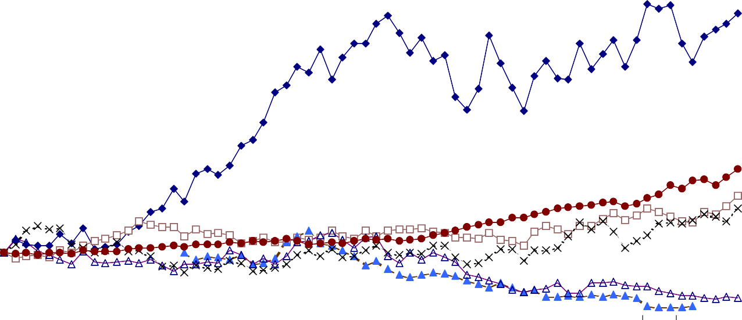Source: Casewriter, based on CRSP (Center for Research in Security Prices, University of Chicago) data.

BUILDERS SQUARE: SELECT INCOME STATEMENT AND BALANCE SHEET DATA (1)

Year | 1992 | 1993 | 1994 | 1995 | 1996
Number of Stores
Builders Square I | 165 | 123 | 75 | 57 | 53
Builders Square II | - | 54 | 91 | 110 | 109
Total | 165 | 177 | 166 | 167 | 162
($ Millions)
Sales | 2,419 | 2,719 | 2,951 | 2,676 | 2,550 ⁽²⁾
Comparable Store Sales (%) | 8.5% | 0.9% | 5.9% | 8.7% | *
Cost of Goods Sold | * | * | 2,300 | 2,118 | 2,026
Selling, General and Administrative Expenses | * | * | * | 575 | 519
Store Opening Costs | * | * | 24 | 8 | 1
Store restructuring and other charges | - | (226) (4 | ) - | (370) | (3) -
Charge, net of taxes | - | (141) | - | (240) | -
Operating Income (Loss), excluding extraordinary | 81 | 60 | 28 | (17) | 5
Operating Income (Loss) | 81 | (166) | 28 | (387) | 5
Net Interest Expense | (4) | (9) | (15) | (12) | (13)
Income (Loss) from Continuing Retail Operations | 77 | (175) | 13 | (399) | (8)
Net Income (loss) | * | * | 6 | (261) | (6)
Additional
Cash | * | * | * | 12 | 19
Net Working Capital ⁽⁵⁾ | * | * | * | 579 | 540
Capital Expenditures ⁽⁶⁾ | 57 | 112 | 104 | 38 | 8
Depreciation and Amortization | 30 | 35 | 39 | 46 | 1
Total Assets | 877 | 1,130 | 1,211 | 968 | 902
* Not Reported
- Source: Kmart and Hechinger public filings.
- In 1996, the average store size and average sales per store for Builders Square I and II stores were 75,000 and 100,000 square feet, and $13.1 and $15.8 million, respectively.
- Adoption of FAS 121 “Accounting for the Impairment of Long-Lived Assets and for Long-Lived Assets to be Disposed of.”
- Portion of Kmart’s 1993 $1.35 billion restructuring plan attributed to converting BSQ stores to the new BSQ II format.
- Net working capital is defined as current assets minus current liabilities, and in 1996, inventory, accounts receivable and accounts payable were $610MM, $18.5MM, and $218MM, respectively.
- In 1996, property, plant, and equipment, net of depreciation, totaled $283MM.

200-044 Kmart Inc. and Builders Square

Exhibit 5(B)

Builders Square, Inc.—Financial Statements Balance Sheet (dollars in millions)
January 28, 1996 January 25, 1997

ASSETS
Current Assets:
Cash $ 12.2 $ 18.9
Merchandise inventories 612.8 609.7
Accounts receivable and other current assets 63.8 18.5
Deferred income taxes 26.1 9.8
Property held for resale 144.0 140.1
Total current assets $858.9 $797.0
Property Owned:
Land 2.6 2.6
Buildings 6.0 6.0
Leasehold improvements 107.7 123.1
Furniture and fixtures 267.1 272.6
Construction in progress 13.9 1.0
Property under capital leases 133.4 108.9
$530.7 $514.2
Less—accumulated depreciation and amortization:
Property owned (157.8) (205.4)
Property under capital leases (34.1) (25.8)
Total owned and leased property $338.8 $283.0
Other assets and deferred charges 6.78 11.4
Deferred income taxes 109.0 91.8
Goodwill—net of accumulated amortizationa 24.4 23.6
Allowance for impairment (369.9) (305.0)
$967.9 $901.8

LIABILITIES AND PARENT COMPANY INVESTMENT
Current Liabilities:
Current portion of long-term obligations $ 3.7 $ 3.4
Accounts payable—trade 190.4 217.9
Accrued payrolls and other liabilities 63.7 30.3
Taxes other than income taxes 12.5 5.0
Total current liabilities $270.3 $256.6
Capital lease obligations 107.5 96.2
Long-term debt 12.7 12.5
Other long-term liabilities 38.5 34.0
Total liabilities $429.0 $399.3
Parent company investment 538.9 502.5
$967.9 $901.8

Source: Leonard Green & Partners.
aGoodwill is defined as the excess of cost over the fair value of net assets of Builders Square, Inc. as of the September 23, 1984 date of the acquisition by Kmart Corporation. Goodwill was capitalized and is being amortized over 40 years using the straight-line method. Builders Square, Inc. evaluates the recoverability of goodwill and reviews the amortization period on an annual basis. Several factors are used to evaluate goodwill, including but not limited to: management’s plans for future operations, recent operating results, and projected, undiscounted cash flows.

16

Kmart Inc. and Builders Square 200-044
Exhibit 6 (A)
HECHINGER: HISTORICAL FINANCIAL INFORMATION

For 13-weeks ended
Fiscal Year Ending January 31 | 1993 | 1994 | 1995 | 1996 3-May-97
($millions)
Sales | 2,095 | 2,450 | 2,253 | 2,199 508
COGS | 1,595 | 1,856 | 1,738 | 1,744 | 405
SG&A | 412 | 469 | 453 | 443 | 106
Depreciation | 37 | 53 | 59 | 57 | 14
Interest Expense | 28 | 33 | 34 | 40 | 11
Store Closing and Restructuring Charges | * | 62 | 25 | - | 32
Impairment of Long-Lived Assets | * | - | 30 | - | -
Taxes 11 (6) (3) 0 -
Net Income | 25 | (10) | (78) | (25) | (54)
Cash | 20 | 26 | 36 | 37 | 45
Net Working Capital ⁽¹⁾ | 327 | 274 | 213 | 210 | 206
Current Portion of Long-Term Debt
and Capital Lease Obligations | 3.0 | 3.5 | 3.8 | 3.7 | 3.4
Long-Term Debt and
Capital Lease Obligations ⁽²⁾ | 408 | 403 | 400 | 394 | 394
PP&E (net of depreciation) | 483 | 504 | 498 | 462 | 454
Total Assets | 1,229 | 1,261 | 1,150 | 1,105 | 1,158
Additional Information:
Number of Stores | 125 | 133 | 118 | 117 | 117
Capital Expenditures | 163 | 171 | 99 | 20 | 5
Shares Outstanding as of 7/16/97 (MM)
Class A | 33.0
Class B | 9.6
Share price as of 7/16/97 ($)  Class A | 2.125
Class B | 3.000
Beta | 0.54
Annual Volatility ⁽³⁾ | 80.55%
Debt Rating | B
* Not Reported
Source: Hechinger public filings.
(1) Net working capital is defined as current assets minus current liabilities, and in 1996, inventory and accounts receivable were $492MM and $291MM, respectively.
(2) As of February 1, 1997, the book and market values of Hechinger's long-term debt were $381 million and $200 million, respectively.
(3) Calculated using data from January to July 1997.

17

For the exclusive use of H. Xu, 2020.
200-044 -18-
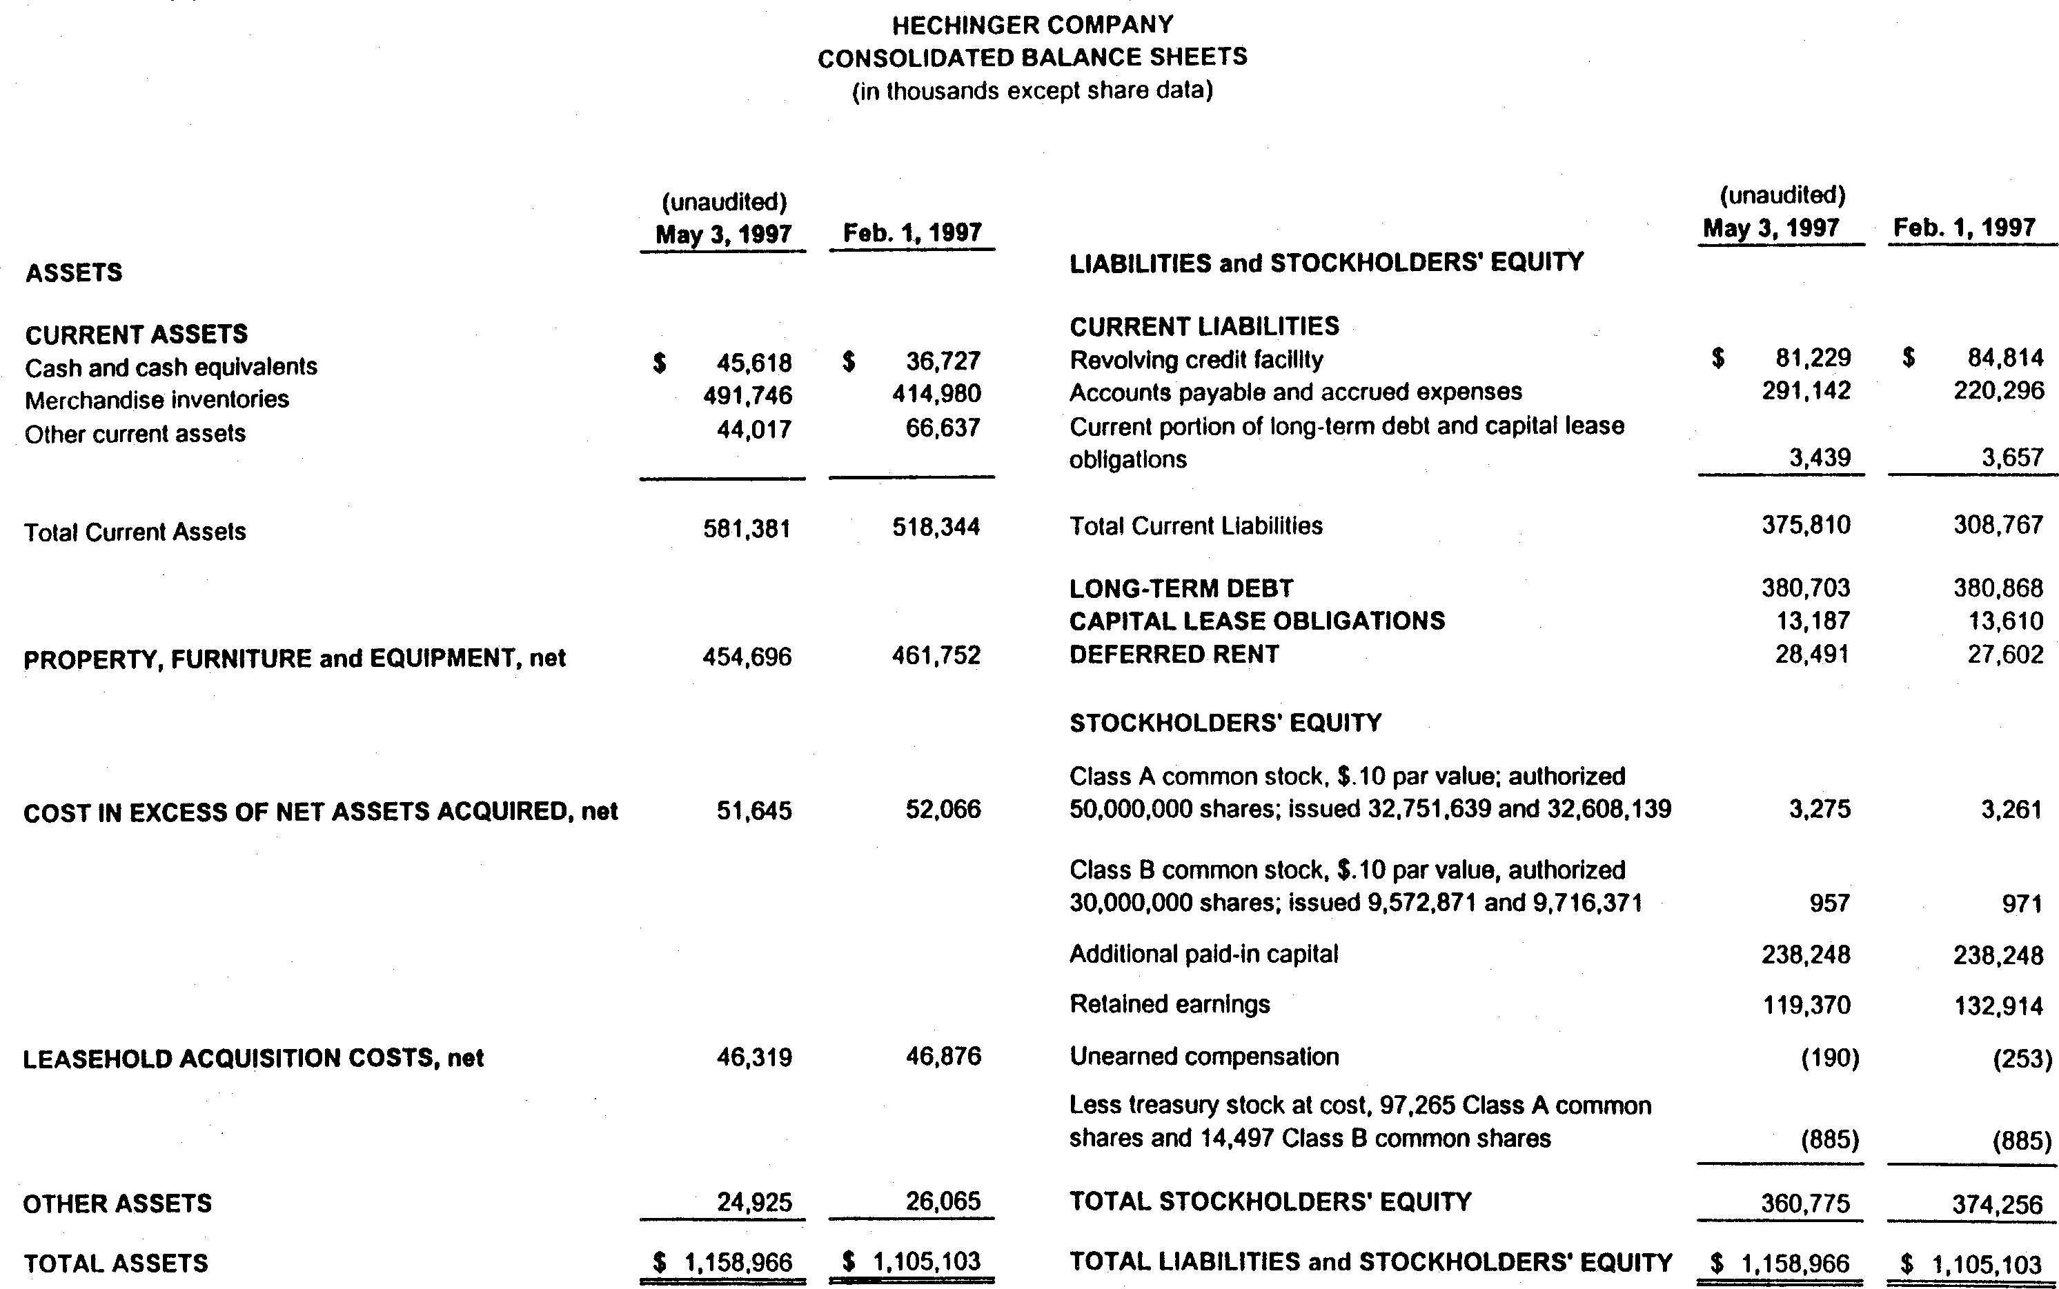
Source: Hechinger Public Filings.

.

Kmart Inc. and Builders Square 200-044
Exhibit 7
BSQ LEASE OBLIGATIONS
"At September 27, 1997, the minimum fixed rental commitments related to all noncancelable leases together with the present value of the net minimum lease payment for capital leases were as follows:"(1)
Operating Leases ($ thousands)

Total Operating Lease
Fiscal Year Payments
1998 | $ | 109,895
1999 | $ | 109,027
2000 | $ | 108,774
2001 | $ | 107,846
2002 | $ | 100,147
Thereafter | $ | 1,476,289
Total minimum lease payments | $ | 2,011,978

Capital Leases ($ thousands)

Total Capital Lease
Fiscal Year Payments
1998 | $ | 9,021
1999 | $ | 9,021
2000 | $ | 9,020
2001 | $ | 9,021
2002 | $ | 9,020
Thereafter | $ | 123,550
Total minimum lease payments | $ | 168,653
Less executory costs & imputed interest $ (101,278)
Present value of net minimum lease
payments (including current portion)(2) $ 67,375

Operating lease:

Capital lease:
A lease, normally involving equipment, whereby the contract is written for considerably less than the life of the equipment and the lessor handles all maintenance and servicing; also called a service lease. Common examples of equipment financed with operating
leases are office copiers, computers, automobiles, and trucks.⁽³⁾

A lease that under Statement 13 of the Financial Accounting Standards Board must be reflected on a company's balance sheet as an asset and corresponding liability. Generally, this applies to leases where the lessee acquires esentially all of the economic benefits and risks of the leased property.

(1) Source: Public filings.
(2) As reported in Kmart's 1997 Annual Report, Note 7: "Other Commitments and Contingencies", Kmart used a 7% discount rate in calculating the present value of all outstanding lease commitments.
(3) Downes, John and Jordan Elliot Goodman, ed., Dictionary of Finance and Investment Terms , Fifth Edition (Barron's Educational Series, Inc. 1998).

19

  - Kmart Inc. and Builders Square

Exhibit 8
July 1997 Bond Yields and Debt Ratings

10-Year Corporate Bond Yields | Rating | % Yieldª
 | AAA | 6.32
 | AA | 6.35
 | A | 6.48
 | BBB | 6.65
 | BB | 7.24
 | B | 8.37
 | CCC | 13.18
Debt Ratings
Kmart | BB
Home Depot | AA-
Lowes Cos. | A
Hechinger Payless Cashway | B  B-
HomeBase | BB+
Source: Bloomberg
aAs of July 1997, the three- and twelve-month LIBOR rates were 5.74% and 5.99%, respectively.

Exhibit 9
BUILDERS SQUARE - HECHINGER MERGER
PROPOSED FINANCING SOURCES AND USES FOR BUYOUT TRANSACTION

($MM)
Sources |  | Uses
Cash on Hand | 82.3 | Purchase Hechinger Common | 128.4
Revolving Credit Facility | 262.8 | Purchase BSQ Equity | 10.0
LGP Equity | 25.0 | Refinance Existing Debt | 126.8
 |  | Funding of A/R Buildup | 47.7
 |  | Hechinger & BSQ Severance | 27.3
 |  | Transaction Fees & Expenses | 30.0
Total | 370.2 | Total | 370.2

Source: Leonard Green & Partners

20

Kmart Inc. and Builders Square 200-044

Exhibit 10
COMBINED PROJECTIONS FOR PROPOSED BUIILDERS SQUARE - HECHINGER MERGER
Fiscal Year Ending January 31

Year | 1997 | 1998E | 1999E | 2000E | 2001E
Revenues ($MM)
Builders Square Base ⁽¹⁾ | 2,416 | 2,464 | 2,514 | 2,564 | 2,615
Hechinger & HQ Base ⁽¹⁾ | 2,199 | 2,234 | 2,279 | 2,325 | 2,371
Builders Square Impact of Competitive Openings ⁽⁴⁾ | 0 | (114) | (213) | (267) | (311)
Hechinger & HQ Impact of Competitive Openings ⁽⁴⁾ | 0 | (148) | (237) | (305) | (357)
Effect of Closed Stores 0 0 (379) (489) (499)
Total Revenues | 4,615 | 4,437 | 3,964 | 3,826 | 3,819
Gross Profit Margin | 27% | 27% | 28% | 29% | 29%
Gross Profit 1,243 1,209 1,127 1,108 1,124
EBITDA | 80 | 53 | 74 | 81 | 95
Anticipated Cost Savings 0 48 48 65 77
EBITDA after Cost Savings | 80 | 101 | 122 | 146 | 172
EBITDA Margin after Cost Savings | 2% | 2% | 3% | 4% | 5%
Cash and Equivalents | (4) | (4) | (4) | (4) | (4)
Asset Sales Proceeds | NA | 67 | 115 | 13 | -
Capital Expenditures | NA | 60 | 48 | 35 | 35
Net Working Capital ⁽³⁾ | 635 | 601 | 600 | 594 | 593
Cash Interest Expense | 69 | 69 | 61 | 53 | 48
Bank Debt | 265 | 287 | 207 | 151 | 76
Total Debt | 736 | 736 | 648 | 584 | 498
EBITDA after Savings/Cash Interest Expense | 1.2 | 1.5 | 2.0 | 2.7 | 3.6
EBITDA after Savings less Cap-X/Cash Interest Expense | NM | 0.6 | 1.2 | 2.1 | 2.9
Bank Debt /EBITDA after Savings | 3.3 | 2.9 | 1.7 | 1.0 | 0.4
Total Debt /EBITDA | 9.2 | 7.3 | 5.3 | 4.0 | 2.9
Source: Leonard Green & Partners
    - Assumes 2% revenue growth prior to impact of competitive store openings.
    - At fiscal-year-end 1996, Builders Square's 162 stores consisted of 53 Builders Square I stores and 109 Builders Square II stores. The average size and average sales per Builders Square I and II stores were 75,000 and 100,000 square feet, and $13.1 and $15.8 million, respectively.
    - At fiscal-year-end 1996, Hechinger's 117 stores consisted of 64 Hechinger stores, 52 HQ stores, and one Better Spaces store. The average size and sales per Hechinger and HQ store were 71,000 and 101,000 square feet, and $14.6 and $23.3 million, respectively.
    - The impact of anticipated new Big Box store openings on competing Builders Square and Hechinger store revenues between 1998 and 2001 was assumed to be -25%, -20%, -20%, and -15%, respectively.

21

For the exclusive use of H. Xu, 2020.
200-044 -22-

Exhibit 11

Identifying Comparable Companies
HOME DEPOT
LOWE'S
PAYLESS CASHWAYS
HECHINGER
BUILDERS SQUARE

Year | 1993 | 1994 | 1995 | 1996 | 1993 | 1994 | 1995 | 1996
Sales Growth (Annual) | 29% | 35% | 24% | 26% | 18% | 35% | 16% | 22%
EBIT/Sales | 8% | 8% | 8% | 8% | 5% | 6% | 6% | 6%
EBITDA/Sales | 9% | 9% | 9% | 9% | 7% | 8% | 8% | 8%
Stores | 264 | 340 | 423 | 512 | 311 | 336 | 365 | 402
Sales/Store ($MM) | 35 | 37 | 37 | 38 | 15 | 18 | 19 | 21
EBITDA/Store ($MM) | 3.3 | 3.4 | 3.3 | 3.5 | 1.0 | 1.5 | 1.5 | 1.8

Year | 1993 | 1994 | 1995 | 1996 | 1993 | 1994 | 1995 | 1996 | 1993 | 1994 | 1995 | 1996
Sales Growth (Annual) | 4% | 5% | -2% | -1% | 12% | 17% | -8% | -2% | 12% | 9% | -9% | -5%
EBIT/Sales | 4% | 6% | -3% | 0% | 3% | 1% | -2% | 1% | -1% | 1% | -5% | 0.2%
EBITDA/Sales | 6% | 8% | 0% | 2% | 5% | 3% | 1% | 3% | 0.4% | 2% | -4% | 0.22%
Stores | 196 | 202 | 206 | 192 | 125 | 133 | 118 | 117 | 177 | 166 | 169 | 164
Sales/Store ($MM) | 13 | 13 | 13 | 14 | 17 | 18 | 19 | 19 | 15 | 18 | 16 | 16
EBITDA/Store ($MM) | 0.8 | 1.0 | (0.1) | 0.3 | 0.8 | 0.5 | 0.1 | 0.6 | 0.06 | 0.40 | (0.60) | 2.38

Source: Public filings. For Builders Square, Kmart's annual reports

Exhibit 12 COMPETITIVE ENVIRONMENT
Number of Stores at Fiscal Year End (January 31)

Year | 1996 | 1997 | 1998E
Builder Square - total stores | 163 | 162 | 162
Number competing against Home Depot | 91 | 117 | 134
Percent competing against Home Depot | 56% | 72% | 83%
Hechinger - total stores | 64 | 64 | 64
Number competing against Home Depot | 40 | 51 | 54
Percent competing against Home Depot | 63% | 80% | 84%
Percent competing against other Big Box competitor | 75% | 84% | 88%
HQ - total stores | 53 | 53 | 53
Number competing against Home Depot | 27 | 37 | 44
Percent competing against Home Depot | 51% | 70% | 83%
Percent competing against other Big Box competitor | 87% | 94% | 96%

Source: Leonard Green & Partners.

23

200-044 Kmart Inc. and Builders Square

Exhibit 13 Hechinger/HQ Store Locations
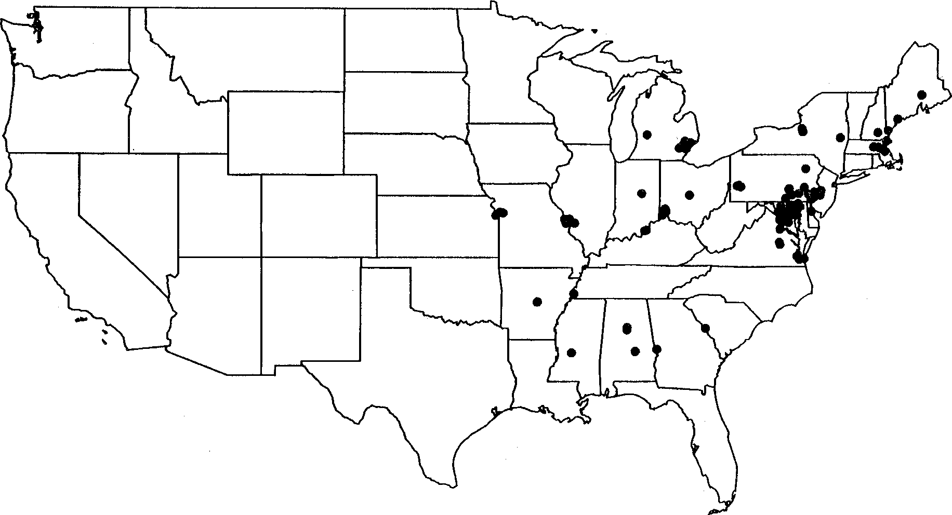

Builders Square Locations
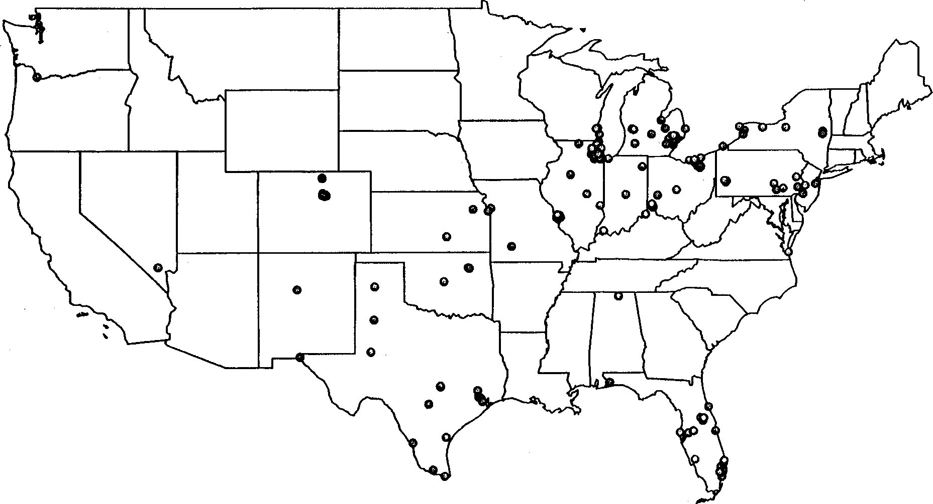
Source: Leonard Green & Partners.

24

Kmart Inc. and Builders Square 200-044

Exhibit 14

KMART LEASE GUARANTEES
FOR THE FORMER "SPECIALTY RETAILING GROUP"

"Kmart has outstanding guarantees for property leased by certain formerly owned subsidiaries as follows:"

 | Present Value (7%) |  | Gross Lease
 | 1997 | 1997 |  | 1996
($MM)  Furr's | 134 | 193 |  | 199
Borders Group | 114 | 205 |  | 218
Office Max | 111 | 168 |  | 186
The Sports Authority | 250 | 424 |  | 453
Builders Square | 849 | 1,568 |  | 1,655
Total | 1,458 | 2,558 |  | 2,711

Source: Kmart 1997 Annual Report, Note 7: "Other Commitments and Contingencies"

25

