HMD 407: HOSPITALITY ORGANIZATION BEHAVIOR
Exercise 4: Individual Culture Case Study [10 points]

Please work on this exercise individually.

Your names and student ID numbers:
Your names | Student ID numbers

Purpose: The purpose of this exercise is for you to apply the Hofstede culture dimensions to understand employee’s service behaviors.

Overview:


The Shangri-La story began in 1971 with our first deluxe hotel in Singapore. Inspired by the legendary land featured in James Hilton's 1933 novel, Lost Horizon, the name Shangri-La encapsulates the serenity and service for which our hotels and resorts are renowned worldwide. Today, Hong Kong-based Shangri-La Hotels and Resorts is Asia Pacific's leading luxury hotel group. They are also regarded as one of the world’s finest hotel ownership and management companies. Owning and/or managing over 95 hotels and resorts throughout the Asia Pacific, North America, the Middle East, and Europe, the Shangri-La group has a room inventory of over 40,000.

One thing special about Shangri-la Hotels is their service standard - they ask their employees to serve guests tea/ menu kneeling down. Kneel down service is a service style practiced across all Shangri-La’s as it is reminiscent of our Chinese roots on how tea is served. Guests love this special treatment. Shangri-La has implemented this service in China. However, Shangri-La faced a problem of asking their employees to implement this service standard when they first open their hotel in Australia.

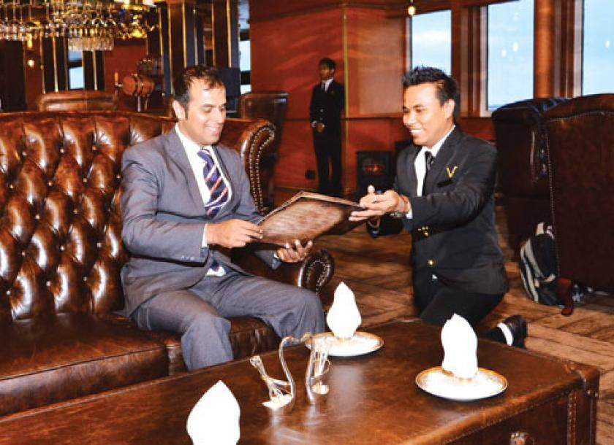
Consider one Hofstede culture value, explain why Australia employee, compare to Chinese employees, are more likely to resist and refuse to implement the kneel-down service.

Check culture value score at https://www.hofstede-insights.com/product/compare-countries/

Question:
- Pick ONE cultural value – you will focus on applying this cultural value to this case for this exercise
Individualism/ Collectivism
Power distance
Masculinity
Uncertainty avoidance
Short term/ Long term orientation

- Define the culture value in Q1. (1 points)

- What is the cultural value score for China and Australia, respectively? (2 points)
Country | Score
China
Australia

- Does China or Australia have a higher cultural value score? (1 point)
China
Australia

- What is the implication of the cultural value in Q3 for Chinese and Australian, respectively (2 points)

- Based on the cultural difference in Q3, explain Australia employees’ and Chinese employees’ differential attitudes towards kneel-down service? (4 points)

