BA 4101 – Global Business Policies
Strategic Analysis
Templates
For Homework & Case Assignments
Note:
- From the case information we may not be able to fill in every data cell.
- Consider what is known and what is most important.
- These formats are intended as starting points, they may be adapted to specific case situations. Take care to maintain the key concepts of the analysis framework.

Summary of Frameworks and Purposes
Name | A.k.a. | Internal/ external | Main Purpose
Stakeholder analysis |  | internal & external | Determine who the main stakeholders are. Evaluate whether specific stakeholders may withdraw their commitment.
General environment |  | external (general) | Determine the main opportunities and threats from the general environment of the firm.
Industry-level analysis | Porter’s 5 forces | external (industry) | Evaluate the industry attractiveness. Determine the potential threats from within the industry.
Internal analysis | Resource Based View | internal | Evaluate the strengths and weaknesses of the firm. Determine whether there is a sustainable competitive advantage.
Business-level strategies | Porter’s generic strategies | internal | Description of the strategy (value proposition). How does the firm (or business unit) want to position itself? How does the firm outperform its competitors?
Value-chain analysis |  | internal & external | Determine the main primary and support activities. Consider what activities could be outsourced.
SWOT analysis |  | internal & external | Use an analysis of the external opportunities and threats (general & industry environment) and the internal strengths and weaknesses (RBV) to determine the strategic intent and mission. Good as a summary of analyses.
2
Name: __________________________________ Class Time: ____________
The General Environment (Threats & Opportunities)
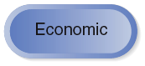
  Environment | Threat (& why?) | Opportunity (& why?)
  Economic
  Demographic
  Political / Legal
  Technological
  Sociocultural
  Global
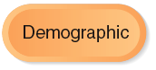
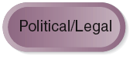




Porter’s Five Forces Time: ____________ Industry Level Analysis
4
Threat of
Potential
Entrants
Bargaining Power
of Buyers
Bargaining Power
of
Suppliers
Threat of
Substitutes
Rivalry Between Competitors
•
Identify Competitors and intensity
of Rivalry amongst competitors.
•
Briefly explain.
•
Identify Buyers and
Bargaining Power of each.
•
Briefly explain.
What business segment or industry is being considered:
___________________________________________
•
Identify Suppliers and
Bargaining Power of each.
•
Briefly explain.
•
Identify Substitutes and
the threat level of each.
•
Briefly explain
•
Identify Potential Entrants and
the threat level of each.
•
Briefly explain.
How attractive is this industry?
Briefly explain why.
Process steps:
1.
Identify industry or segment boundaries.
2.
Identify players in each Force using case facts.
3.
Assess level of threat, power, intensity of each Force
using case facts and course concepts.
4.
Make final assessment of how attractive the industry
is in which to compete, using results of 5 Forces
analysis to support your view.
5.
Identify the strategic implications for the firm.
___________________________________________
Name: __________________________________

The Resource Based View Class Time: ____________ Internal Analysis
Resource/ Capability
Valuable
Rare
Costly to
Imitate
Non
-
sub
-
stitutable
Competitive
Consequence
Does the firm have a sustainable competitive advantage? Briefly explain, why or why not?
___________________________________________
Five Business- Time: ____________
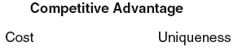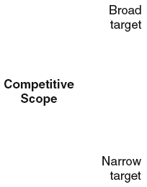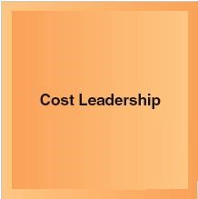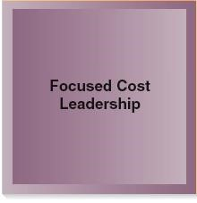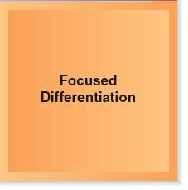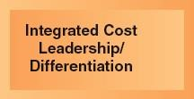Level Strategies
Figure 4.1
Which strategy was selected?
_________________________________
Why do you believe so?
____________________ ….
What business segment or industry?
_______________________________

Value Chain Activities
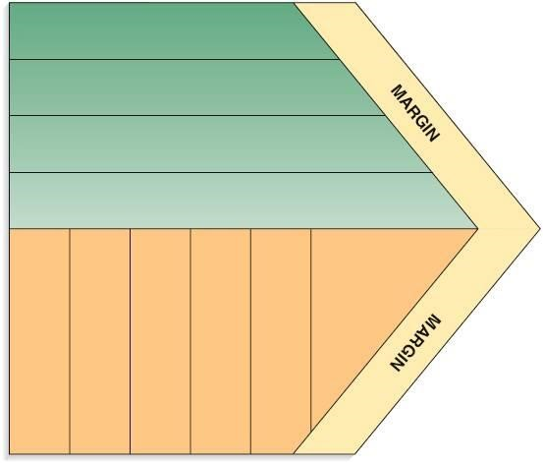
Inbound Logistics
Operations
Outbound Logistics
Marketing and Sales
Service
Firm Infrastructure
Human Resource Management
Technological Development
Procurement
Primary Activities
Each activity should
be examined relative
to competitors’
abilities. Accordingly,
firms rate each
activity as
superior,
equivalent,
or
inferior
to others
.
From this analysis
recommendations
can be made.

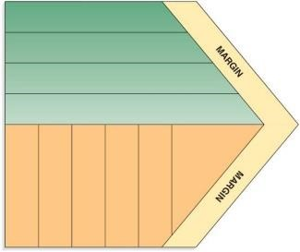
Time: ____________ Value Chain Assessment
Inbound Logistics
Operations
Outbound Logistics
Marketing and Sales
Service
Firm Infrastructure
Human Resource Management
Technological Development
Procurement
Primary Activities
Value Chain Category | Observed Activity* | Rating  (S, E, I) | Recommendation
Primary
Inbound Logistics
Operations
Outbound Logistics
Marketing and Sales
Service
Support
Firm Infrastructure
Human Resource Management
Technological Development
Procurement
* Observed activity may include Note: Other columns may be added as needed for case analysis.
capability, approach, etc. The “recommendation” column is not required for homework 4.
** Rate activity superior, equivalent, or S, E, I = superior, equivalent, or inferior inferior relative to competitors
Name: __________________________________
Class Time: ____________

Stakeholder Analysis
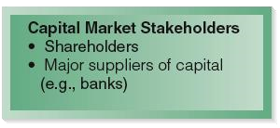
  Stakeholders | Wants/Needs? | Impact level on your outcome * | Implications /  Recommendations
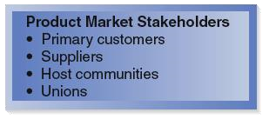
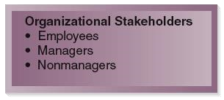
* Many other areas might be assessed (power, risk, importance, etc)

