The Struggle for Civil Rights
From the earliest colonial days, American history has been haunted by the specter of African slavery. Even after its legal abolition in 1865 America's "original sin," as James Madison first called it, lived on through a deeply entrenched system of legal, social, and economic discrimination against African Americans. (Madison, 1820)
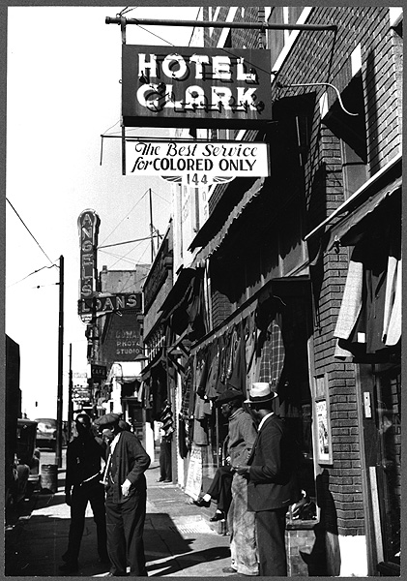
(Click button for citation) 
The movement to overturn that systemic discrimination has been ongoing for more than 150 years. The most blatant form of racial discrimination—the system of de juresegregation* enacted in the South, which legally required the discriminatory treatment of African Americans—was essentially abolished by federal legislation, including the Voting Rights Act, in the 1960s. But the problem of de factosegregation* has long been a fact of life not only in the South but throughout the nation.
It continued—in the segregated schools of cities such as Boston, and the segregated housing markets of cities such as Chicago and Los Angeles—long after the legal and political battles of the modern Civil Rights Movement* had ended. While African Americans, as a group, have made significant gains in income and educational attainment over the last 50 years, de facto segregation continues to affect many aspects of American life. (U.S. Census Bureau, 2012; National Center for Education Statistics, 2012)
In this theme, we will focus on the modern Civil Rights Movement, looking at efforts to affirm and expand African-American rights in two specific areas that have been central to the overall civil rights struggle: voting and public education. The fight to end the disenfranchisement of African-American voters and secure their right to vote, free from intimidation and legal obstruction, culminated with the passage of the Voting Rights Act in 1965. The struggle to desegregate public schools and win equal educational opportunities for African-American children—first affirmed in the landmark Supreme Court case, Brown v. Board of Education (1954)*—has continued for generations. In this theme, we will look specifically at the tumultuous and emotionally charged effort to desegregate Boston's public schools in the mid-1970s.
We will use these two case studies to examine the historical concept of contingency*and to learn how to use historical evidence* to draw conclusions about the impact of historical events on American society, through the process of historical analysis*.

The Early Struggle for Civil Rights
The end of the Civil War brought the legal abolition of slavery by the Thirteenth Amendment, the first of the three so-called Civil War Amendments*. But the end of slavery did not bring equality for the former slaves.
While the southern states had to ratify the Thirteenth Amendment as a condition of their readmission to the Union, most of them quickly enacted laws to close off opportunities to the newly freed slaves and deny them the rights of citizenship. The postwar Black Codes*—based on older southern laws that sought to limit the freedoms of freed blacks in the years before the Civil War—barred African Americans from voting, denied them most legal rights, and restricted their ability to find work outside of plantations. Such laws laid the groundwork for the later Jim Crow laws, which institutionalized segregation in all walks of life throughout the South. (Dunning, 1907)
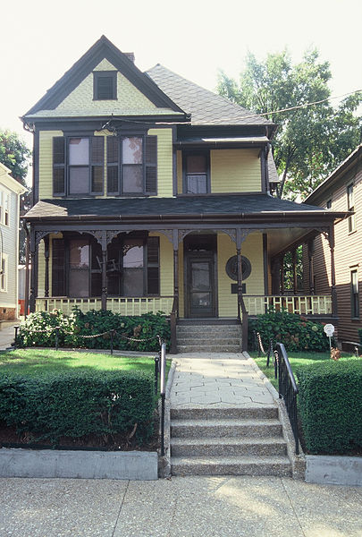
The house in Atlanta where Martin Luther King Jr. was born is now part of the Martin Luther King Jr. National Historic Site. Click on the image above to go to the National Park Service's "Historic Places of the Civil Rights Movement" website. (Click button for citation) 
In response to the Black Codes, Congress passed the Civil Rights Act of 1866, which formally made African Americans citizens. To further safeguard the citizenship rights of the freed slaves, Congress passed the Fourteenth Amendment, which was ratified in 1868. The Reconstruction Acts, passed in 1867 and 1868, essentially placed the southern states under military rule for a decade, allowing for a brief period in which freed African Americans in the South enjoyed political rights.
The profound significance of the Fourteenth Amendment was that, through its Equal Protection and Due Process clauses, it prohibited the states from abridging the rights and liberties guaranteed to all citizens under the Constitution. In reality, however, for African Americans through the end of the 19th century (and well beyond), the promise of equal protection and due process went unrealized. The southern states flouted the Fourteenth Amendment, and the Supreme Court refused to interpret it as making the Bill of Rights binding on the states. (Foner, 1988)
The Black Codes also led Congress to pass the Fifteenth Amendment (ratified in 1870), which guaranteed African Americans the right to vote. It did so by decreeing that citizens' right to vote could not be denied or abridged based on race, color, or prior slave status. Despite the Fifteenth Amendment, southern states continued to deprive blacks of their voting rights by imposing voter-qualification restrictions (e.g., literacy tests and property-ownership requirements) that effectively disenfranchised African Americans. (Valelly, 2009)
The Fifteenth Amendment divided the pioneering women's rights movement, which sought the franchise for women as well as for African Americans. As we saw in Theme: Communicating Historical Ideas, some leaders in the nascent woman suffrage movement opposed ratification of the Fifteenth Amendment because it did not also extend the voting right to women. Women did not gain the right to vote until ratification of the Nineteenth Amendment in 1920.
Jim Crow Laws and the Segregated South
Unyielding southern resistance to black equality led Congress to pass the Civil Rights Act of 1875, which prohibited racial segregation in public accommodations such as hotels, restaurants, and transportation. It also barred the exclusion of African Americans from jury service. But when the federal government ended its military occupation of the South in 1877, marking the end of Reconstruction*, the southern states further defied federal efforts to guarantee the civil rights of blacks. (Foner, 1988)
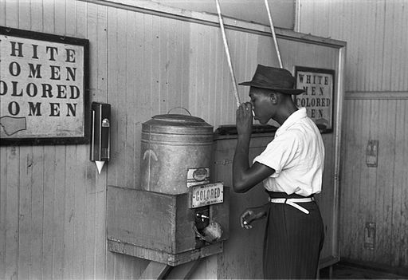
"Colored" water cooler in streetcar terminal, Oklahoma City, Oklahoma, 1939. (Click button for citation)
Southern state legislatures enacted Jim Crow laws*, which discriminated against African Americans by requiring racial segregation of schools, restaurants, hotels, theaters, and other public accommodations. Under Jim Crow laws, the southern states created separate facilities for whites and blacks in every walk of life, covering all public accommodations. This institutionalization of race-based separation throughout the South, which endured for a hundred years after the Civil War, was known as de jure segregation* because it was backed by law.
After Reconstruction, African Americans throughout the South faced state legal systems that denied them equal justice and routinely violated their due-process rights. The courts and law enforcement in the South abided lynching* and other white mob violence committed against blacks. And the federal courts, well into the 1900s, proved unwilling or unable to uphold the civil rights of blacks. (Equal Justice Initiative, 2015)
Disenfranchisement Despite the Fifteenth Amendment
After Reconstruction, the southern states devised obstacles to block African Americans from voting despite the Fifteenth Amendment, which decreed that the right to vote could not be denied on the basis of race or color. To circumvent the Fifteenth Amendment's intent, southern states employed devices for determining voter eligibility which, though not expressly racial, had the particular effect of disenfranchising blacks, who were overwhelmingly poor and uneducated.
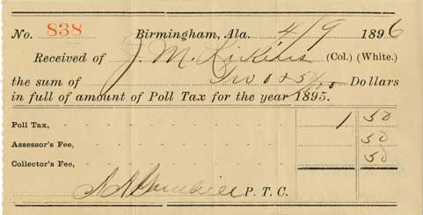
A poll tax receipt. Image courtesy of the African American Intellectual History Society.
These devices included literacy tests, poll taxes (a tax paid as a qualification for voting), and property-ownership requirements. Many states in the South also imposed a so-called grandfather clause, which restricted voting to those whose grandfathers had voted before Reconstruction (i.e., pre 1867). Grandfather clauses effectively denied the descendants of slaves the right to vote. (Valelly, 2009) All of these legally enacted devices represented forms of de jure segregation—as opposed to de facto segregation, which lacked the force of law.
Black disenfranchisement continued in one form or another throughout the South for a century after the Civil War.
Separate but Equal
Legal segregation in the South was validated by the Supreme Court in a landmark decision at the close of the 1800s. Homer Plessy, an African American, defied a Louisiana segregation law by riding in a "whites only" railroad car. He was arrested when he refused to move to a car reserved for blacks as mandated by the state law. Plessy challenged the constitutionality of the law on the grounds that segregation violated the equal protection clause of the Fourteenth Amendment.
The Supreme Court rejected this challenge, ruling in Plessy v. Ferguson (1896)* that state laws requiring racial segregation in public facilities are constitutional if the facilities are "separate but equal." The Court's decision ignored the fact that most facilities available to African Americans were not equal but vastly inferior; nonetheless, Plessy and the doctrine of "separate but equal" remained the law of the land for more than half a century. (Medley, 2003)

The Struggle for Civil Rights, 1900 – 1950
The first half of the 20th century saw limited progress in the fight to secure the civil rights of African Americans. Booker T. Washington, president of the Tuskegee Institute and the leading figure in the African-American community in the early 1900s, was an outspoken proponent of black education and entrepreneurship. But Washington was criticized within the African-American community for his strategic decision not to challenge Jim Crow laws* and the disenfranchisement of black voters directly.
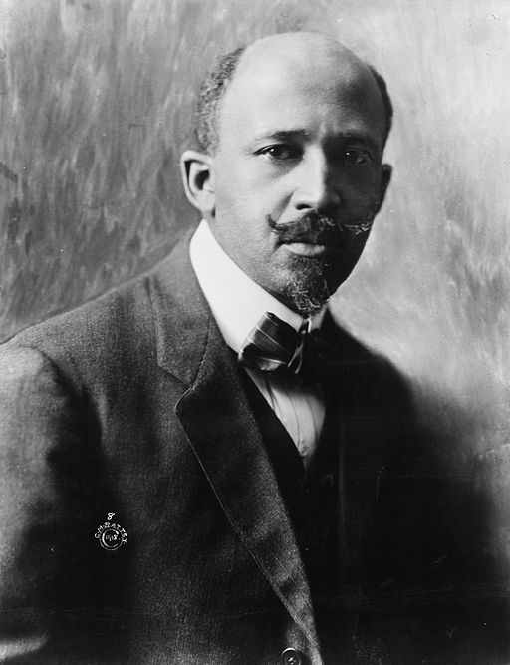
W.E.B. Du Bois, 1918. (Click button for citation)
More militant African-American leaders, including W.E.B. DuBois and Ida Wells, founded the National Association for the Advancement of Colored People (NAACP*) in 1909, with the mission of actively fighting against racial prejudice. The organization focused in its early years largely on efforts to prevent lynchings* in the South and on mounting legal challenges to Jim Crow legislation. (Finch, 1981)
The return of thousands of African-American veterans of World War I highlighted the huge divide between America's rhetorical commitment to democracy and individual freedom and the reality of segregation, disenfranchisement, and anti-black violence in the South. This gave rise to the New Negro movement*, which sparked the larger cultural and intellectual movement known as the Harlem Renaissance* (Gates, H.L., 1988)
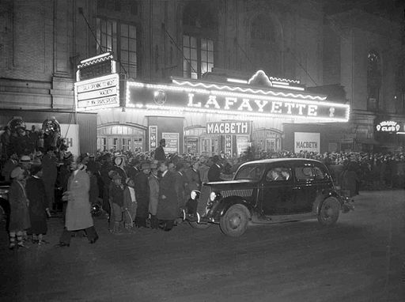
The Lafayette Theatre, Harlem, 1936. (Click button for citation)
Beginning shortly before World War I, the Great Migration* saw an estimated six million African Americans move from the deep South to the North, Midwest, and West over the next 60 years. Fleeing segregation and poverty, many of these African Americans found work in industrial cities such as Chicago, Detroit, and Gary, Indiana. While many African Americans had previously been suspicious of organized labor, A. Philip Randolph, head of the Brotherhood of Sleeping Car Porters, became the leading voice for black workers within the labor movement. As the number of African Americans working in industrial jobs swelled, organized labor became increasingly outspoken in its advocacy for black workers' rights; in the 1950s and 1960s, labor would be a powerful ally of the civil rights movement. (Lemann, 1992)
The Great Depression of the 1930s hit African Americans disproportionally hard; the collapse of cotton prices drove thousands of Southern sharecroppers to the brink (Thompson and Clarke, 1935), and the scarcity of factory jobs led to increased racial tensions in Northern industrial cities. The unemployment rate among African Americans was estimated to exceed 50 percent—more than twice the rate among whites. (Wolters, 1970)
African Americans, traditionally supporters of the Republican Party because of its historical opposition to slavery, were initially skeptical of Democrat Franklin Roosevelt, who had won the Presidency with strong backing from the South. Early New Deal*programs were not aimed toward the African-American community, and some, such as the Federal Housing Authority, initially reinforced existing patterns of segregation. But other programs, such as the Works Progress Administration and the Civilian Conservation Corps, provided jobs to substantial numbers of African Americans, especially in the North. By the end of the decade, many African Americans in the North were strongly behind the New Deal, and urban black voters began a major shift that would eventually make them an integral part of the Democratic electoral coalition. (Reed, 2008)
America's entry into World War II effectively ended the Depression, as factories geared up for the war effort. At the same, time, more than a million African Americans joined the armed forces; when they returned from war in 1945, they embodied the argument that African Americans were entitled to the same freedoms for which America had fought in Europe and the Pacific. (Taylor, 2014)
While resistance to the campaign for African-American civil rights was still deeply entrenched, the late 1940s saw a couple of notable victories: Jackie Robinson famously broke baseball's "Color Line"* in 1947, and in 1948, President Harry S Truman issued an executive order that desegregated the U.S. military. While these breakthroughs were largely symbolic, more substantive gains were just over the horizon.

The Modern Civil Rights Movement, 1954 – 1968
The NAACP's strategy of mounting legal challenges to Jim Crow laws* had produced minor gains in the first decades of the 20th century. In 1938, the Supreme Court sided with the NAACP in ruling that states that provide a law school for whites had to provide in-state legal education to African Americans as well. And in 1944, the Court struck down the "white primary" system that effectively barred African Americans from voting in Democratic primaries in the South.
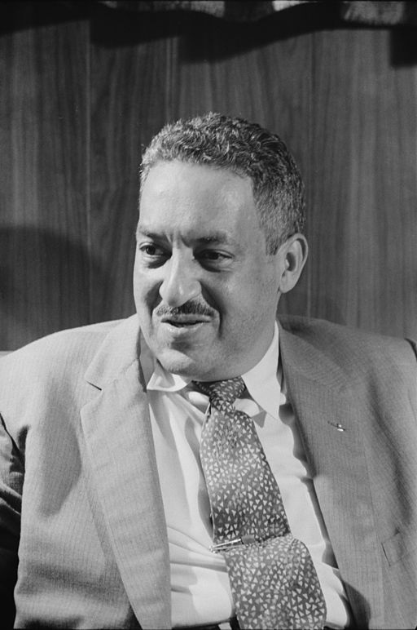
Thurgood Marshall, NAACP's chief counsel, who argued the case before the Supreme Court for the plaintiffs. (Click button for citation)
The greatest victory, however, came in a case involving public elementary and secondary schools. In Brown v. Board of Education (1954)*, the Supreme Court unanimously ruled that "separate educational facilities are inherently unequal"—overturning Plessy v. Ferguson (1896)* and ushering in an intense period of activism that would, within a generation, tear down the facade of legal segregation. (Cottrol et al, 2004)
Because of the magnitude of the Brown decision, many scholars consider 1954 to mark the beginning of the modern Civil Rights Movement*. During the roughly 15 years following Brown, a wide range of African-American leaders and organizations sought to galvanize American public opinion—and, as a result, political will—against the structures of de juresegregation* in the South: segregated schools, "whites only" lunch counters and restrooms, and separate "colored" sections on public buses, to name only a few.
The movement's tools were civil disobedience and nonviolent protests, including boycotts, sit-ins, and protest marches. Very often, nonviolent civil rights protesters met with violence at the hands of Southern law enforcement officers and civilians; some of these confrontations were covered on the network television news, and the images of police brutally beating peaceful protesters helped generate public sympathy and support for the cause of civil rights. (Bodroghkozy, 2012)
The modern Civil Rights Movement addressed a wide range of issues. While its immediate focus was on the South—the states of the former Confederacy, where segregation actually had the force of law—the movement sought to confront racial prejudice and injustice throughout American society. Click on the tabs below to learn more specifics about the civil rights movement.
Fifty years after the fact, societal perceptions of the modern civil rights movement tend to focus on a few heroic figures, such as Rosa Parks, Rev. Martin Luther King Jr., and Medgar Evers. And many students who did not live through the era may assume that the movement itself was unified and had a clear-cut agenda.
In fact, there were many prominent civil rights leaders, not all of whom agreed at any given time. And there were a multitude of civil rights organizations; the so-called Big Four included the Southern Christian Leadership Conference (SCLC*); the Congress of Racial Equality (CORE*); the Student Nonviolent Coordinating Committee (SNCC*); and the NAACP*, among many others. Some of these groups were more inclined to compete with each other than to cooperate.
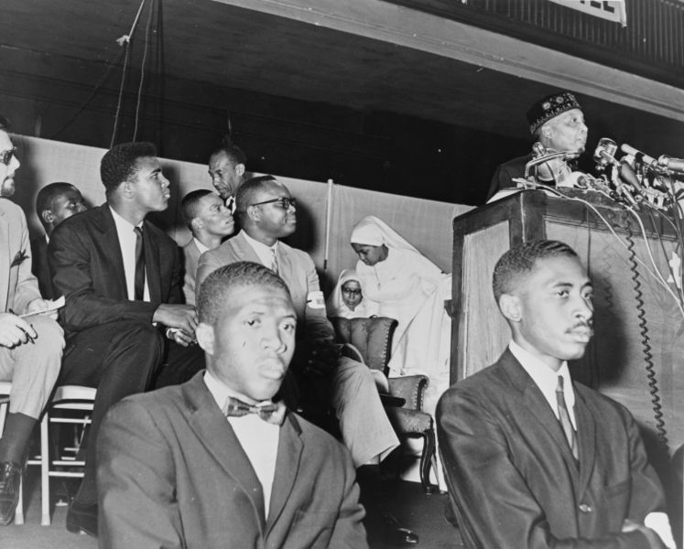
Elijah Muhammad, leader of the Nation of Islam, at the podium (right). At left is heavyweight champion Muhammad Ali, then known as Cassius Clay. (Click button for citation)
These groups had somewhat different agendas, with some more focused on voting rights, say, and others more focused on housing and economic issues. Nor did everyone in the movement agree on the principle of nonviolent protest; some leaders, such as Robert F. Williams of North Carolina, believed strongly that African Americans needed to arm themselves and fight back against anti-black violence. Other, more militant leaders, such as Elijah Muhammad of the Nation of Islam, rejected the philosophy of nonviolence and argued that African Americans should separate themselves completely from whites.
While it is not accurate to say that the civil rights movement had any one, single leader, it is nonetheless clear that the movement began to crumble after the assassination of Martin Luther King in April 1968. The loss of King as an eloquent advocate of nonviolent protest definitely hurt the movement. And perhaps more important, the wave of racial violence that convulsed many cities in the wake of King's death shattered whatever fragile political consensus might have been forming behind the idea of comprehensive reforms to address the root causes of racial discrimination and African-American poverty. (Garrow, 2004)
While the modern civil rights movement succeeded, in large measure, in bringing about the end of legal segregation in the Old South, the problems of racism and inequality—the legacy of "America's original sin"—have yet to be fully addressed.

