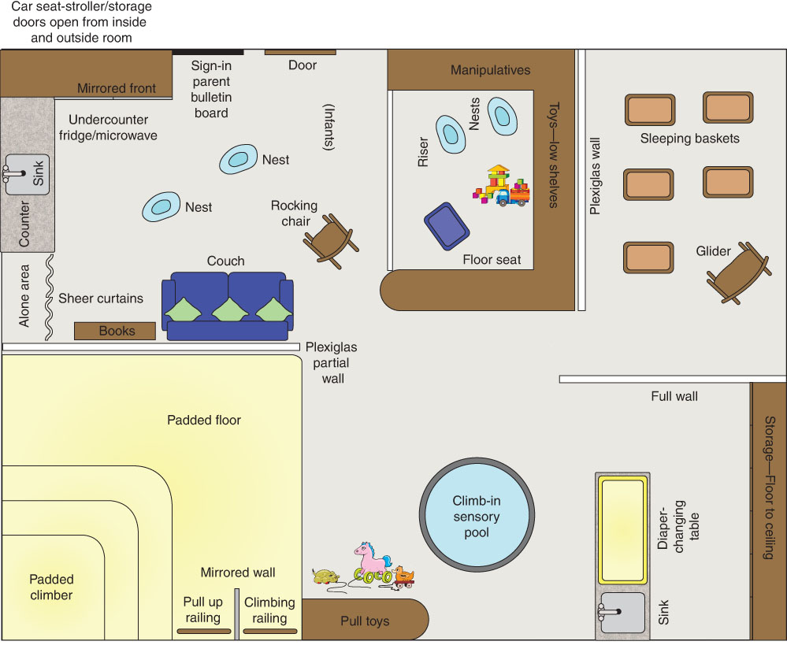
FIGURE 5.2 Infant Room Arrangement
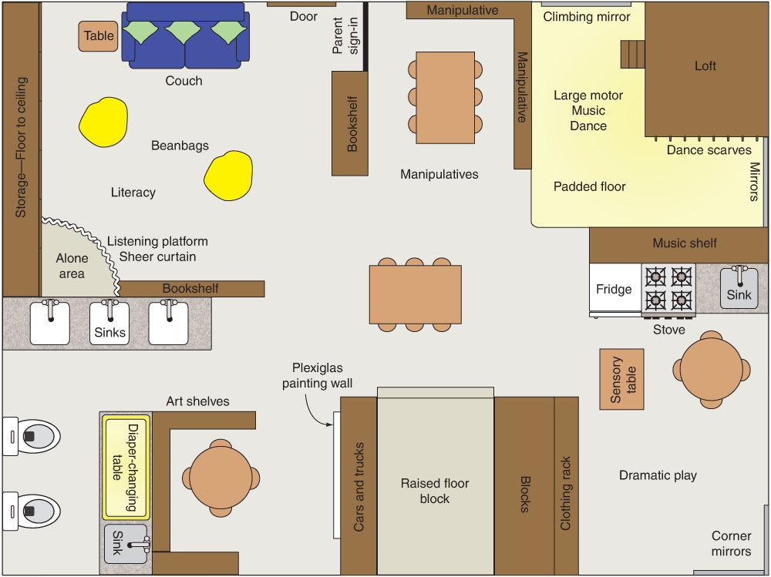
FIGURE 5.3 Toddler Room Arrangement
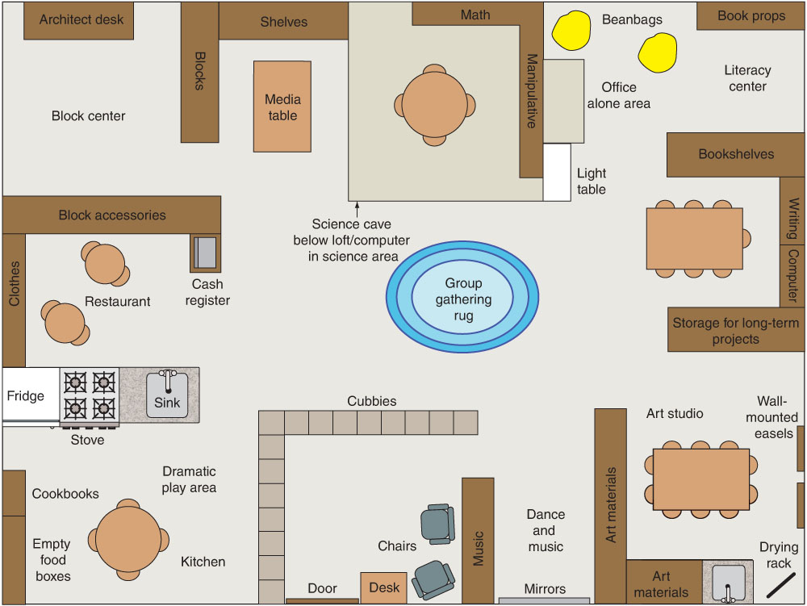
FIGURE 5.4 Preschool Room Arrangement

