American Government 2305
Homework Assignment #2A: Political Self-Exam and Assessment

For this homework assignment each student will take two online exams for purposes of measuring where they stand in the political world. The website for both exams is provided. Additionally, the instructor has included the results of their own test so the student knows what should be displayed once they successfully complete all the questions in the questionnaire.

Upon completion of the self-exams, write a summary report of the findings. The following information should be discussed in your report:

- Results of each exam with a description of the findings.
- Comparison of the two findings. For example, do they match? Are there differences in the two outcomes?
- An explanation of your interpretation; do you agree or disagree with the results? Do they match your political ideology? Why or why not?
- Would you change anything in either exam and, if so, what?
- Were these exams interesting and helpful in your self-assessment? In other words, did they provide you with a better understanding of your political views or, to the contrary, the information simply reinforced what you already knew?
- Would you recommend them to friends and family?

Please write your summary in twelve-point font, if typed, and double-space for instructor comments if necessary.

Let the instructor know if you have questions or need clarification.

Have fun!

EXAM #1

The Advocates for Self Government: http://www.theadvocates.org/quiz/quiz.php


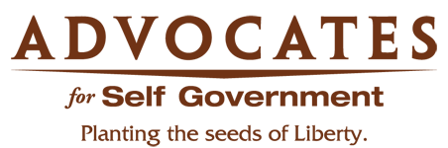

The World's Smallest Political Quiz
Thank you for taking The World's Smallest Political Quiz undefined. Below are your results!

The RED DOT on the Chart shows where you fit on the political map.
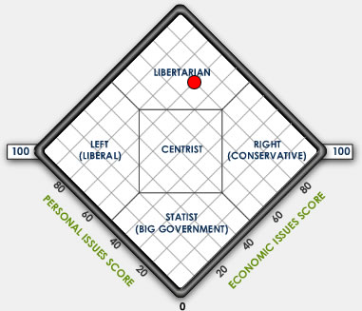

Your PERSONAL issues Score is 70%

Your ECONOMICS issues Score is 80%

This quiz has been taken 20,621,632 times

According to your answers, the political group that agrees with you most is...
LIBERTARIAN
Libertarians support maximum liberty in both personal and economic matters. They advocate a much smaller government; one that is limited to protecting individuals from coercion and violence. Libertarians tend to embrace individual responsibility, oppose government bureaucracy and taxes, promote private charity, tolerate diverse lifestyles, support the free market, and defend civil liberties.

“ The Quiz has gained respect as a valid measure of a person’s political leanings. ”Â  - The Washington Post  “ The World’s Smallest Political Quiz stands ready to help you determine your political identity. Quick and relatively painless. ”Â  - USA Today | “ The World’s Smallest Political Quiz is savvy and willing to tell you the truth. ”Â  - YAHOO! Magazine  “ Give this quiz a try. It’s fun, and who knows, you may be surprised at what you find. ”Â  - Politics on the Net by Bill Mann

Contents copyrighted © The Advocates for Self-Government, a nonprofit 501(c)(3) educational organization

EXAM #2
Political Compass: http://www.politicalcompass.org/test

International Chart: Instructor Results
http://www.politicalcompass.org/printablegraph?ec=7.12&soc=1.18

http://www.politicalcompass.org/crowdchart.php?showform=&Mitt+Romney=7.0%2C6.5&Barack+Obama=6.0%2C6.0&Virgil+Goode=9.0%2C9.0&Gary+Johnson=9.5%2C0.0&Rocky+Anderson=4.5%2C-2.0&Jill+Stein=-3.0%2C-3.0&Stewart+Alexander=-5.0%2C-2.0&You=7.12,1.18
A diverse professional team has assessed the words and actions of internationally known contemporary leaders to give you an idea of how they relate to each other on the political compass.
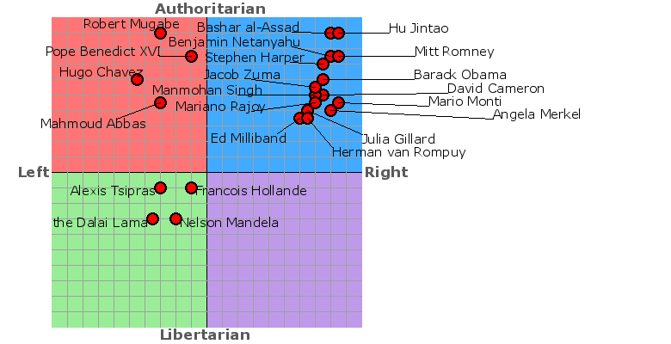

Your political compass

Economic Left/Right: 7.12
Social Libertarian/Authoritarian: 1.18

Mitt Romney 7.0,6.5
Barack Obama 6.0,6.0
Virgil Goode 9.0,9.0
Gary Johnson 9.5,0.0
Rocky Anderson 4.5,-2.0
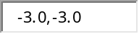Jill Stein -3.0,-3.0
Stewart Alexander -5.0,-2.0
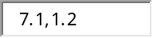You 7.1,1.2
