Research Paper Using Word 2010

This assignment has two goals: 1) have students increase their understanding of the concept of Protecting Personal Information (PPI) and other ethical issues related to the use of information technology through research, and 2) learn to correctly use the tools and techniques within Word to format a research paper including using Word 2010/2013/Office 365's citation tools. These skills will be valuable throughout a students’ academic career. The paper will require a title page, NO abstract, three to four full pages of content with incorporation of a minimum of 3 external resources from credible sourcesand a Works Cited/Reference page. Wikipedia and similar general information sites, blogsor discussion groups are not considered creditable sources for a research project. No more than 10% of the paper may be in the form of a direct citation from an external source.

A list of topics from which students can choose is provided below.
Topics for Research Paper

- Personally Identifiable Information (PII)
- Social Engineering
- Employee Monitoring
- Information Privacy
- Electronic Medical Records
- Biometrics (in terms of ethical and privacy issues)
- Identity Theft
- Use of Cookies
- Privacy Laws related to Information Technology use
- Intellectual Property Rights; Copyright

If there is another topic that addresses ethical issues as related to information technology that is of special interest to you but one that is not in the list above, request permission from your instructor before selecting this alternate topic.

Writing Quality for the Research Paper
* All Grammar, Verb Tenses, Pronouns, Spelling, Punctuation, and Writing Competency should be without error.

Be particularly careful about mis-matching a noun and pronoun. For example, if you say "A person does this…" then do not use "their" or "they" when referring to that person. "Person" is singular; "their" or "they" is plural.

* Remember: there is not their, youris not you're, itsis not it's, too is not to or two, site is not cite, and who should be used after an individual, not that. For example, "the person WHO made the speech" not "the person THAT made the speech."

* In a professional paper one does not use contractions (doesn't, don't, etc.) and one does not use the personal I,you or your. Use the impersonal as in the previous sentence. It is more business-like to say "In a professional paper one should not use contractions," rather than saying, "In a professional paper you don't use contractions."
*Remember: spell-check, then proofread. Better yet, have a friend or colleague read it before submitting it. Read it out loud to yourself. Read it as if you are submitting it to your boss.

A note about the References tool in Word (based on Office 2010)
When you need to create a citation (giving credit for work that you are referencing), you click on References, then on Insert Citation. The next step is to add a new source. When you get to the "Create Source" window, it is suggested that you click on the "Show All Bibliography Fields." Here is a sample Source screen.

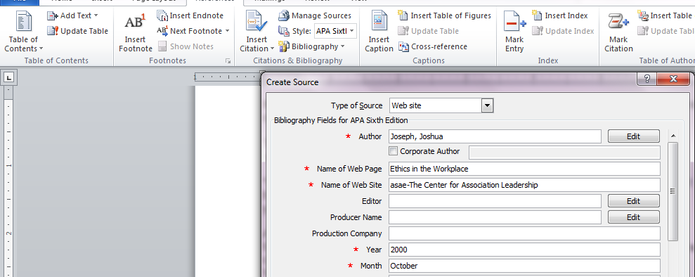
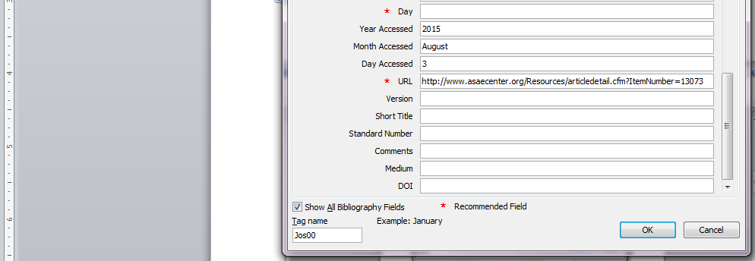

Once you have entered all the source information, click on Bibliography and then Insert Bibliography.

This is the citation:
(Joseph, 2000)
This is how the source is entered into the References list:

Joseph, J. (2000, October). Ethics in the Workplace. Retrieved August 3, 2015, from asae-The Center for Association Leadership: http://www.asaecenter.org/Resources/articledetail.cfm?ItemNumber=13073
Other fields on the source page would be used for a journal article or an article from a periodical.

Complete rubrics for this paper are found in the table on the next page.

Element # | Requirement | Points Allocated | Comments
01 | Paper should be double-spaced, 1” margins, 12 point Arial type | 0.5 | This is the font in normal paragraphs. Heading and title fonts may be in bold, but should remain in 12 point font.
02 | Deliverable is at least three full pages and does not exceed five typed, double-spaced pages | 0.5 | Charts and other graphical information are not included in the page count. Title and reference pages are not included in page count.
03 | Title Page which shows title and author's (student's) name. | 0.5 | Title must be appropriate for content
04 | At least three (3) APA formatted in-text citations.  You are required to use the References feature in Word 2010/2013/Office 365 for your citations and Reference List. It is important to review the final format for APA-style correctness even if generated by Word. | 2 | These can be anywhere in the document, but the citations must be relevant to what is being referenced and the APA format is used correctly.
05 | At least two (2) informational footnotes.  (Note: APA Style does not use footnotes for citations; however, APA style does allow for the incorporation of informational footnotes)  Footnotes are not used to list a reference! Footnotes contain information about the topic to which the footnote has been attached. | 1.0 | These can be anywhere in the document, but the informational footnotes must be relevant to the associated text. The purpose of this requirement is to effectively incorporate the information and demonstrate that you can use the MS Word footnoting functionality.
06 | Reference Page using APA format for references  You are required to use the References feature in Word 2010/2013/Office 365 for your citations and Reference List. It is important to review the final format for APA-style correctness even if generated by Word. | 1.0 | All works listed must be incorporated within the writing of your paper as specified in APA style
07 | Describe the topic and ethical issue as it relates to the use of Information Technology | 2
08 | Discuss the trends, ways individuals and/or organizations are impacted by the issue or are working to prevent the impact. | 2
09 | Paper must be well-organized, clearly written in a style appropriate for college level work. | 1
10 | Paper should be grammatically correct and contain no spelling errors. | 1.5 | Although you should use the SpellCheck and Grammar Check function in Word, this will not catch all errors – you are ultimately responsible for proofreading. Direct citations should not exceed 10% of total words (use Word’s ‘word count’ function)
TOTAL: |  | 12

