Memorandum

To: Dr. Brad Herzog
From: Yaojiong Ma
Date: February 16th,2017

Subject: Problem Analysis

The problem that I would like to focus on is poverty. Poverty is considered a social problem because it affects the society as a whole and thus can permeate at every dimension of culture and society. I believe poverty makes one inferior in quality which may include all the social, economic, and political elements. Individuals can lack or have scarce of something such as money or material possession. There are other difficulties that are of concern when considering the problem of poverty. For example, those audiences affected by poverty experience a lot of difficulties when trying to meet their necessary basic needs in life such as food, clothing and shelter.
I consider the lack of those three basic needs in life as an absolute poverty which is to the extreme and does not just involve lacking money or material resources. For example, according to the World Bank report, it has estimated that about 1.44 billion people are living in the extreme poverty and this can also be compared to the multidimensional poverty index which also estimates that about 1.6 billion people are living in extreme poverty.
There have always been efforts to reduce poverty especially extreme poverty but work to completely achieve this has always remained far from being over with a number of challenges still remaining (Chandy & Kharas, 2015). Causes of poverty are also a major part of my concern and the solutions which are also social.

Problem Analysis Report

Yaojiong Ma

Saginaw Valley State University

Writing in the Professions – RPW 300

Dr. Brad Herzog

March 16th, 2017

POVERTY AS A SOCIAL PROBLEM

Background Information, causes, effects, and Problems Being Faced
Individuals or the society can be considered poor if they lack the economic resources necessary to enjoy and experience a sufficient standard of living.Poverty is considered a big issue that affects every dimension of culture and society. It is also considered a cause of national instability as a lot of resources are directed towards curbing the issue. Poverty may involve constant lack or scarcity of a something for example money or material possession.
Being poor can make an individual or a society inferior in all elements that include social, economic and political stability. Poverty can generally be viewed in different ways with the most consideration being based on the monetary terms. Poverty deprives an individual of his or her dignity, respect and close relationships. An individual can be referred as poor if he or she cannot meet his or her basic needs and that of the family. The necessary basic needs in life include food, clothing and shelter. The lack these three commodities means one is in an extreme poverty condition.
Poverty can also extend and affect a whole nation especially where the people in that nation are not able to afford certain levels of living standards compared to the rest of the world. Therefore, poverty can vary from society to society, country to country, and individuals living in the same country. The level of poverty can be measured to be either absolute or relative. Absolute poverty refers to the deprivation of the basic human needs such as food, shelter, safe drinking water, health and sanitation facilities, education and information while relative poverty is the condition in which people may lack the minimum amount of income needed in order to maintain the average standard of living in the society.
According to the World Bank, poverty is depriving one of well-being which may be in terms of low income and the inability to access life’s basic needs that enables one to live with dignity. Due to the inability to have choices and opportunities, a person may not participate effectively in the society. This is according to the United Nations point of view.

Evidence of the Problem
Causes
When focusing on the causes of poverty, we should reflect on the social and economic conditions that impact the nation either positively or negatively. This is because the trends in the social and economic status of a nation may contribute to poverty. Level of education, overpopulation, war, violence and environmental problems among others are other causes of poverty in a country (Layard, Stewart & Piachaud, 1979).
A good example is found in those countries that have always been affected by violence over years. These countries have experienced very high poverty levels than the peaceful countries. Sometimes poor people have always been blamed for their own predicament with claims such as having poor decisions, being lazy, and always begging. No matter the state of any nation, there will still be certain levels of inequality. This inequality may be in terms of education, health, and other basic services which the poor people and communities have less or no access.
Cases of malnutrition and hunger are also highest in the poorest societies. Countries especially the developing nations are supposed to have open economies so as to compete with other nations especially the more powerful ones. Therefore, in order to attract investments, poor countries have entered into a spiraling race to see who can provide lower standards, reduced wages and cheaper resources which is a major cause of increased poverty level.
In such a situation, countries are provided with financial assistance by the World Bank and the International Monetary Fund (IMF) under various preconditions. This state of poverty has seen most developing and poor countries continue to depend on the already developed nations, a factor that has affected growth of the developed nations (Choudhury & Malik, 2016).
Climatic change such as lack of rainfall has also led to an increase in the levels of poverty in the regions. This lack of rainfall is found to be caused by human beings mainly because they have embarked on activities that harm the environment, for example deforestation and mining among others.
In addition to the fact that poor communities are faced with high levels of illiteracy, they also lack the required knowledge that can help them engage in production techniques thus degrading the environmental status.
Effects
Regardless of the cause, poverty has devastating effects and consequences for those affected with nearly all possible effects of poverty having an impact on children’s lives. Hunger and health problems are considered to be the major effects of poverty. These effects are usually interrelated as one factor causes another. For example, with poor sanitation and lack of clean water, people are usually very susceptible to diseases. Hunger leads to the disease vulnerability as the bodies become weak. Effects can be felt in every level of the society and may include;
Malnutrition – Malnutrition is a condition by which people living in poverty lack foods with balanced diets. In this case, it is very difficult for them to purchase the types of foods. Malnutrition is the most common effect of poverty that affects especially young children. The Food types said to be healthiest for human beings are not affordable and therefore poor families continue to languish in poverty.

Health – Those living in poverty stricken societies are more likely to be affected by infant mortality and mental illness due inadequate medical care facilities. Poverty stricken communities and the people living in them have limited resources to maintain a healthy living environment. They therefore cannot afford nutritious foods which makes their bodies to have decreased ability to fight off diseases. Sanitation conditions are also very low and this increases the chances of being sick. Lack of proper nutrition in children impairs their cognitive ability in education sessions.
Education – the level of education in the poverty stricken society is very low due to inadequate facilities available to facilitate the education. Most of the people are even not able to attend school at all when they are still very young especially because such families lack the means to get to the schools. This leads to increased level of illiteracy in the societies as well as affecting the skilled labor force. Lack of education therefore means that people will continue to languish in poverty.
Society – poverty has all sorts of social effects such as homelessness. The poor have very high chances of lacking a home to live and even living in slums. Most of their income is spent on paying for housing in poor neighborhoods with poor health conditions and no life opportunities such as good jobs. There is also a close connection between poverty and crime and this is facilitated by unemployment, being homeless, and social unrest. Many may turn to crimes as a means of finding ways to survive and this creates problems within the society.
Countries have always taken measures with the intentions of permanently lifting people out of poverty. Poverty occurs in both developed and developing countries and historically some nations have already accepted poverty to be inevitable as non-industrialized economies are producing very little compared to the high population growth and thus resources have become very scarce. The war on poverty has been in existence for decades but it has never shown positive results due to various factors such high population growth. Overpopulation has led to wealth scarcity that has also led to poor education and low access to health facilities. Despite the economic growth, poverty levels have always remained stagnant and this means the economic growth does not reduce the poverty levels.
The programs towards poverty reduction that are based on the economic growth have always failed. This has led to multilateral lending institutions and governments to come up with ways that support programs to try and alleviate poverty. Although the programs have been observed to lower the poverty levels, they have not succeeded in completely alleviating the poverty issue. Most people have always had the idea that it is not possible to conquer poverty but focusing on the major causes and having a psychological focus would be a better path towards poverty reduction (Danziger & Haveman, 2009).
ILLUSTRATIONS IN GRAPHS

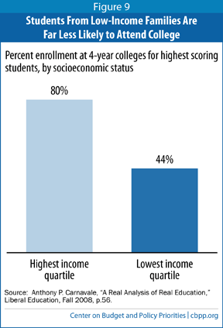

This is a representation of the Percentage enrollment at 4-year colleges for highest scoring students, by socioeconomic status.

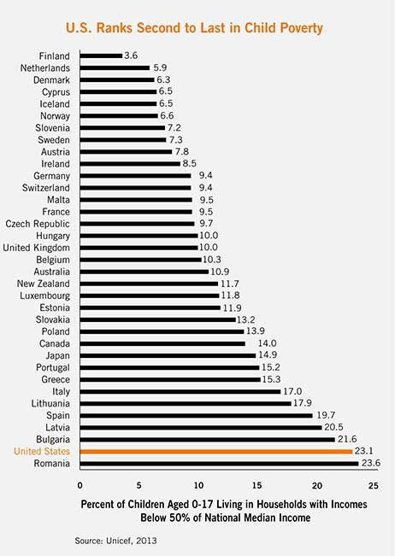

This graph presents the Percentage of children aged 0-17 living in households with incomes below 50% of national median income

References

Chandy, L., Katō, H., & Kharas, H. J. (2015). The last mile in ending extreme poverty.

Washington, DC: Brookings Institution Press.

Choudhury, M. A., & Malik, U. A. (2016). The social economy: poverty alleviation and social wellbeing. Newcastle upon Tyne: Cambridge Scholars Publishing.
Danziger, S. H., & Haveman, R. H. (2009). Understanding Poverty. Cambridge: Harvard University Press.

Layard, R., Stewart, M., & Piachaud, D. (1979). The causes of poverty. London: H.M.S.O.

