Milestone Two: Database Analysis and Design
Southern New Hampshire University
Principles of Database Design
IT-650
Prof. Bindu George
September 26, 2017

Milestone Two: Database Analysis and Design
Conceptual model
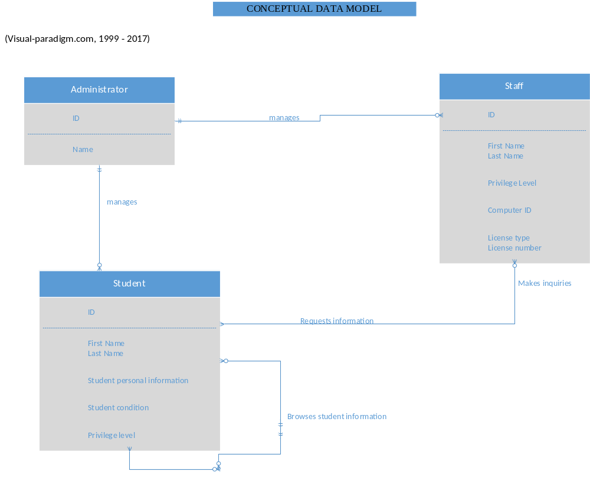

Logical Model
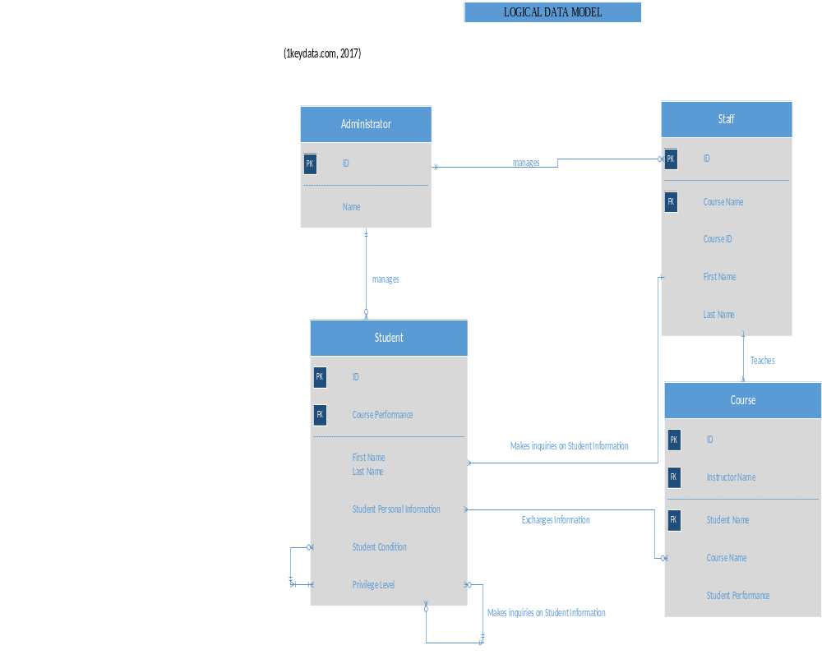

Physical Model
(Zheng, 2012)
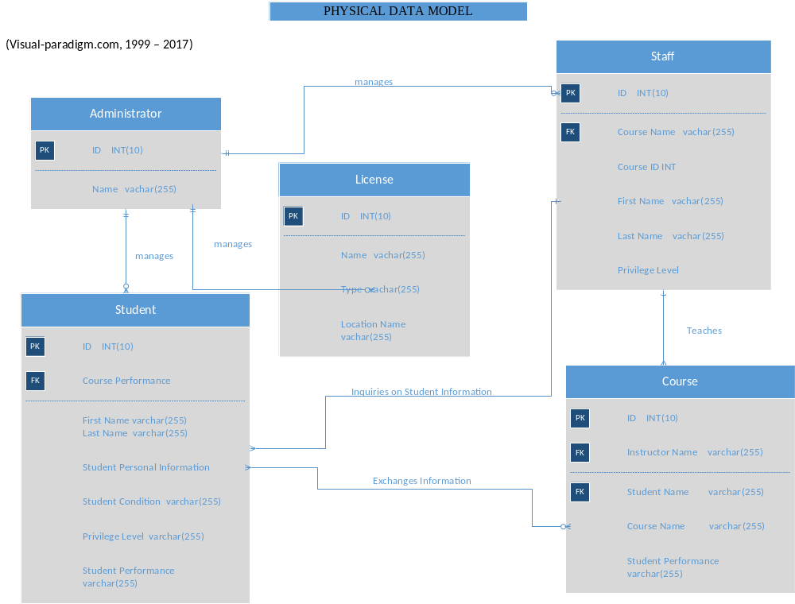

References
Logical Data Model. (2017). Retrieved from https://www.1keydata.com/datawarehousing/logical-data-model.html
Conceptual Model. (2004). Retrieved from https://www.visual-paradigm.com/support/documents/vpuserguide/3563/3564/85378_conceptual,l.html
Conger, S. (2014). Hands-On Database (2nd ed.). [MBS Direct]. https://doi.org/https://mbsdirect.vitalsource.com/#/books/9780133927078/
Zheng, J. (2012). Visio Tutorial: Database Model Design. Visio Tutorial: Database Model Design. Retrieved from http://jackzheng.net/teaching/it4153/files/visio-db.pdf

