Instructions for this assignment – DUE SATURDAY APRIL 15 @ 12 NOON
There are two parts to this assignment, first I must create a visual argument of this essay, I’m creating something similar to the images below.

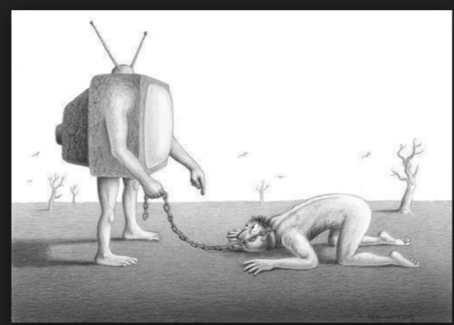
The assignment is an argumentative research assignment that should contain at least 3 sources/citation (like the previous essay). For this assignment, you will write your final argumentative essay on an aspect of your chosen topic. Ensure that it is a focus that can be fully explored in an essay of 750-1000 words (3-4 pages). This can be especially tricky for an argumentative essay.
Your essay needs to demonstrate your mastery of the course concepts we have addressed throughout the semester.
Because this is a research-based essay, you should begin by collecting and reading appropriate sources. Then spend time brainstorming, drafting, and fleshing out your ideas. Remember: by this third essay, you should be an expert on your topic and writing sophisticated, in-depth content that reflects that content knowledge.
As we are focused on college-level writing, this essay should be polished and professional. Neither first nor second person narration are acceptable. Your language should be polished and sophisticated and appropriate to the topic you have chosen. For an argumentative essay, your rhetorical situation is an especially important consideration.
These are the topics I have chosen to choose from:
- How are online technologies changing the way we live?
- How is social media changing family relationships?
- Has media hurt or helped family communication? Friendship communication? Romantic relationships?

