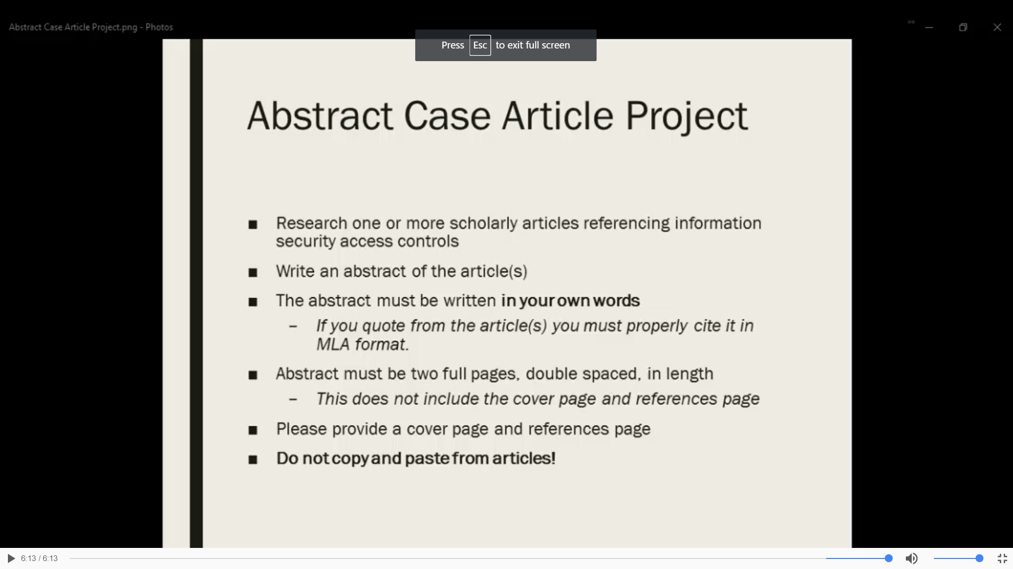

- Type of Access control to be used- Physical control or Administrative control or technical control
- 2 or 3 pages

