Review Exhibit 2.1: Typical State Court System.
Assume that the higher on this chart the case is the more expensive it is for all parties.
Write a memo on a state (not federal) level business dispute. Describeas if you were writing a "white paper" for your boss who wants to know how a case like the one you have chosen would be processed throughout the various legal phases in a state court system.
Because most cases never make it to trial, it is also important to consider alternative methods of dispute resolution. Suppose your selected case was initially submitted to ADR. What methods of ADR would be available to pursue? Which of these ADR methods do you think would be the most appropriate? Why?
Required elements:
- Discuss the differences in costs and benefits of going through traditional litigation and pursuing ADR in this case (Consider for example, why one of the parties in the case you're looking at may have preferred keeping the case out of court).
- Between 500 and 700 words.
- Format must comply with APA guidelines.
- References must include the course text and at least two other peer reviewed sources.

Exhibit 2.1: Typical State Court System.

Courts and Jurisdiction
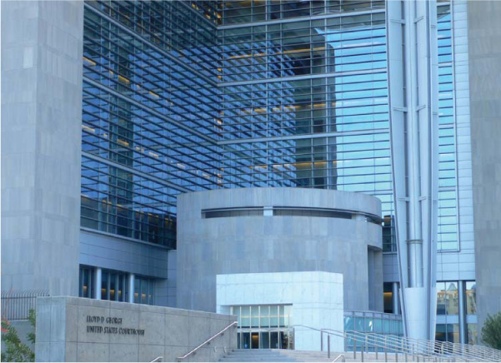
U.S. DISTRICT COURT, LAS VEGAS, NEVADA
This is the Lloyd D. George United States District Court for the District of Nevada, which is located in Las Vegas, Nevada. This is a federal trial court. This court, along with the other U.S. district courts located throughout the country, hears and decides lawsuits concerning matters over which it has jurisdiction. State, Washington, DC, and U.S. territory courts hear and decide matters over which they have jurisdiction. The process of bringing and defending lawsuits, preparing for court, and the trial itself is complicated, time-consuming, and expensive.
Learning Objectives
After studying this chapter, you should be able to:
- Describe state court systems.
- Describe the federal court system.
- List and describe the types of decisions that are issued by the U.S. Supreme Court.
- Compare the jurisdiction of state courts with that of federal courts.
- Define personal jurisdiction, standing to sue, and venue.
Chapter Outline
Introduction to Courts and Jurisdiction
State Court Systems
- CONTEMPORARY ENVIRONMENT Delaware Courts Specialize in Hearing Business Disputes
Federal Court System
Supreme Court of the United States
- CONTEMPORARY ENVIRONMENT The Process of Choosing a U.S. Supreme Court Justice
- CONTEMPORARY ENVIRONMENT “I’ll Take You to the U.S. Supreme Court!”
Jurisdiction of Federal Courts
- CASE 2.1 U.S. SUPREME COURT Hertz Corporation v. Friend
Standing to Sue, Jurisdiction, and Venue
- LANDMARK U.S. SUPREME COURT CASE International Shoe Company v. State of Washington
Jurisdiction in Cyberspace
- CASE 2.2 Chanel, Inc. v. Banks
- INTERNATIONAL LAW Judicial System of Japan
“I was never ruined but twice; once when I lost a lawsuit, and once when I won one.”
Voltaire

Introduction to Courts and Jurisdiction
There are two major court systems in the United States: (1) the federal court system and (2) the court systems of the 50 states, Washington, DC (District of Columbia), and territories of the United States. Each of these systems has jurisdiction to hear different types of lawsuits. This chapter discusses the various court systems and the jurisdiction of different courts to hear and decide cases.
The glorious uncertainty of law.
Thomas Wilbraham
A toast at a dinner of judges and counsel at Serjeants’ Inn Hall

State Court Systems
Each state; Washington, DC; and each territory of the United States has its own separate court system (hereafter collectively referred to as state courts). Most state court systems include the following: limited-jurisdiction trial courts, general-jurisdiction trial courts, intermediate appellate courts, and a supreme court.

Limited-Jurisdiction Trial Courts
State limited-jurisdiction trial courts, which are sometimes referred to as inferior trial courts, hear matters of a specialized or limited nature.
Examples Traffic courts, juvenile courts, justice-of-the-peace courts, probate courts, family law courts, and courts that hear misdemeanor criminal law cases are limited-jurisdiction courts in many states.
Because limited-jurisdiction courts are trial courts, evidence can be introduced and testimony can be given. Most limited-jurisdiction courts keep records of their proceedings. A decision of such a court can usually be appealed to a general-jurisdiction court or an appellate court.
Many states have also created small claims courts to hear civil cases involving small dollar amounts (e.g., $5,000 or less). Generally, the parties must appear individually and cannot have lawyers represent them. The decisions of small claims courts are often appealable to general-jurisdiction trial courts or appellate courts.
sidenote: Web Exercise
Use www.google.com or another Internet search engine and find if your state has a small claims court. If so, what is the dollar amount limit for cases to qualify for small claims court?

General-Jurisdiction Trial Courts
Every state has a general-jurisdiction trial court. These courts are often referred to as courts of record because the testimony and evidence at trial are recorded and stored for future reference. These courts hear cases that are not within the jurisdiction of limited-jurisdiction trial courts, such as felonies, civil cases more than a certain dollar amount, and so on.
Some states divide their general-jurisdiction courts into two divisions, one for criminal cases and one for civil cases. Evidence and testimony are given at general-jurisdiction trial courts. The decisions handed down by these courts are appealable to an intermediate appellate court or the state supreme court, depending on the circumstances.

Intermediate Appellate Courts
In many states, intermediate appellate courts (also called appellate courts or courts of appeals) hear appeals from trial courts. They review the trial court record to determine whether there have been any errors at trial that would require reversal or modification of the trial court’s decision. Thus, an appellate court reviews either pertinent parts or the whole trial court record from the lower court. No new evidence or testimony is permitted.
The parties usually file legal briefs with the appellate court stating the law and facts that support their positions. Appellate courts usually grant a brief oral hearing to the parties. Appellate court decisions are appealable to the state’s highest court. In sparsely populated states that do not have an intermediate appellate court, trial court decisions can be appealed directly to the state’s highest court.

Highest State Court
Each state has a highest state court in its court system. Many states call this highest court the state supreme court. Some states use other names for their highest courts. The function of a state’s highest court is to hear appeals from intermediate appellate state courts and certain trial courts. No new evidence or testimony is heard. The parties usually submit pertinent parts of or the entire lower court record for review. The parties also submit legal briefs to the court and are usually granted a brief oral hearing. Decisions of highest state courts are final unless a question of law is involved that is appealable to the U.S. Supreme Court.
Exhibit 2.1 portrays a typical state court system. Exhibit 2.2 lists the websites for the court systems of 50 states, Washington, DC, and territories associated with the United States.
Exhibit 2.1 Typical State Court System
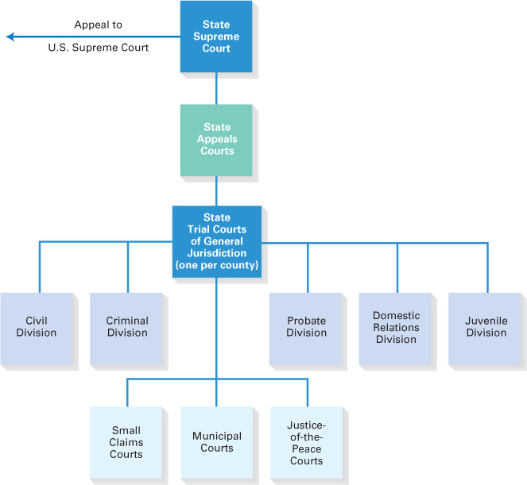
Exhibit 2.2 State; Washington, Dc; and Territory Court Systems
State, District, or Territory | Website
Alabama | www.judicial.state.al.us
Alaska | www.state.ak.us/courts
Arizona | www.supreme.state.az.us
Arkansas | www.courts.state.ar.us
California | www.courtinfo.ca.gov/courts
Colorado | www.courts.state.co.us
Connecticut | www.jud.state.ct.us
Delaware | www.courts.state.de.us
District of Columbia | www.dccourts.gov
Florida | www.flcourts.org
Georgia | www.georgiacourts.org
Guam | www.guamsupremecourt.com
Hawaii | www.courts.state.hi.us
Idaho | www.isc.idaho.gov
Illinois | www.state.il.us/court
Indiana | www.in.gov/judiciary
Iowa | www.judicial.state.ia.us
Kansas | www.kscourts.org
Kentucky | www.courts.ky.gov
Louisiana | www.lasc.org
Maine | www.courts.state.me.us
Maryland | www.courts.state.md.us
Massachusetts | www.mass.gov/courts
Michigan | www.courts.michigan.gov
Minnesota | www.courts.state.mn.us
Mississippi | www.mssc.state.ms.us
Missouri | www.courts.mo.gov
Montana | www.montanacourts.org
Nebraska | www.court.nol.org
Nevada | www.nvsupremecourt.us
New Hampshire | www.courts.state.nh.us
New Jersey | www.judiciary.state.nj.us
New Mexico | www.nmcourts.com
New York | www.courts.state.ny.us
North Carolina | www.nccourts.org
North Dakota | www.ndcourts.com
Ohio | www.sconet.state.oh.us
Oklahoma | www.oscn.net/oscn/schome
Oregon | www.ojd.state.or.us
Pennsylvania | www.courts.state.pa.us
Puerto Rico | www.tribunalpr.org
Rhode Island | www.courts.state.ri.us
South Carolina | www.judicial.state.sc.us
South Dakota | www.sdjudicial.com
Tennessee | www.tsc.state.tn.us
Texas | www.courts.state.tx.us
Utah | www.utcourts.gov
Vermont | www.vermontjudiciary.org
Virginia | www.courts.state.va.us
Virgin Islands | www.visuperiorcourt.org
Washington | www.courts.wa.gov
Washington, DC | www.dccourts.org
West Virginia | www.wv.gov
Wisconsin | www.wicourts.gov
Wyoming | www.courts.state.wy.us
The following feature discusses special business courts.
Contemporary Environment: Delaware Courts Specialize in Hearing Business Disputes
In most states, business and commercial disputes are heard by the same courts that hear and decide criminal, landlord–tenant, matrimonial, medical malpractice, and other non-business-related cases. One major exception to this standard has been the state of Delaware, where a special chancery court hears and decides business litigation. The Delaware Court of Chancery, which decides cases involving corporate governance, fiduciary duties of corporate officers and directors, mergers and acquisitions, and other business issues, has earned a reputation for its expertise in handling and deciding corporate matters. Perhaps the existence of this special court and a corporation code that tends to favor corporate management are the primary reasons that more than 50 percent of the corporations listed on the New York Stock Exchange (NYSE) and the NASDAQ stock exchange are incorporated in Delaware.
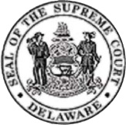
Businesses tend to favor special commercial courts because the judges presiding over business cases have the expertise to handle complex commercial lawsuits. The courts are also expected to be more efficient in deciding business-related cases, thus saving time and money for the parties. Other states are also establishing courts that specialize in commercial matters.
sidenote: Web Exercise
Go to the website of the Delaware Court of Chancery at www.courts.delaware.gov/chancery. Read the brief description of the court on the page.
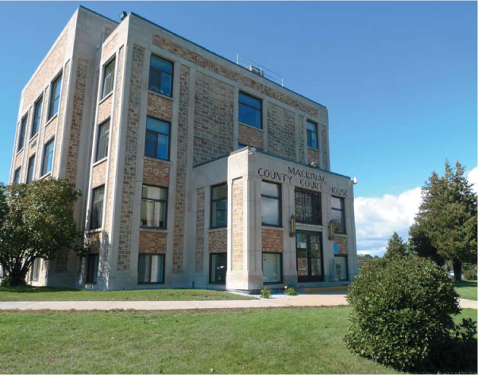
STATE COURT
This is a county courthouse in the state of Michigan. Each state, the District of Columbia, and territories administered by the United States have their own court system. Most counties have a general-jurisdiction trial court. State courts resolve more than 95 percent of the lawsuits brought in this country.

Federal Court System
Article III of the U.S. Constitution provides that the federal government’s judicial power is vested in one “Supreme Court.” This court is the U.S. Supreme Court. Article III also authorizes Congress to establish “inferior” federal courts. Pursuant to its Article III power, Congress has established the U.S. district courts, the U.S. courts of appeals, and the U.S. bankruptcy courts. Pursuant to other authority in the Constitution, the U.S. Congress has established other federal courts. Federal judges of the U.S. Supreme Court, U.S. courts of appeals, and U.S. district courts are appointed for life by the president, with the advice and consent of the Senate. Judges of other courts are not appointed for life but are appointed for various periods of time (e.g., bankruptcy court judges are appointed for 14-year terms).

Special Federal Courts
The special federal courts established by Congress have limited jurisdiction. They include the following:
- U.S. Tax Court. The U.S. Tax Court hears cases that involve federal tax laws. Website: www.ustaxcourt.gov.
- U.S. Court of Federal Claims. The U.S. Court of Federal Claims hears cases brought against the United States. Website: www.uscfc.uscourts.gov.
- U.S. Court of International Trade. The U.S. Court of International Trade handles cases that involve tariffs and international trade disputes. Website: www.cit.uscourts.gov.
- U.S. Bankruptcy Court. The U.S. Bankruptcy Court hears cases that involve federal bankruptcy laws. Website: www.uscourts.gov/bankruptcycourts.html.
- U.S. Court of Appeals for the Armed Forces. The U.S. Court of Appeals for the Armed Forces exercises appellate jurisdiction over members of the armed services. Website: www.armfor.uscourts.gov.
- U.S. Court of Appeals for Veterans Claims. The U.S. Court of Appeals for Veterans Claims exercises jurisdiction over decisions of the Department of Veterans Affairs. Website: www.uscourts.cavc.gov.
sidenote: Web Exercise
Go to www.cit.uscourts.gov. Click on “About the Court” and click on “Forward.” What is the purpose of this court? Why is this court unique?
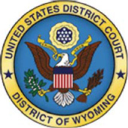

U.S. District Courts
The U.S. district courts are the federal court system’s trial courts of general jurisdiction. There are 94 U.S. district courts. There is at least one federal district court in each state and the District of Columbia, and heavily populated states have more than one district court. The geographical area served by each court is referred to as a district. The federal district courts are empowered to impanel juries, receive evidence, hear testimony, and decide cases. Most federal cases originate in federal district courts.

U.S. Courts of Appeals
The U.S. courts of appeals are the federal court system’s intermediate appellate courts. There are 13 circuits in the federal court system. The first 12 are geographical. Eleven are designated by numbers, such as the “First Circuit,” “Second Circuit,” and so on. The geographical area served by each court is referred to as a circuit. The 12th circuit court, located in Washington, DC, is called the District of Columbia circuit.
Congress created the 13th court of appeals in 1982. It is called the Court of Appeals for the Federal Circuit and is located in Washington, DC.¹ This court has special appellate jurisdiction to review the decisions of the Court of Federal Claims, the Patent and Trademark Office, and the Court of International Trade. This court was created to provide uniformity in the application of federal law in certain areas, particularly patent law.
As an appellate court, each of these courts hears appeals from the district courts located in its circuit as well as from certain special courts and federal administrative agencies. An appellate court reviews the record of the lower court or administrative agency proceedings to determine whether there has been any error that would warrant reversal or modification of the lower court decision. No new evidence or testimony is heard. The parties file legal briefs with the court and are given a short oral hearing. The number of judges of various U.S. courts of appeals range from approximately six to 30. Appeals are usually heard by a three-judge panel. After a decision is rendered by the three-judge panel, a petitioner can request an en banc review by the full appeals court.
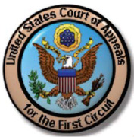
Exhibit 2.3 shows a map of the 13 federal circuit courts of appeals. Exhibit 2.4 lists the websites of the 13 U.S. courts of appeals.
Exhibit 2.3 Map of the Federal Circuit Courts
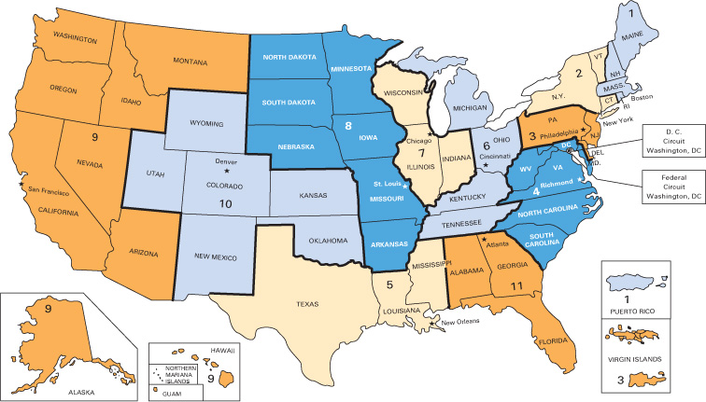
Exhibit 2.4 Federal Courts of Appeal
United States Court of Appeals | Main Office | Website
First Circuit | Boston, Massachusetts | www.ca1.uscourts.gov
Second Circuit | New York, New York | www.ca2.uscourts.gov
Third Circuit | Philadelphia, Pennsylvania | www.ca3.uscourts.gov
Fourth Circuit | Richmond, Virginia | www.ca4.uscourts.gov
Fifth Circuit | Houston, Texas | www.ca5.uscourts.gov
Sixth Circuit | Cincinnati, Ohio | www.ca6.uscourts.gov
Seventh Circuit | Chicago, Illinois | www.ca7.uscourts.gov
Eighth Circuit | St. Paul, Minnesota | www.ca8.uscourts.gov
Ninth Circuit | San Francisco, California | www.ca9.uscourts.gov
Tenth Circuit | Denver, Colorado | www.ca10.uscourts.gov
Eleventh Circuit | Atlanta, Georgia | www.ca11.uscourts.gov
District of Columbia | Washington, DC | www.dcd.uscourts.gov
Court of Appeals for the Federal Circuit | Washington, DC | www.cafc.uscourts.gov

Supreme Court of the United States
The highest court in the land is the Supreme Court of the United States, also called the U.S. Supreme Court, which is located in Washington, DC. The Court is composed of nine justices who are nominated by the president and confirmed by the Senate. The president appoints one justice the Chief Justice of the U.S. Supreme Court, who is responsible for the administration of the Supreme Court. The other eight justices are Associate Justices of the U.S. Supreme.
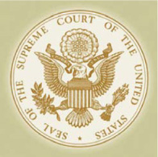
Following is Alexis de Tocqueville’s description of the Supreme Court’s role in U.S. society:
The peace, the prosperity, and the very existence of the Union are vested in the hands of the justices of the Supreme Court. Without them, the Constitution would be a dead letter: the executive appeals to them for assistance against the encroachments of the legislative power; the legislature demands their protection against the assaults of the executive; they defend the Union from the disobedience of the states, the states from the exaggerated claims of the Union; the public interest against private interests, and the conservative spirit of stability against the fickleness of the democracy.
The following feature discusses the process of choosing a U.S. Supreme Court justice.
Contemporary Environment: The Process of Choosing a U.S. Supreme Court Justice
In an effort to strike a balance of power between the executive and legislative branches of government, Article II, Section 2, of the U.S. Constitution gives the president the power to appoint Supreme Court justices “with the advice and consent of the Senate.” This means that the majority of the one hundred senators must approve the president’s nominee in order for that nominee to become a justice of the U.S. Supreme Court.
In 1993, President Bill Clinton, a Democrat, with the consent of the Senate, placed Ruth Bader Ginsburg, a moderate liberal, on the Court. She was the second female to serve on the U.S. Supreme Court.
President George W. Bush, a Republican, placed two justices on the Supreme Court. In 2005, when presiding Chief Justice Rehnquist died, President Bush nominated John G. Roberts, Jr., to be the next chief justice of the Supreme Court. Justice Roberts, a conservative, was easily confirmed by the Senate. In the same year, Justice Sandra Day O’Connor, the centrist vote on the Court, resigned from the Supreme Court. President Bush nominated Samuel A. Alito, Jr., a conservative, to fill the vacancy. Justice Alito was confirmed by a majority vote of the Senate.
President Barack Obama was inaugurated as president in January 2009. Within months after taking office, he had the opportunity to nominate a justice for the U.S. Supreme Court when Justice Souter retired from the Court. President Obama nominated Sonia Sotomayor, a liberal, for the seat. Sotomayor was born in the Bronx, New York City, and is of Puerto Rican descent. As a child, she was raised in public housing projects. Sotomayor graduated from Princeton and then Yale Law School, attending both schools on scholarships. After practicing law, she served as a U.S. District Court judge and a U.S. Court of Appeals justice of the federal court system. Sotomayor was confirmed to the Supreme Court by a majority vote of the U.S. Senate, becoming the first Hispanic person to be a justice of the U.S. Supreme Court and the third female appointed to the Court.
In 2010, President Obama had a second opportunity to nominate another justice, when 90-year-old Justice Stevens retired. The president nominated Elena Kagan, the U.S. solicitor general. Kagan clerked for Justice Thurgood Marshall when he was a justice of the Supreme Court. Kagan, although not a judge, was a constitutional law professor at the University of Chicago and Harvard University law schools and served as dean of Harvard Law School. Kagan was confirmed by a majority vote of the U.S. Senate.
A president who is elected to one or two four-year terms in office may have the opportunity to nominate justices to the U.S. Supreme Court who, if confirmed, may serve many years after the president leaves office.

Jurisdiction of the U.S. Supreme Court
The Supreme Court, which is an appellate court, hears appeals from federal circuit courts of appeals and, under certain circumstances, from federal district courts, special federal courts, and the highest state courts. No new evidence or testimony is heard. As with other appellate courts, the lower court record is reviewed to determine whether there has been an error that warrants a reversal or modification of the decision. Legal briefs are filed, and the parties are granted a brief oral hearing. The Supreme Court’s decision is final.
sidenote: Web Exercise
Go to www.supremecourt.gov/about/members.aspx. Click on the names of the current members of the U.S. Supreme Court and read their short biographies.
The federal court system is illustrated in Exhibit 2.5.
Exhibit 2.5 Federal Courts of Appeal
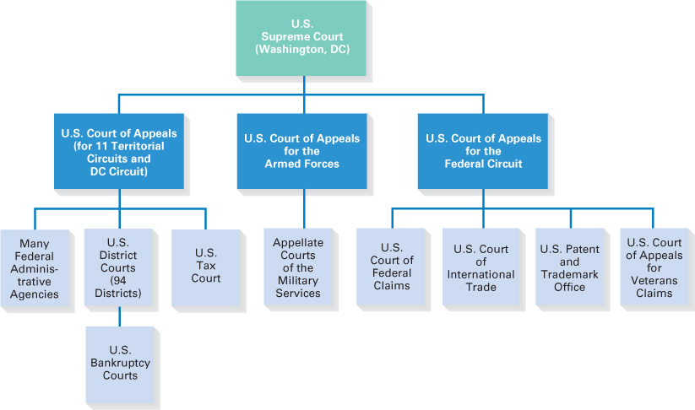

Decisions of the U.S. Supreme Court
The U.S. Constitution gives Congress the authority to establish rules for the appellate review of cases by the Supreme Court, except in the rare case in which mandatory review is required. Congress has given the Supreme Court discretion to decide what cases it will hear.²
A petitioner must file a petition for certiorari, asking the Supreme Court to hear the case. If the Court decides to review a case, it issues a writ of certiorari. Because the Court issues only about one hundred opinions each year, writs are usually granted only in cases involving constitutional and other important issues.
Each justice of the Supreme Court, including the chief justice, has an equal vote. The Supreme Court can issue several types of decisions:
- Unanimous Decision If all the justices voting agree as to the outcome and reasoning used to decide a case, it is a unanimous decision. Unanimous decisions are precedent for later cases.
Example Suppose all nine justices hear a case, and all nine agree to the outcome (e.g., the petitioner wins) and the reason why (e.g., the Equal Protection Clause of the U.S. Constitution had been violated); this is a unanimous decision. This unanimous decision becomes precedent for later cases.
Sancho: But if this is hell, why do we see no lawyers?
Clarindo: They won’t receive them, lest they bring lawsuits here.
Sancho: If there are no lawsuits here, hell’s not so bad.
Lope de Vega
The Star of Seville, Act 3, Scene 2
- Majority Decision If a majority of the justices agree as to the outcome and reasoning used to decide a case, it is a majority decision. Majority decisions are precedent for later cases. A majority decision occurs if five, six, seven, or eight justices vote for the same outcome for the same reason.
Example If all nine justices hear a case, and five of them agree as to the outcome (e.g., the petitioner wins) and all of these five justices agree to the same reason why (e.g., the Equal Protection Clause of the U.S. Constitution has been violated), it is a majority opinion. The majority opinion becomes precedent for later cases and has the same force of law as a unanimous decision. The votes of the remaining four justices for the respondent have no legal effect whatsoever.
- Plurality Decision If a majority of the justices agree as to the outcome of a case but not as to the reasoning for reaching the outcome, it is a plurality decision. A plurality decision settles the case but is not precedent for later cases.
Example If all nine justices hear a case, and five of them agree as to the outcome (e.g., the petitioner wins), but not all of these five agree to the reason why (e.g., three base their vote on a violation of the Equal Protection Clause and two base their vote on a violation of the Due Process Clause of the U.S. Constitution), it is a plurality decision. Five justices have agreed to the same outcome, but those five have not agreed for the same reason. The petitioner wins his or her case, but the decision is not precedent for later cases. The votes of the remaining four justices for the respondent have no legal effect whatsoever.
- Tie Decision Sometimes the Supreme Court sits without all nine justices being present. This could happen because of illness, conflict of interest, or a justice not having been confirmed to fill a vacant seat on the Court. If there is a tie decision, the lower court decision is affirmed. Such votes are not precedent for later cases.
Example A petitioner wins her case at the U.S. Court of Appeals. At the U.S. Supreme Court, only eight justices hear the case. Four justices vote for the petitioner, and four justices vote for the respondent. This is a tie vote. The petitioner remains the winner because she won at the Court of Appeals. This decision of the Supreme Court sets no precedent for later cases.
sidenote: Web Exercise
Go to the website of the U.S. Supreme Court at www.supremecourtus.gov. Who are the nine justices of the U.S. Supreme Court? Who is the Chief Justice? Who was the last Supreme Court justice appointed to the Court?
A justice who agrees with the outcome of a case but not the reason proffered by other justices can issue a concurring opinion that sets forth his or her reasons for deciding the case. A justice who does not agree with a decision can file a dissenting opinion that sets forth the reasons for his or her dissent.
The following feature discusses the process for having a case heard by the U.S. Supreme Court.
Contemporary Environment: “I’ll Take You to the U.S. Supreme Court!”
In reality, the chance of ever having a case heard by the highest court is slim to none. Each year, approximately ten thousand petitioners ask the Supreme Court to hear their cases. In recent years, the Supreme Court has accepted only fewer than one hundred of these cases for full review each term.
Each of the nine Supreme Court justices has law clerks—recent law school graduates usually chosen from elite law schools across the country—who assist them. The justices rarely read the appellate petitions but instead delegate this task to their law clerks. A clerk writes a short memorandum, discussing the key issues raised by the appeal, and recommends to the justices whether they should grant or deny a review. The justices meet once a week to discuss what cases merit review. The votes of four justices are necessary to grant an appeal and schedule an oral argument before the Court; this is called the rule of four. Written opinions by the justices are usually issued many months later.
So what does it take to win a review by the Supreme Court? The U.S. Supreme Court usually decides to hear cases involving major constitutional questions, such as freedom of speech, freedom of religion, equal protection, and due process. The Supreme Court also hears many cases involving the interpretation of statutes enacted by Congress. The Court rarely decides day-to-day legal issues such as breach of contract, tort liability, or corporations law unless they involve more important constitutional or federal law questions.
So the next time you hear someone say, “I’ll take you to the U.S. Supreme Court!” just say, “Probably not!”

Jurisdiction of Federal Courts
Article III, Section 2 of the U.S. Constitution sets forth the jurisdiction of federal courts. Federal courts have limited jurisdiction to hear cases involving a federal question or diversity of citizenship. These are each discussed in the following paragraphs.

Federal Question
The federal courts have subject matter jurisdiction to hear cases involving “federal questions.” Federal question cases are cases arising under the U.S. Constitution, treaties, and federal statutes and regulations. There is no dollar-amount limit on federal question cases that can be brought in federal court.³
Example A defendant is sued by a plaintiff for engaging in insider trading, in violation of the Securities Exchange Act of 1934, which is a federal statute. This lawsuit involves a federal question, a federal statute, and therefore qualifies to be brought in federal court.

Diversity of Citizenship
A case may be brought in federal court even though it involves a nonfederal subject matter question, which would usually be heard by state, Washington, DC, or territory courts, if there is diversity of citizenship. Diversity of citizenship occurs if a lawsuit involves (1) citizens of different states or (2) a citizen of a state and a citizen or subject of a foreign country. A corporation is considered to be a citizen of the state in which it is incorporated and in which it has its principal place of business.
If there is diversity of citizenship, the plaintiff may bring the case in either state or federal court. If a plaintiff brings a diversity of citizenship case in federal court, it remains there. If the plaintiff brings a diversity of citizenship case in state court, it will remain there unless the defendant removes the case to federal court. Federal courts must apply the relevant state law to diversity of citizenship cases.
The original reason for providing diversity of citizenship jurisdiction to federal courts was to prevent state court bias against nonresidents, although this reason has been questioned as irrelevant in modern times. The federal court must apply the appropriate state’s law in deciding the case. The dollar amount of the controversy must exceed the sum or value of $75,000.⁴ If this requirement is not met, action must be brought in the appropriate state, Washington, DC, or territory court.
Example Henry, a resident of the state of Idaho, is driving his automobile in the state of Idaho when he negligently hits an automobile driven by Mary, a resident of the state of New York. Mary is injured in the accident. There is no federal question involved in this case; it is an automobile accident that involves state negligence law. However, there is diversity of citizenship in this case because the parties are residents of different states. Therefore, Mary can sue Henry and bring her case in federal court in Idaho, and if she does, the case will remain in federal court. If she brings the case in Idaho state court, the case will remain in Idaho state court unless Henry has the case removed to federal court. If this case is heard by a federal court, the court must apply Idaho law to the case.
Federal courts have exclusive jurisdiction to hear cases involving federal crimes, antitrust, bankruptcy, patent and copyright cases, suits against the United States, and to most admiralty cases. State courts cannot hear these cases.
Concept Summary: Jurisdiction of Federal Courts
Type of Jurisdiction | Description
Federal question | Cases arising under the U.S. Constitution, treaties, and federal statutes and regulations. There is no dollar-amount limit for federal question cases that can be brought in federal court.
Diversity of citizenship | Cases between citizens of different states or between a citizen of a state and a citizen or subject of a foreign country. Federal courts must apply the appropriate state law in such cases. The controversy must exceed $75,000 for the federal court to hear the case.
The following U.S. Supreme Court case involves diversity of citizenship jurisdiction when a corporation is a party to a lawsuit.
Case 2.1 U.S. Supreme Court Diversity of Citizenship
“A corporation shall be deemed to be a citizen of any State by which it has been incorporated and of the State where it has its principal place of business.”
Breyer, Justice
Facts
Melinda Friend, a California citizen, sued the Hertz Corporation in California state court seeking damages for Hertz’s alleged violation of California’s wage and hour laws. Hertz filed notice to remove the case to federal court, asserting diversity of citizenship of the parties. Friend argued that because Hertz operated more than 270 rental car locations and had more than 2,000 employees in California, it was a citizen of California and diversity of citizenship did not apply and the case could not be moved to federal court. Hertz alleged that because it was incorporated in the state of Delaware and its headquarters office was in the state of New Jersey, it was a citizen of those states and not a citizen of California. Hertz concluded that because it was not a citizen of California but plaintiff Friend was, there was diversity of citizenship, and Friend’s California state court action could be moved to federal court. The U.S. District Court held that Hertz was a citizen of California and that the case could not be moved to federal court. The U.S. Court of Appeals affirmed this decision. Hertz appealed to the U.S. Supreme Court.
Issue
Is Hertz Corporation a citizen of California?
Language of the U.S. Supreme Court
The federal diversity jurisdiction statute provides that “a corporation shall be deemed to be a citizen of any State by which it has been incorporated and of the State where it has its principal place of business.” 28 U. S. C. §1332(c) (1). And we conclude that the phrase “principal place of business” refers to the place where the corporation’s high level officers direct, control, and coordinate the corporation’s activities. Lower federal courts have often metaphorically called that place the corporation’s “nerve center.” We believe that the “nerve center” will typically be found at a corporation’s headquarters. The metaphor of a corporate “brain,” while not precise, suggests a single location.
Decision of the U.S. Supreme Court
The U.S. Supreme Court held that Hertz’s corporate headquarters—its nerve center—is located in New Jersey, not California. As such, there is diversity of citizenship with Friend, a California citizen, and the case could be moved to federal court. The plaintiff will get her day in court, but it will be in federal court and not California state court.
Case Questions
Critical Legal Thinking
What is diversity of citizenship? What is the public policy for recognizing diversity of citizenship jurisdiction of federal courts?
Ethics
Was it ethical for Hertz to try to avoid trial in California state court? Why would Hertz want the case tried in federal court rather than in state court?
Contemporary Business
What are the consequences of this decision for corporations and for plaintiffs who are suing corporations?
Note Hertz has sufficient “minimum contacts” with California to be subject to suit in California. However, because of diversity of citizenship, the case will be heard by a federal court located in California and not California state court. The federal court will apply California law in deciding the case. Hertz is a citizen of Delaware, where its articles of incorporation are filed, and of New Jersey, where its headquarters is located. If Hertz was sued in the state court in either of these two states, there is no diversity of citizenship and Hertz could not remove the case to federal court.

Jurisdiction of State Courts
State courts and the courts of Washington, DC, and territories of the United States have jurisdiction to hear cases that federal courts do not have jurisdiction to hear. These usually involve laws of states, Washington, DC, territories, and local governments (e.g., cities, counties).
Examples Cases involving real estate, corporations, partnerships, limited liability companies, contracts, sales and lease contracts, and negotiable instruments are usually state law subject matters. (Remember that state law cases that involve diversity of citizenship can be heard by federal courts.)
State courts have concurrent jurisdiction with federal courts to hear cases involving diversity of citizenship and federal questions over which federal courts do not have exclusive jurisdiction. If a case involving concurrent jurisdiction is brought by a plaintiff in federal court, the case remains in federal court. If the plaintiff brings a case involving concurrent jurisdiction in state court, the defendant can either let the case be decided by the state court or remove the case to federal court. If a case does not qualify to be brought in federal court, it must be brought in the appropriate state court.
Exhibit 2.6 illustrates the jurisdiction of federal and state courts.
Exhibit 2.6 Jurisdiction of Federal and State Courts
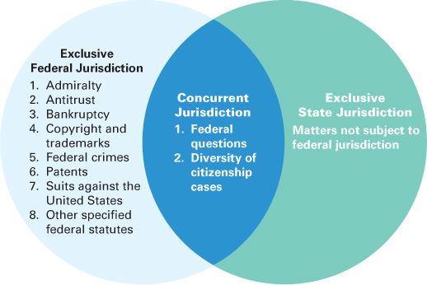

Standing to Sue, Jurisdiction, and Venue
Not every court has the authority to hear all types of cases. First, to bring a lawsuit in a court, the plaintiff must have standing to sue. In addition, the court must have personal jurisdiction or other jurisdiction to hear the case, and the case must be brought in the proper venue. These topics are discussed in the following paragraphs.

Standing to Sue
To bring a lawsuit, a plaintiff must have standing to sue. This means the plaintiff must have some stake in the outcome of the lawsuit.
Example Linda’s friend Jon is injured in an accident caused by Emily. Jon refuses to sue. Linda cannot sue Emily on Jon’s behalf because she does not have an interest in the result of the case.
A few states now permit investors to invest money in a lawsuit for a percentage return of any award of judgment. Courts hear and decide actual disputes involving specific controversies. Hypothetical questions will not be heard, and trivial lawsuits will be dismissed.

In Personam Jurisdiction
A court’s jurisdiction over a person is called in personam jurisdiction, or personal jurisdiction. A plaintiff, by filing a lawsuit with a court, gives the court in personam jurisdiction over himself or herself. The court must also have in personam jurisdiction over the defendant, which is usually obtained by having a summons served to that person within the territorial boundaries of the state (i.e., service of process). Service of process is usually accomplished by personal service of the summons and complaint on the defendant.
If personal service is not possible, alternative forms of notice, such as mailing of the summons or publication of a notice in a newspaper, may be permitted. A corporation is subject to personal jurisdiction in the state in which it is incorporated, has its principal office, or is doing business.
A party who disputes the jurisdiction of a court can make a special appearance in that court to argue against imposition of jurisdiction. Service of process is not permitted during such an appearance.

Long-Arm Statute
In most states, a state court can obtain jurisdiction in a civil lawsuit over persons and businesses located in another state or country through the state’s long-arm statute. These statutes extend a state’s jurisdiction to nonresidents who were not served a summons within the state. The nonresident defendant in the civil lawsuit must have had some minimum contact with the state such that the maintenance of that lawsuit in that state does not offend traditional notions of fair play and substantial justice.⁵
The exercise of long-arm jurisdiction is generally permitted over nonresidents who have (1) committed torts within the state (e.g., caused an automobile accident in the state), (2) entered into a contract either in the state or that affects the state (and allegedly breached the contract), or (3) transacted other business in the state that allegedly caused injury to another person.
Following is the landmark U.S. Supreme Court case that established the minimum contacts standard.
Landmark U.S. Supreme Court Case
How far can a state go to require a person or business to defend himself, herself, or itself in a court of law in that state? That question was presented to the Supreme Court of the United States in the landmark case International Shoe Company v. State of Washington.⁶
The International Shoe Company was a Delaware corporation that had its principal place of business in St. Louis, Missouri. The company manufactured and distributed shoes throughout the United States. The company maintained a sales force throughout the United States. In the state of Washington, its sales representative did not have a specific office but sold shoes door to door and sometimes at temporary locations. The sales representatives were paid commissions based on the number of shoes they sold.
The state of Washington assessed an unemployment tax on International Shoe for the sales representative it had in the state. When International Shoe failed to pay, Washington served personal service on a sales representative of the company in Washington and mailed the service of process to the company’s headquarters in St. Louis. International Shoe appeared specially to argue that it did not do sufficient business in Washington to warrant having to pay unemployment taxes in that state. The office of unemployment ruled against International Shoe, and the Appeals Tribunal, the Superior Court, and Supreme Court of Washington agreed. International Shoe appealed to the U.S. Supreme Court. In its decision, the U.S. Supreme Court stated:
Due process requires only that in order to subject a defendant to a judgment in personam, if he be not present within the territory of the forum, he have certain minimum contacts with it such that the maintenance of that suit does not offend traditional notions of fair play and substantial justice.
Applying these standards, the activities carried on in behalf of International Shoe in the state of Washington were neither irregular nor casual. They were systematic and continuous throughout the years in question. They resulted in a large volume of interstate business, in the course of which International Shoe received the benefits and protection of the laws of the state, including the right to resort to the courts for the enforcement of its rights. The obligation which is here sued upon arose out of those very activities. It is evident that these operations establish sufficient contacts or ties with the state of the forum to make it reasonable and just, according to our traditional conception of fair play and substantial justice, to permit the state to enforce the obligations which International Shoe has incurred there.
Thus, the famous “minimum contacts” test and “traditional notions of fair play and substantial justice” establish when a state may subject a person or business to the walls of its courtrooms. Obviously, this is not a bright-line test, so battles of in personam jurisdiction abound to this day.

In Rem Jurisdiction
A court may have jurisdiction to hear and decide a case because it has jurisdiction over the property of the lawsuit. This is called in rem jurisdiction (“jurisdiction over the thing”).
Example A state court would have jurisdiction to hear a dispute over the ownership of a piece of real estate located within the state. This is so even if one or more of the disputing parties live in another state or states.

Quasi In Rem Jurisdiction
Sometimes a plaintiff who obtains a judgment against a defendant in one state will try to collect the judgment by attaching property of the defendant that is located in another state. This is permitted under quasi in rem jurisdiction, or attachment jurisdiction. Under the Full Faith and Credit Clause of the U.S. Constitution (Article IV, Section 1), a judgment of a court of one state must be given “full faith and credit” by the courts of another state.
Example A plaintiff wins a dollar judgment against a defendant in California court. The defendant owns property in Ohio. If the defendant refuses to pay the judgment, the plaintiff can file a lawsuit in Ohio to enforce the California judgment and collect against the defendant’s property in Ohio.
Concept Summary: In Personam, in Rem, and Quasi in Rem Jurisdiction
Type of Jurisdiction | Description
In personam jurisdiction | With in personam jurisdiction, a court has jurisdiction over the parties to the lawsuit. The plaintiff submits to the jurisdiction of the court by filing the lawsuit there. Personal jurisdiction is obtained over the defendant through service of process to that person.
In rem jurisdiction | With in rem jurisdiction, a court has jurisdiction to hear and decide a case because it has jurisdiction over the property at issue in the lawsuit (e.g., real property located in the state).
Quasi in rem jurisdiction | A plaintiff who obtains a judgment against a defendant in one state may utilize the court system of another state to attach property of the defendant that is located in the second state.

Venue
Venue requires lawsuits to be heard by the court of the court system that has jurisdiction to hear the case that is located nearest to where the incident occurred, where witnesses and evidence are available, and such other relevant factors.
Example Harry, a resident of the state of Georgia, commits a felony crime in Los Angeles County, California. The California Superior Court system has jurisdiction to hear the case. The superior court located in the county of Los Angeles is the proper venue because the crime was committed in Los Angeles, the witnesses are probably from the area, and so on. Although Harry lives in Georgia, the state of Georgia is not the proper venue for this case.
Occasionally, pretrial publicity may prejudice jurors located in the proper venue. In such cases, a change of venue may be requested so that a more impartial jury can be found. The courts generally frown upon forum shopping (i.e., looking for a favorable court without a valid reason).

Forum-Selection and Choice-of-Law Clauses
One issue that often comes up when parties from different states or countries have a legal dispute is which jurisdiction’s court will be used. Also, sometimes there is a dispute as to which jurisdiction’s laws apply to a case. When the parties have not agreed in advance, courts must make the decision about which court has jurisdiction and what law applies. This situation causes ambiguity, and resolving it will cost the parties time and money.
Therefore, parties sometimes agree in their contract as to what state’s courts, what federal court, or what country’s court will have jurisdiction to hear a legal dispute should one arise. Such clauses in contracts are called forum-selection clauses or choice of forum clauses. Of course, the selected court must have jurisdiction to hear the case.
In addition to agreeing to a forum, the parties also often agree in contracts as to what state’s law or country’s law will apply in resolving a dispute. These clauses are called choice-of-law clauses. The selected law may be of a jurisdiction that does not have jurisdiction to hear the case.
Example Export Company, located in Shanghai, China, enters into a contract with Import Company, located in San Francisco, California, United States, whereby Export Company agrees to deliver designated goods to Import Company. In their contract, the parties agree that if there is a dispute, the Superior Court of California, located in San Francisco, will hear the case and that the United Nations Convention on Contracts for the International Sale of Goods (CISG) will be the contract law that will be applied in resolving the dispute.

Jurisdiction in Cyber Space
Obtaining personal jurisdiction over a defendant in another state has always been difficult for courts. Today, with the advent of the Internet and the ability of persons and businesses to reach millions of people in other states electronically, particularly through websites, modern issues arise as to whether courts have jurisdiction in cyberspace. For example, if a person in one state uses the website of an Internet seller located in another state, can the user sue the Internet seller in his or her state under that state’s long-arm statute?
One seminal case that addressed jurisdiction in cyberspace was Zippo Manufacturing Company v. Zippo Dot Com, Inc.⁷ Zippo Manufacturing Company (Zippo) manufacturers its well-known line of tobacco lighters in Bradford, Pennsylvania, and sells them worldwide. Zippo Dot Com, Inc. (Dot Com), which was a California corporation with its principal place of business and its servers located in Sunnyvale, California, operated an Internet website that transmitted information and sexually explicit material to its subscribers.
Three thousand of Dot Com’s 140,000 paying subscribers worldwide were located in Pennsylvania. Zippo sued Dot Com in U.S. District Court in Pennsylvania for trademark infringement. Dot Com defended, alleging that it was not subject to personal jurisdiction in Pennsylvania because the “minimum contacts” and “traditional notions of fair play and substantial justice” standards were not met and therefore did not permit Pennsylvania to assert jurisdiction over it. In addressing jurisdiction, the court created a “sliding scale” in order to measure the nature and quality of the commercial activity effectuated in a forum state through a website:
At one end of the spectrum are situations where a defendant clearly does business over the Internet. If the defendant enters into contracts with residents of a foreign jurisdiction that involve the knowing and repeated transmission of computer files over the Internet, personal jurisdiction is proper. At the opposite end are situations where a defendant has simply posted information on an Internet Web site which is accessible to users in foreign jurisdictions. A passive Web site that does little more than make information available to those who are interested in it is not grounds for the exercise of personal jurisdiction. The middle ground is occupied by interactive Web sites where a user can exchange information with the host computer. In these cases, the exercise of jurisdiction is determined by examining the level of interactivity and commercial nature of the exchange of information that occurs on the Web site.
In applying this standard, the court found that the case involved doing business over the Internet. The court held that Dot Com was subject to personal jurisdiction under the Pennsylvania long-arm statute and ordered Dot Com to defend itself in Pennsylvania. In the following case, a court had to decide whether it had jurisdiction over an Internet seller.
Case 2.2 Jurisdiction over an Internet Seller
“The Zippo court distinction between interactive, semi-interactive, and passive websites is also particularly relevant.”
Gauvey, Magistrate Judge
Facts
Chanel, Inc., is a corporate entity duly organized under the laws of the state of New York, with its principal place of business in New York City. Chanel is engaged in the business of manufacturing and distributing throughout the world various luxury goods, including handbags, wallets, and numerous other products under the federally registered trademark “Chanel” and monogram marks.
Chanel filed suit in U.S. District Court in Maryland against defendant Ladawn Banks, a resident of Florida. Chanel alleges that Banks owned and operated the fully interactive website www.lovenamebrands.com, through which she sold handbags and wallets bearing counterfeit trademarks identical to the registered Chanel marks. Chanel claimed that the counterfeit goods were substantially inferior in quality to Chanel’s genuine goods and that the defendant’s actions confused consumers as to the origin of the counterfeit goods. The goods at issue in this case were sold to a resident of Maryland. Chanel sought a default judgment against the defendant, an award of damages, and a permanent injunction against the defendant’s further violation of its trademarks. The court first had to address the issue of whether it had personal jurisdiction over the defendant.
Issue
Does the court have personal jurisdiction over the defendant?
Language of the Court
According to Chanel, although defendant Banks is a resident of Florida, she conducted business in this jurisdiction via several interactive websites. The domain name “lovenamebrands.com” was registered anonymously, but shows Banks’ Florida address. That defendant allegedly sold counterfeit Chanel goods via her website to a Maryland customer demonstrates that she directed electronic activity into the state and gives rise to a potential cause of action cognizable in the state’s courts.
The Zippo court distinction between interactive, semi-interactive, and passive websites is also particularly relevant. Semi-interactive sites, such as defendant’s website “lovenamebrands.com,” are websites through which there have not occurred a high volume of transactions between the defendant and residents of the foreign jurisdiction, yet which do enable residents to exchange information with the host computer. Defendant’s website at issue in this case was highly interactive and provided a platform for the commercial exchange of information, goods, and funds. Thus, this Court has personal jurisdiction over defendant in this matter.
Decision
The U.S. Court of Appeals for Maryland held that defendant Banks was subject to personal jurisdiction of the court. The Court granted default judgment to Chanel, assessed damages of $133,712 against Banks, and issued a permanent injunction prohibiting Banks from infringing on Chanel’s trademarks.
Case Questions
Critical Legal Thinking
What is the Zippo test for finding jurisdiction over a website owner?
Ethics
Do you think Banks acted unethically in this case?
Contemporary Business
Has the Internet created special problems for trademark and copyright holders?
The following feature compares the legal systems of Japan and the United States.
International Law: Judicial System of Japan
Businesses often complain that there are too many lawyers and there is too much litigation in the United States. There are currently more than one million lawyers and approximately 20 million civil lawsuits filed per year in this country. On the other hand, in Japan, a country with about forty percent of the population of the United States, there are approximately 25,000 lawyers and there is little litigation. Why the difference?
Much of the difference is cultural: Japan nurtures the attitude that confrontation should be avoided, and the Japanese bias against courtroom solutions is strong. Thus, companies often avoid battle in court and instead opt for private arbitration of many of their disputes. The current system is designed to save time and money and to preserve long-term relationships.
Other differences are built into the legal system itself. Plaintiffs usually must pay their lawyers a large up-front fee to represent them. Plaintiffs must pay a filing fee with the court, which is based on amount claimed rather than a flat fee. And contingency fees are rarely available. To make matters even more difficult, plaintiffs are denied access before trial to an opponent’s potential evidence. Even if the plaintiff wins the lawsuit, damage awards are low.
In the past, there have been few law schools in Japan to attend to become a bengoshi, or lawyer, and the government restricted the number of new bengoshis that were admitted to Japan’s exclusive legal club per year. However, with globalization and increasing business and personal disputes, the Japanese government has decided that more lawyers are necessary to represent business and personal clients in court. Therefore, the government has permitted new law schools to open and intends to double the number of lawyers in Japan by 2020.

Golden Pavilion, Kyoto, Japan

Key Terms and Concepts
- Article III of the U.S. Constitution (24)
- Associate Justices of the U.S. Supreme Court (26)
- Change of venue (34)
- Chief Justice of the U.S. Supreme Court (26)
- Choice-of-law clause (35)
- Circuit (24)
- Concurrent jurisdiction (31)
- Concurring opinion (28)
- Court of Appeals for the Federal Circuit (24)
- Delaware Court of Chancery (23)
- Dissenting opinion (28)
- District (24)
- District of Columbia circuit (24)
- Diversity of citizenship (29)
- En banc review (25)
- Exclusive jurisdiction (29)
- Federal question case (29)
- Forum shopping (34)
- Forum-selection clause (choice of forum clause) (34)
- Full Faith and Credit Clause (34)
- General-jurisdiction trial court (court of record) (20)
- Highest state court (21)
- In personam jurisdiction (personal jurisdiction) (32)
- In rem jurisdiction (33)
- Intermediate appellate court (appellate court or court of appeals) (20)
- International Shoe Company v. State of Washington (33)
- Limited-jurisdiction trial court (inferior trial court) (20)
- Long-arm statute (32)
- Majority decision (27)
- Minimum contact (32)
- Petition for certiorari (27)
- Plurality decision (28)
- Quasi in rem jurisdiction (attachment jurisdiction) (33)
- Rule of four (28)
- Service of process (32)
- Small claims court (20)
- Special federal courts (24)
- Standing to sue (32)
- State courts (20)
- State supreme court (21)
- Supreme Court of the United States (U.S. Supreme Court) (26)
- Tie decision (28)
- Unanimous decision (27)
- U.S. Bankruptcy Court (24)
- U.S. Court of Appeals (24)
- U.S. Court of Appeals for the Armed Forces (24)
- U.S. Court of Appeals for Veterans Claims (24)
- U.S. Court of Federal Claims (24)
- U.S. Court of International Trade (24)
- U.S. district courts (24)
- U.S. Tax Court (24)
- Venue (34)
- Writ of certiorari (27)
- Zippo Manufacturing Company v. Zippo Dot Com, Inc. (35)

Critical Legal Thinking Cases
2.1 Standing to Sue Four friends, John Bertram, Matt Norden, Scott Olson, and Tony Harvey, all residents of Ohio, traveled to the Upper Peninsula of Michigan to go snowmobiling. On their first day of snowmobiling, after going about 135 miles, the lead snowmobiler, Olson, came to a stop sign on the snowmobile trail where it intersected a private driveway. As Olson approached the sign, he gave the customary hand signal and stopped his snowmobile. Harvey, second in line, was going too fast to stop, so Olson pulled his snowmobile to the right side of the private driveway. Harvey, to avoid hitting Olson, pulled his snowmobile to the left and went over a 5- or 6-foot snow embankment. Bertram, third in line, going about 30 miles per hour, slammed on his brake, turned 45 degrees, and slammed into Olson’s snowmobile. Bertram was thrown from his snowmobile. Norden, fourth in line, could not stop, and his snowmobile hit Bertram’s leg. Bertram’s tibia and fibula were both fractured and protruded through his skin. Bertram underwent surgery to repair the broken bones.
Bertram filed a lawsuit against Olson, Harvey, and Norden in a trial court in Ohio, claiming that each of his friends was liable to him for their negligent snowmobile operation. A Michigan statute specifically stated that snowmobilers assumed the risks associated with snowmobiling. Ohio law did not contain an assumption of the risk rule regarding snowmobiling. The three defendants made a motion for summary judgment. Does Michigan or Ohio law apply to this case? Bertram v. Norden, et al., 159 Ohio App.3d 171, 823 N.E.2d 478, Web 2004 Ohio App. Lexis 550 (Court of Appeals of Ohio)
2.2 Federal Question Nutrilab, Inc., manufactures and markets a product known as Starch Blockers. The purpose of the product is to block the human body’s digestion of starch as an aid in controlling weight. The U.S. FDA classified Starch Blockers as a drug and requested that it be removed from the market until the FDA approved its use. The FDA claimed that it had the right to classify new products as drugs and prevent their distribution until their safety is determined. Nutrilab disputed the FDA’s decision and wanted to bring suit to halt the FDA’s actions. Do the federal courts have jurisdiction to hear this case? Nutrilab, Inc. v. Schweiker, 713 F.2d 335, Web 1983 U.S. App. Lexis 25121 (United States Court of Appeals for the Seventh Circuit)
2.3 Forum Selection Clause Mr. and Mrs. Shute, residents of the state of Washington, purchased passage for a seven-day cruise on the Tropicale, a cruise ship operated by Carnival Cruise Lines, Inc. (Carnival). They paid the fare to the travel agent, who forwarded the payment to Carnival’s headquarters in Miami, Florida. Carnival prepared the tickets and sent them to the Shutes. Each ticket consisted of five pages, including contract terms. The ticket contained a forum-selection clause that designated the state of Florida as the forum for any lawsuits arising under or in connection with the ticket and cruise. The Shutes boarded the Tropicale in Los Angeles, which set sail for Puerto Vallarta, Mexico. While the ship was on its return voyage and in international waters off the coast of Mexico, Mrs. Shute was injured when she slipped on a deck mat during a guided tour of the ship’s galley. Upon return to the state of Washington, she filed a negligence lawsuit against Carnival in U.S. District Court in Washington, seeking damages. Carnival defended, arguing that the lawsuit could only be brought in a court located in the state of Florida, pursuant to the forum-selection clause contained in its ticket. Is the forum-selection clause in this case enforceable? Carnival Cruise Lines, Inc. v. Shute, 499 U.S. 585, 111 S.Ct. 1522, 113 L.Ed.2d 622, Web 1991 U.S. Lexis 2221 (Supreme Court of the United States)
2.4 Jurisdiction James Clayton Allison, a resident of the state of Mississippi, was employed by the Tru-Amp Corporation as a circuit breaker tester. As part of his employment, Allison was sent to inspect, clean, and test a switch gear located at the South Central Bell Telephone Facility in Brentwood, Tennessee. One day, when he attempted to remove a circuit breaker manufactured by ITE Corporation (ITE) from a bank of breakers, a portion of the breaker fell off. The broken piece fell behind a switching bank and, according to Allison, caused an electrical fire and explosion. Allison was severely burned in the accident. Allison brought suit against ITE in a Mississippi state court, claiming more than $50,000 in damages. Can this suit be removed to federal court? Allison v. ITE Imperial Corp., 729 F.Supp. 45, Web 1990 U.S. Dist. Lexis 607 (United States District Court for the Southern District of Mississippi)

Ethics Cases

2.5 Ethics One day, Joshua Gnaizda, a 3-year-old, received what he (or his mother) thought was a tantalizing offer in the mail from Time, Inc. The front of the envelope contained a see-through window that revealed the following statement: “Joshua Gnaizda, I’ll give you this versatile new calculator watch free just for opening this envelope.” Beneath the offer was a picture of the calculator watch itself. When Joshua’s mother opened the envelope, she realized that the see-through window had not revealed the full text of Time’s offer. Not viewable through the see-through window were the following words: “And mailing this Certificate today.” The certificate required Joshua to purchase a subscription to Fortune magazine in order to receive the free calculator watch. Joshua (through his father, a lawyer) sued Time in a class action lawsuit, seeking compensatory damages in an amount equal to the value of the calculator watch and $15 million in punitive damages. The trial court dismissed the lawsuit as being too trivial for the court to hear. Joshua appealed. Should Joshua be permitted to maintain his lawsuit against Time, Inc.? Did Time act ethically? Should Joshua’s father have sued for $15 million? Harris v. Time, Inc., 191 Cal.App.3d 449, 237 Cal.Rptr. 584, Web 1987 Cal.App. Lexis 1619 (Court of Appeals of California)
2.6 Ethics The National Enquirer, Inc., is a Florida corporation with its principal place of business in Florida. It publishes the National Enquirer, a national weekly newspaper with a total circulation of more than five million copies. About six hundred thousand copies, almost twice the level in the next highest state, are sold in California. The Enquirer published an article about Shirley Jones, an entertainer. Jones, a California resident, filed a lawsuit in California state court against the Enquirer and its president, who was a resident of Florida. The California lawsuit sought damages for alleged defamation, invasion of privacy, and intentional infliction of emotional distress. California had a long-arm statute. The defendants allege that they were not subject to lawsuit in California. Did the defendants act ethically in trying to avoid the lawsuit in California? Are the defendants subject to suit in California? Why or why not? Calder v. Jones, 465 U.S. 783, 104 S.Ct. 1482, 79 L.Ed.2d 804, Web 1984 U.S. Lexis 4 (Supreme Court of the United States)

Notes
¹Federal Courts Improvement Act of 1982, Public Law 97–164, 96 Stat. 25, 28 U.S.C. Sections 1292 and 1295.
²Effective September 25, 1988, mandatory appeals were all but eliminated, except for reapportionment cases and cases brought under the Civil Rights Act and Voting Rights Act, antitrust laws, and the Presidential Election Campaign Fund Act.
³Prior to 1980, there was a minimum dollar amount controversy requirement of $10,000 to bring a federal question action in federal court. This minimum amount was eliminated by the Federal Question Jurisdictional Amendment Act of 1980, Public Law 96–486.
⁴The amount was raised to $75,000 by the 1996 Federal Courts Improvement Act. Title 28 U.S.C. Section 1332(a).
⁵International Shoe Co. v. Washington, 326 U.S. 310, 66 S.Ct. 154, 90 L.Ed. 95, Web 1945 U.S. Lexis 1447 (Supreme Court of the United States).
⁶326 U.S. 310, 66 S.Ct. 154, 90 L.Ed 95, Web 1945 U.S. Lexis 1447 (Supreme Court of the United States).

Business Law. Legal Environment, Online Commerce, Business Ethics, and International Issues, Eighth Edition
Chapter 2: Courts and Jurisdiction
ISBN: 9780132890410 Author: Henry R. Cheeseman
Copyright © Pearson Education (2013)

