Herman Miller Inc. A Case Analysis
Ryerson University Instructor: Tony Power
George Naguib, Maurice Mpiana and Yuri Navarro March 31st, 2013

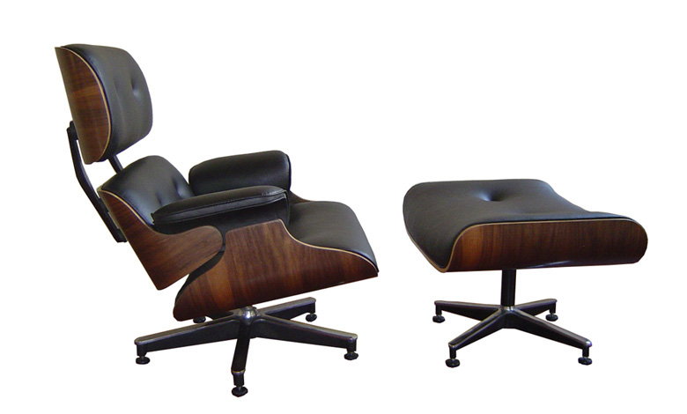
STRATEGY

Introduction
Herman Miller Inc. (HMI) was a recognized leader in product design and innovation, representing 7.3% of the overall office furniture segment of the office equipment industry. This leadership was the result of decades of disciplined strategy execution which saw HMIinvest in developing a corporate culture that valued employee engagement, investment in R&D and environmental sustainability. In addition to market leadership, this operating culture allowed HMI to enjoy process efficiencies and quality control, as well as profitability, unparalleled by its competitors. However, the largely U.S. led recessions of 2001 and 2008 hit the furniture industry hard and HMI was no exception. HMI saw its revenues decline by 35% and profits by 82% between 2008 and 2010. Although HMI had weathered the recession better than the industry and its competitors overall, the drop in sales and profitability forced the company to make drastic changes to employee compensation and costs overall. HMI began to think carefully about its strategy going forward and how it might need to adjust to the recent economic challenges.

Analysis of Issues

Reduced sales revenues of 35% between 2008-2010 due to the economic downturn
The economic recession of 2008, came just as HMI was beginning to recover from the impacts of the 2001 recession. Many of the changes that were made in response to that recession, worked well to insulate HMI to the effects of the 2008 recession. In 2001, HMI had announced changes to its employee compensation policies, including elimination of its life-time jobs policy and the announcement of a 38% reduction in the company’s labour force. When in 2008, HMI was faced with yet another deep recession, it proceeded to further reduce operating expenses. In response to a significant drop in sales, HMI instituted immediate cuts to employee compensation; all in all, HMI cut general, selling and administrative expenses by $78 million in 2010, over 2008.
In spite of these efforts to control costs, HMI was unable to match spending cuts to the lost revenue. In 2010, operating earnings dropped to 4.1% of sales vs. 12.3% in 2008 and profits plummeted to 2.1% of sales, vs. 7.6% in 2008. As HMI struggled to downsize its operations, return on total assets dropped to 3.1% in 2010 vs. 19% in 2008, perhaps indicating that production capacity was being underutilitized.
However, when compared with the industry as a wholewe see that HMI performed relatively well during the recession, losing 19% of sales between 2008-2009, compared to the industry’s drop of 26.5% in the same period. HMI also managed to remain profitable in 2010 in spite ofincreasing investment in R&D to 3.1% of sales, reaching a five year low profit ratio of 2.1%.

Lack of sales outside of North America; only 15% of global sales in 2008
In order to distribute its product to the global marketplace, HMI had established wholly owned subsidiaries in Canada, Mexico, France, Germany,the Netherlands, Italy, Japan, Singapore, China, India andAustralia, to sell products internationally. It had also established independent dealers who would service over 100 additional countries. In addition to these international sales channels, HMI also had manufacturing operations in the United Kingdom and China.
Despite a history of international sales dating back to the 1960’s, HMI’s market penetration outside of North America has been wanting. In 2008, only 15% of HMI’s revenues and 10% of its profits came from markets outside of North America, a decrease over 2007 when 16.5% of its revenues and 20% of its profits came from these markets. The largest market outside of North America during this period was the United Kingdom.
Although we do not have sufficient information to understand the nature of these changing numbers in detail, it is worth noting that decisions about product design are usually made in the U.S. and influenced by American design principles which may not be socio culturally compatible with buyers in emerging markets. Additionally, the 2007 profit numbers indicate that there may be an opportunity to earn greater profits in foreign markets, while at the same time diversifying market risk exposure.

Impact on employee culture from changes to employee benefits package
In reaction to the economic pressures put on HMI by the 2001 and 2008 recessions, significant changes were made to the company’s employee benefits and compensation plans. In 2001, the company established a new “social contract” with employees which no longer guaranteed jobs for life and made changes to employee benefit packages, including 401K retirement plans. In 2009, the company instituted a further 15% reduction in the workforce and instituted immediate cuts to employee compensation as follows: executives took a 20% cut; all other salaried staff took a 10% pay cut; all production workers were switched to schedules of 9 days in 2 weeks or approximately a 10% reduction in work hours. In addition to these cuts to compensation, the company also suspended 401K employer contributions.
The strong corporate culture at HMI meant that when these changes were announced, they were praised by HMI staff as necessary to the future success of the company. However, these changes represent a significant departure from the traditional operating philosophy that allowed the company to so successfully establish an effective corporate culture and the company’s actions as they emerge from the crisis will determine their ultimate success in maintaining that culture.

Recommendations
Herman Miller Inc. presents us with a model for strategy execution that has set it apart from the competition for nearly 100 years. Even in difficult financial times, HMI has been able to successfully outperform the competition and re-invent itself as required to both whether the storm and take advantage of new opportunities. Based on the above analysis, we are making the following recommendations:
- Stay the course
- Re-invest in employee culture
- Expand global sales efforts through locally based design and marketing
It is our recommendation that Herman Miller Inc. continue to execute on its corporate and functional strategy of being a high quality product and design leader in the high end office furniture market.
HMI should continue to look for more ways of aligning the interests of its employees, management and shareholders. The cancellation of the 2009 salary reductions and the new Economic Value Added (EVA) based employee profit sharing schemes are a good start, but as a gesture of good faith to employees, HMI should also retroactively restart its contributions to employee 401K plans to regain employee engagement.
HMI should also begin exploring the establishment of functional R&D teams in emerging markets and involving foreign born designers and marketers that might help the company better understand this rapidly growing customer demographic. Foreign customers should account for 25% of sales by 2014.
Making these minor changes help reinforce HMI’s sustainable competitive advantage and allow it to diversify its market exposure to new countries, without losing sight of what made the company an industry leader.

APPENDIX A– EXTERNAL

Key economic and industry variables

Market Size and growth rate
- The office furniture segment of the office equipment industry is a $13.7 billion market, as measured by the total stock market value of the industry. The industry is cyclical in nature and was recently heavily impacted by the economic downturns of 2001 and 2008.

Number and scope of Rivals
- According to Hoover’s HMI’s three majors competitorsare HNI Corporation, Steelcase and Haworth. There has been increased competition from overseas.

Societal/Lifestyle Changes
- Shifting trends towards flexible schedules and telecommuting have shifted the industry’s focus from large corporate salestowards smaller, dynamic offices and home offices. Long hours spent on computers have increased demand for ergonomically designed furniture.

Product innovation and differentiation
- Leadership based on innovative product design, quality and functionality are key differentiating competitive factors for companies in the high end of the furniture segment.

Economies of scale
- Production efficiency, capacity usage and inventory ratios all affect company profitability, as indicated by the decreasing profit ratios in the face of a sudden economic downturn.

Porter's Five Forces Analysis
 | Porters 5Forces | Strength | Detail
1. | Bargaining power of Buyers | Moderate to Low | Large global corporate offices could exhort significant pressure; however the trend to telecommuting is resulting in more and smaller or individual buyers which have significantly less bargaining power.
2. | Potential new entrants | Low | Industry is in its maturity stage with decreasing sales growth. High end furniture production requires significant initial capital outlays.
3. | Substitutes for Office Furniture | Moderate | Many employees are telecommuting and/or working from home; home furniture could double as office furniture
4. | Bargaining power of suppliers | Moderate to Low | Inputs for the furniture industry are largely commoditized with suppliers serving many small companies. Component manufacturing is often outsourced with companies focusing only oncomponents they deem to be a competitive advantage, and assembly. Significant power rests with the company’s design, supply chain and distribution processes.
5. | Rivalry among competing sellers | High | Significant competition between the four top firms in the industry.  Increased competition from overseas as well as the low cost producers.

Summary of Competitive Forces
Overall, competition in the office furniture segment seems to be focused arounddesign leadership, product quality, production management and marketing management. As indicated above, competitive rivalry in this segment is high and is likely the most important of the five forces for this industry. Competition is likely to continue to grow as more companies follow the trend towards ergonomic office furniture and companies begin to compete more heavily on marketing and distribution efforts directed at telecommuters, however new entrants are unlikely given the industry’s maturity and the upfront capital investment required.Telecommuting trends will weaken buyer power and push the industry to focus more on home offices, which could represent an increase in the size of the market, but this force will be offset by the availability of comparable substitutes in home furniture. Finally, the economic recovery following the 2008 recession might work to reduce competition, but likely not significantly.

Key Drivers for the Industry
Technological change: Development oftechnology supporting the design ofergonomically correct office furniture, as well as for developing more efficient production processes.
Industry growth cycle and rate:Industry is cyclical and sales are heavily influenced by macro-economic trends. Companies must adjust operational strategies in response to these changes.
Product and marketing innovation:Design preferences translate into direct sales. Design leadersbenefit from first mover advantage and force competitors to follow. Marketing innovations allow companies to reach new audiences created by shifting customer profiles and preferences.
Changes in customer profile:Telecommuting has lead to more home offices, while computer usage has driven up the importance of ergonomic design. Globalization has also increased the importance of foreign market sales.

Weighted Key Success Factors Analysis Table
 |  | HMI |  | Haworth |  | Steelcase
KSF | Weight | Rating | Score | Rating | Score | Rating | Score
Product & supply chain management | 0.3 | 9 | 2.7 | 7 | 2.1 | 6 | 1.8
Design innovation & leadership | 0.2 | 10 | 2 | 8 | 1.6 | 7 | 1.4
Marketing innovation | 0.2 | 8 | 1.6 | 5 | 1 | 4 | 0.8
High quality labour productivity | 0.1 | 9 | 0.9 | 8 | 0.8 | 7 | 0.7
Geographical coverage | 0.1 | 8 | 0.8 | 8 | 0.8 | 8 | 0.8
Product distribution | 0.1 | 5 | 0.5 | 9 | 0.9 | 8 | 0.8
Weighted Total | 1 | 49 | 8.5 | 45 | 7.2 | 40 | 6.3
(Each strength rating scale measure: 1 = very weak; 5 = average; 10 = very strong)
As demonstrated in the above table, HMI is well positioned from a competitive standpoint on many of the industry key success factors and especially with regards to the key competitive differentiators of production management, design leadership and marketing innovation. They are also very well positioned in terms of having a high quality labour force that can execute on their strategic objectives.

Conclusions about Industry Attractiveness
The office furniture segment of the office equipment industry is very competitive. However, it is costly and difficultfor new companiesto enter and gain market share because margins are small and initial capital outlay is significant. While competition from overseas is increasing, it has mostly impacted the low-cost furniture manufacturers more than the high quality ones. The economic and purchasing cycles that drive the industry make it volatile, both in terms of sales revenues and the price of raw materials and other production inputs. The industry’s cyclical nature requires companies to have solid financial, operational and human resource strategies to survive and sustain profitability in rapidly changing economic conditions. Socio-economic trends moving towards globalization and the proliferation of home offices point to the opportunity for market growth, but also to the threat of new substitute products. Overall, the industry’s size and its ability to experience substantial revenues and profits make it an attractive industry for any established competitor looking to expand their market share as the economy begins its global recovery.

APPENDIX B – INTERNAL

Vision Statement
“To design and build a better world.”

Mission Statement (Implied)
Herman Miller’s mission is to be a recognized innovator in contemporary interior furnishings, using leading design and technology to create solutions with people in mind and while protecting the environment. We operate through several focused businesses, brands, and distribution channels to serve our customers around the globe.

Core Values:
Curiosity & Exploration:Supported by encouraging risk and practicing forgiveness.
Engagement:Encourage employees to care about the company and make a difference by taking “ownership” of its problems and their related solutions.
Performance:Necessary to enrich the lives of employees, delight customers, and create shareholder value; it is everyone’s job at HMI.
Inclusiveness: Valuing the whole person and giving them the chance to realize their potential.
Design:A method for looking at the world, how it works and for solving problems.
Foundations:Valuing HMI’s past without being ruled by it.
A Better World:Pursuing sustainability and environmental wisdom to create a better world.
Transparency:Underpinning the trust and integrity by letting others see how decisions are made.

Strategic Objectives
Herman Miller is employing a focused differentiation strategy by trying to target the high end market for office furniture, using innovative designs that are both functional and visually attractive.

Functional Strategy:
Supply Chain Management – HMI used an efficient and a cost savings system of lean manufacturing referred to as the Herman Miller Production System (HMPS) that helped minimize the amount of inventory on hand through a just-in-time process, as well as limiting fixed production costs by outsourcing component parts from strategic suppliers. This allowed HMI to increase the variable nature of its cost structure and respond quickly to changing market forces.
Human Resource Strategy–HMI’score strength is derived from the company’s management of human resources, which included employee development opportunities and compensation structures that were geared to firm performance. HMI was routinely on the 100 best employers list.
Marketing Strategy –HMI used a green marketing strategy by producing environmentally friendly products made of as much as 45% recycled materials of which 96%were in turn recyclable.
Technology Infrastructure–HMI’s order entry system was digitally linked with its suppliers, distributors, and customers to speed up orders and improve accuracy. They also employed a 3D design computer program for midsize customers.

Corporate Strategy:
Design leadership -The Company’s award winning designs such as the Ergon, Equa& Aeron chairsdemonstrate the firm’s supreme design leadership in the manufacturing of office furniture.
Strong Corporate Culture -HMI has a strong and respected culture because it values and respects all the talents of its employees. HMI included and sought input from employees at all levels in its product and operational decisions by using small functional teams and large cross functional committees. Employees were measured on their economic value added at an organizational level and encouraged to take ownership for the success of the company and their peers. This culture was reinforced with the company’s compensation and benefits structure.

Competitive Advantage
Herman Miller’s competitive advantages are its design leadership position and its production quality and efficiency. However, both of these stem from HMI’s core competency of creating and supporting a corporate culture that encourages the above core values and allows for successful execution of its corporate strategy. HMI’s successful management of this corporate culture is unique, difficult to replicate and cannot be substituted, making their competitive advantage both valuable and sustainable.

Company’s value chain and sources of competitive advantage (VRIO analysis)
Supply Chain Management
Distribution
Sales and Marketing
Service
Profit
Product R&D

Human Resources Management

General Administration
Supply Chain Management:The use of MillerProduction System (HMPS) helps minimize the amount of inventory on hand as well as fixed costs. HMI enjoyed a high inventory turn-over rate with product standard lead times of between 10 to 20 days.
DistributionChannels:Manufacturing was mainly based in the U.S. in Georgia, Michigan, and Washington. They also had a few locations in the United Kingdom and China.
Sales & Marketing:HMI products are offered in over 100 countries by independent dealerships and marketed through cooperative advertising with strategic partners. Environmentally friendly practices meant HMI Products could be used to earn points towards LEED Certification.
Service:HMI stands by its product quality, to reduce services issues, they have investing significant resources to reduce defects and improve on-time shipments.

Financial Analysis
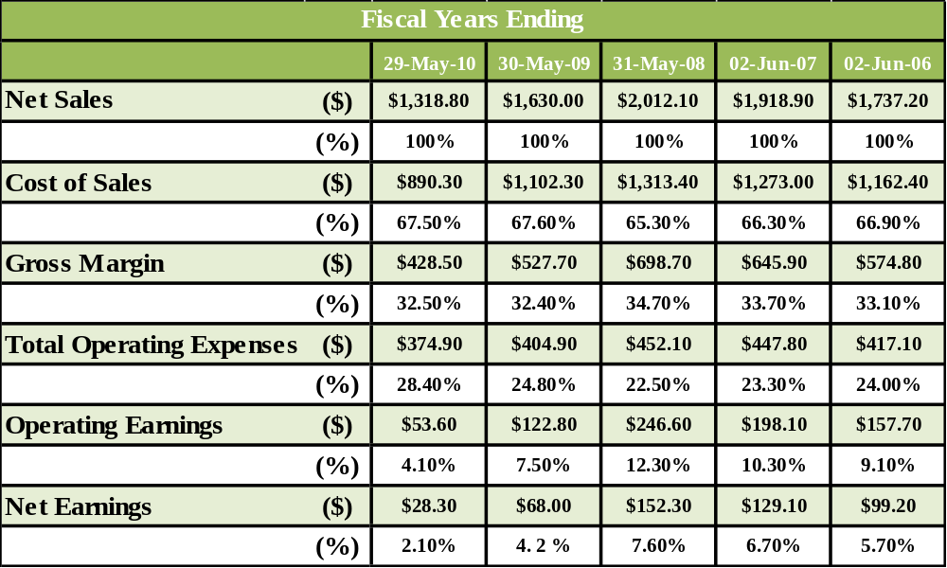
Herman Miller’s bottom line was severely impacted by the recession in late 2007. Despite having already laid off 38% of its workforce after the 2001 recession, HMI had to furthercut salaries by 10-20% and workforce by 15% in an effort to match the 34% decrease in sales it experienced. On a positive note, HMI did manage to remain in the black and continued investment in R&D. HMI performed well in comparison to its industry losing 19% of sales in 2008-2009 compared to the industry average of 26.5%.
- 2010 sales dropped 35% to $1.3 billion vs. $2 billion in 2008
- 2010 profits dropped 82% to $28 million vs. $152 million in 2008
- Reached a five year low profit ratio of 2.1% in 2010
- Investment in R&D, reached a high of 3.1% of sales in 2010
- Herman Miller had decreased general and administrative expenses by over $78 million ($395.8 in 2008 vs. $317.7 in 2010)

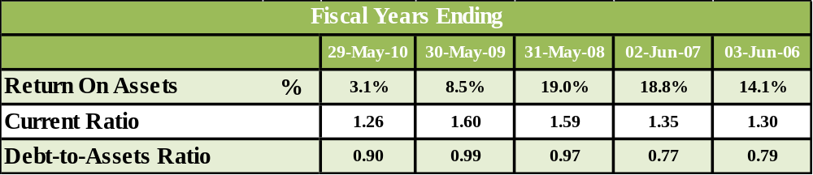
HMI found it difficult to cut expenses as quickly as the drop in sales and wasforced to issue 3 million new shares to balance its financial (debt and cash) position.The company’s drop in return on total assets verifies the impact of the recession on the company’s ability to utilize its capital assets.
- Return on total assets dropped 15.9% to 3.1% in 2010 vs. 19% in 2008
- Debt-to-equity ratio rose from 1.18 in 2006 to 47.66 in 2008
- The current and debt to assets ratio show HMI was also able to stay ahead of its liabilities.

SWOT Analysis
Strengths | Weaknesses
- Recognized design leader  - Recognized environmental leader  - Strong corporate culture  - Strong employee loyalty, engagement  - Alignment of management and staff  - Internally developed management  - Strong command of production process  - Well-designed and executed product and marketing innovation strategies  - Proven R&D strategy | - Over reliance on the North Americanmarket: 85% of global company sales  - Over reliance on third party suppliers  - High cost of employee compensation  - Lack of globally diversified design teams  - Low industry profit margins
Opportunities | Threats
- Growing wealth and demand in developing countries  - Home office furniture segment  - Improving global economic conditions  - Inclusion of foreign design elements to serve developing market needs | - Volatile product input commodity prices  - Cyclical sales volatility  - Home furniture market competitors  - Changes to consumer behaviours  - Changes to employee culture
Reviewing the SWOT analysis, we can see that HMI is well positioned from a competitive standpoint. HMI has many important strengths that will allow it to take advantage of opportunities on the horizon. Although there are some threats and weaknesses, most of these are shared by its competitors. The below list represents the most pertinent issues facing Herman Miller Inc.

Key Issues Facing Herman Miller Inc.
- Reduced sales revenues of 35% between 2008-2010 due to the economic downturn
- Lack of sales outside of North America; only 15% of global sales in 2008
- Impact on employee culture from changes to employee benefits package

